Incommensurate Spin Density Wave at a Ferromagnetic Quantum Critical Point in a Three-Dimensional Parabolic Semimetal

Murray, J.M. (NHMFL); Vafek, O. (NHMFL, FSU) and Balents, L. (U. California Santa Barbara)
____________________________________________________________________________________

Introduction
In recent years semimetallic systems, in which valence and conduction bands touch at isolated points in momentum space, have emerged as a fascinating arena in which to explore competing phase instabilities in strongly interacting itinerant electron systems. Such semimetals can arise in strongly spin-orbit coupled systems with cubic crystalline symmetry in three dimensions. In this work we investigate the fate of a quantum critical point separating paramagnetic and ferromagnetic phases, which we propose could be realized by doping a gapless semiconductor such as HgTe with magnetic impurities.

Results and Discussion
We investigate the role of interactions between electrons and collective spin-wave modes in the vicinity of a ferromagnetic quantum critical point (r = 0 in Fig. 1), and find a negative contribution to the self-energy of the collective mode, indicating the presence of an additional phase instability. Calculating the wavevector dependence of this self-energy, we find that this new phase is an incommensurate spin density wave, in which the spins are oriented longitudinally along the ordering wavevector. In addition, we investigate the effects of symmetry-allowed crystalline anisotropies and show that the ordering wavevector can be pinned either along the [111] or [100] directions.

Conclusions
The appearance of an incommensurate spin density wave in an itinerant system without Fermi surface nesting is unusual. What’s more, the magnitude of the ordering wavevector is independent of the underlying crystal lattice and depends on the interaction strength and temperature. Our work illustrates the potential richness of possible new phases driven by strong electron interactions in three-dimensional semimetallic systems.
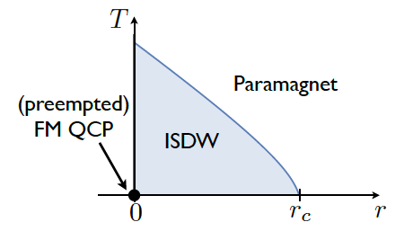
Fig. 1 Schematic phase diagram of a three-dimensional parabolic semimetal near a ferromagnetic quantum critical point. The vertical axis is temperature, while the horizontal axis, which could represent pressure or doping of magnetic impurities, tunes the system between ferromagnetic and paramagnetic phases. In the absence of electron interactions, the system has a quantum phase transition at r = 0 from a ferromagnetic phase to a paramagnetic phase. When interactions are included, the critical point is masked by an incommensurate spin density wave phase.

Acknowledgements
This work was performed at the National High Magnetic Field.In addition, this work was supported by the NSF CAREER award under Grant No. DMR-0955561.

References
1] Murray, J. M., Vafek, O., and Balents, L., Phys. Rev. B, 92, 035137 (2015) [Editor’s Suggestion].

