Tuned Geometrical Frustration in Ba₂MSi₂O₆Cl₂, M = Cu, Co from Magnetostriction in Pulsed Magnetic Fields

Jaime, M. (NHMFL-LANL); Okada, M.; Kurkita, N. and Tanaka, H. (TiTECH, Tokyo, Japan)

Introduction
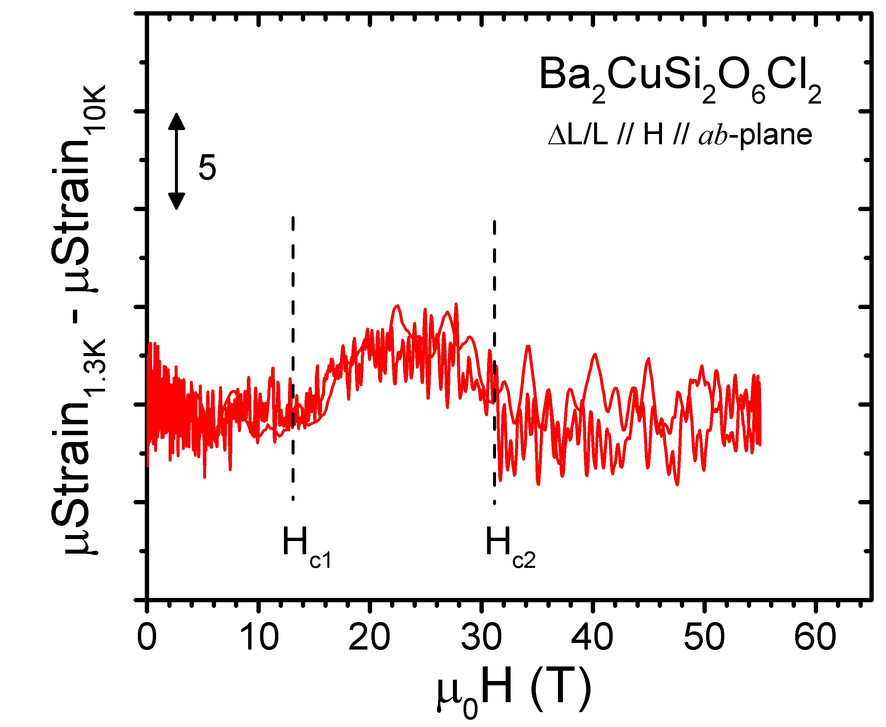
Ba₂MSi₂O₆Cl₂ (M = Cu, Co) has been synthetized as a by-product of the process used for the single-crystal growth of Ba₃CoSb₂O₉, which is well described as an S=1/2 triangular-lattice Heisenberg AFM [1,2]. The crystal structure consists of MO₄Cl pyramids with a Cl⁻ ion at the apex. Magnetic Co²⁺ and Cu²⁺ with effective spin 1/2 is located approximately at the center of the base. Two MO₄Cl pyramids form a chemical dimer with their bases facing each other. The pyramids are linked via SiO₄ tetrahedra in the ab plane. The atomic linkage in the ab plane is similar to that of BaCuSi₂O₆ [3]. Ba₂MSi₂O₆Cl₂ closely approximates a two-dimensional (2D) coupled spin dimer system. In the case of M = Cu we observe field induced magnetic order at H_{c1} = 13T, that extends to H_{c2} = 28T. The order is likely XY-AFM, like in the case of BaCuSi₂O₆. On the other hand, when M = Co the exchange interactions and geometry lead to almost perfect frustration and plateaus reminiscent of those found in the Shastry-Sutherland compound SrCu₂(BO₃)₂ are observed at H^{ab} = 32, 41T and H^{c} = 47, 56T.

Experimental
Fig.1 Magnetostriction at 1.3K, obtained after subtraction of T = 10K data in M = Cu sample.
Fiber Bragg grating dilatometry experiments were conducted in single crystal samples of the title compound. The magnetostriction was measured in a short pulse magnet to 60T, at temperatures between 10K and 0.6 K, with the goal of quantifying the strength of magnetoelastic couplings in the extreme members of this interesting family of compounds where geometric/magnetic frustration can be tuned by chemical means.
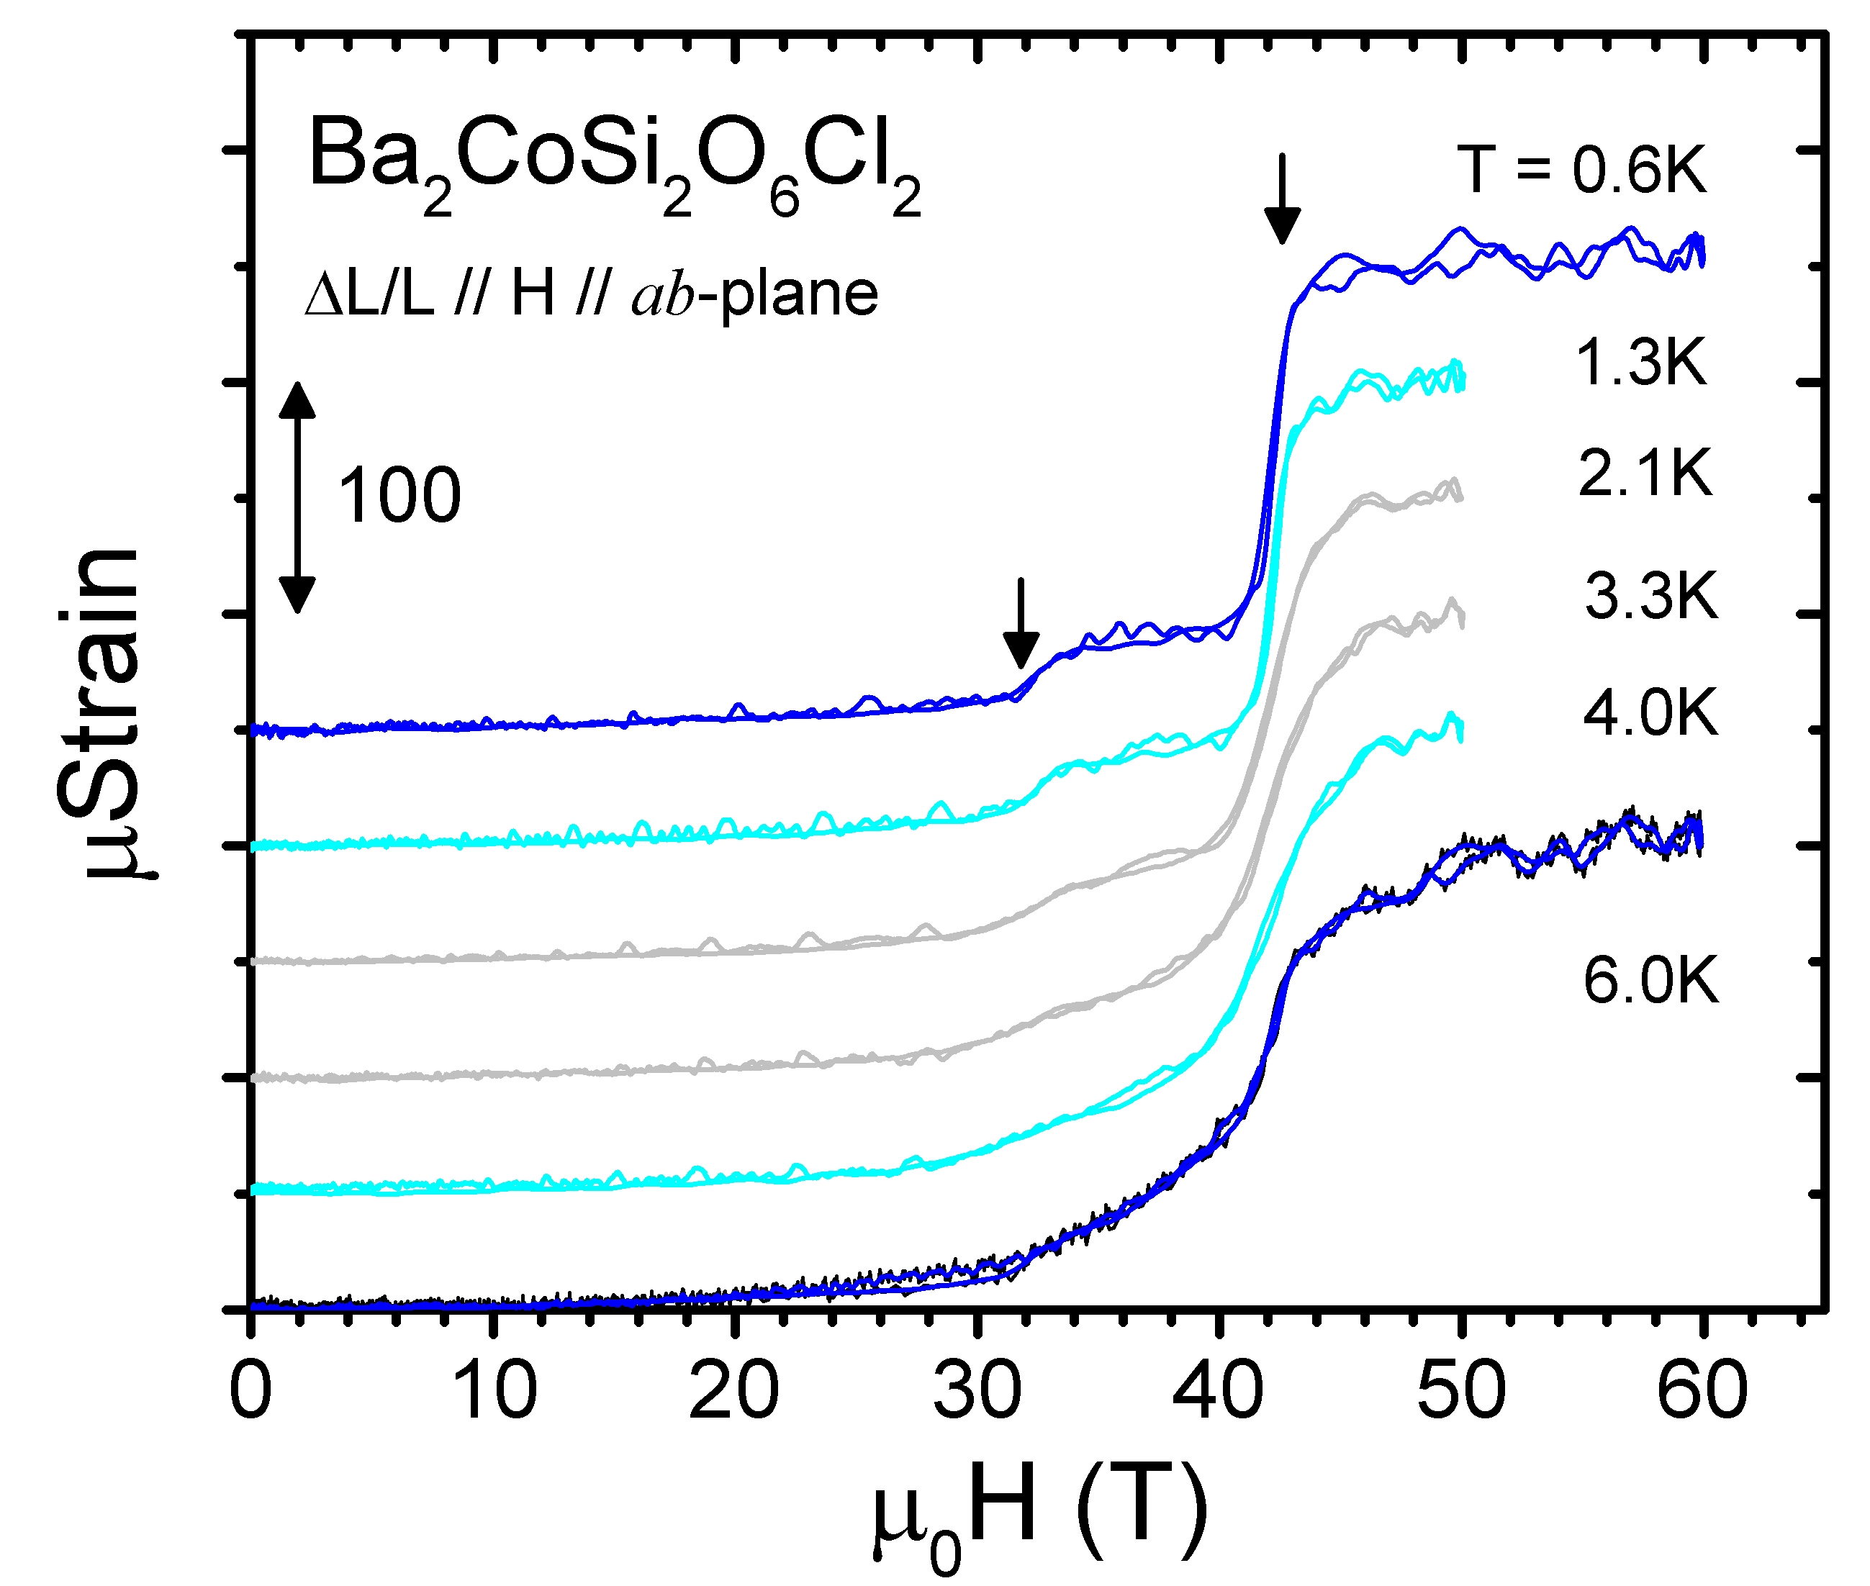
Results and Discussion
We found weak magnetoelastic coupling in the M=Cu member, of the same order of magnitude seen in other XY-AFMs such as NiCl₂-4SC(NH₂)₃. [3] The M = Co member, on the other hand, shows enhanced lattice involvement consistent with strong geometrical frustration.

Conclusions
Our results agree with early expectations, further analysis, modeling and quantification will follow.

Acknowledgements
A portion of this work was performed at the National High Magnetic Field Laboratory, which is supported by National Science Foundation Cooperative Agreement No. DMR-1157490 and the State of Florida.

References
[1] Shirata, Y., et al., Phys. Rev. Lett., 108, 057205 (2012).
Fig. 2 Magnetostriction of M = Co sample at various temperatures.
[2] Tanaka, H., et al., J. Phys. Soc. Jpn. 83, 103701 (2014).
[3] Zapf, V., et al., Rev. Mod. Phys. 86, 563 (2014).

