Li₂O(CuSO₄)₂: A Rare Realization of Frustrated Spin-1/2 Two-Leg Ladder?

Rousse, G. (Collège de France); Radtke G. (Université Pierre et Marie Curie); Sun, M. (Collège de France) and Jaime, M. (Supporting Scientist, NHMFL)

Introduction
Li₂O(CuSO₄)₂ has been synthetized for the first time in 2015. This cuprate displays a very peculiar crystal structure, shown in Figure 1 (a) and (b). In this structure, spin-1/2 are held by Cu²⁺ ions forming chains oriented along the c axis of the crystal and well separated from each other by the Li ions. These chains are build from a stacking of [Cu₂O₆]⁴⁻ plaquettes sharing the central oxygens ions with neighboring plaquettes oriented at 90°. If one only considers super-exchange mechanisms supported by Cu-O-Cu bonds, this geometry is exactly that of a linked-tetrahedra spin chains with intra-plaquette coupling J₁ and inter-plaquette coupling J₂. Additional large interactions through the SO₄ non-magnetic units (J₄) are also present. We are therefore in the presence of a very rare example of frustrated spin-1/2 two-leg ladder (see Figure 1(c) and (d)), a system at the center of a very impressive amount of theoretical work over the past decades. Magnetic susceptibility measurements (see Figure 1(e)) show a clear spin-singlet ground-state and a spin-gapped behavior indicative of dominant AFM couplings of the order of ~ 100K and powder neutron diffraction confirms the absence of long-range order down to 2K.
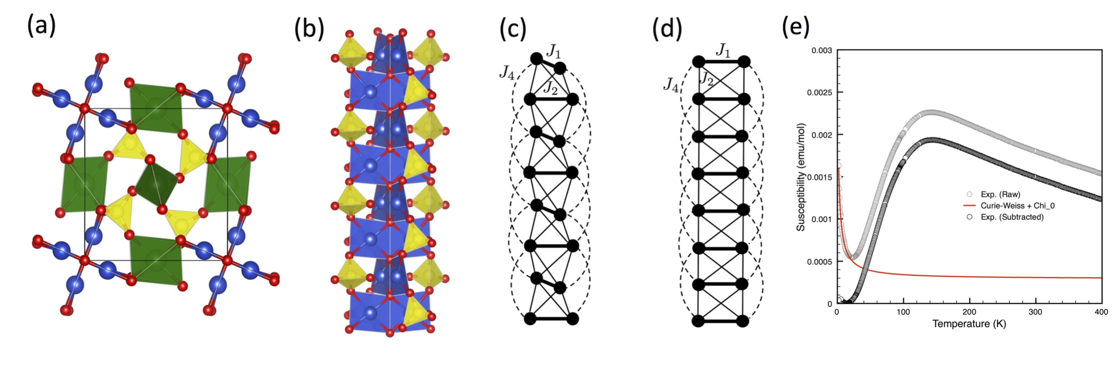
Figure 1: (a) Atomic structure of Li₂OCu₂(SO₄)₂. Cu are in blue, O in red, S in yellow and Li in green. (b) Detail of the atomic structure of the chains (c) Magnetic model deduced from the atomic structure (d) Topologically equivalent frustrated two-leg spin ladder (e) Temperature dependence of the magnetic susceptibility.
Experimental
Pulsed field magnetization experiments have been carried out at different temperatures ….

Results and Discussion
The main goal of these experiments was: (1) to determine experimentally the value of the spin gap in this material and (2) investigate the potential presence of magnetization plateaus associated with the frustration.
Up to 65T, we only observed a very weak signal under the form of a quasi-linear behavior of the magnetization with the field, recorded for different temperatures and consistent with the above magnetic susceptibility. Unfortunately, we were not able to induce any magnetic order with fields up to 65T.

Conclusions
As mentioned above, we were not able to reach the main goals of this project. The energy scale involved in this compound through magnetic couplings J₁, J₂ and J₄ is very large and an investigation of the physics of this frustrated system would require larger fields.

Acknowledgements
A portion of this work was performed at the National High Magnetic Field Laboratory, which is supported by National Science Foundation Cooperative Agreement No. DMR-1157490 and the State of Florida.

