Spin-Peierls Transition in the S=1/2 Compound TiPO₄ with Large Intrachain Coupling

Stern, R. (Natl. Inst of Chem. Phys. & Biophys (NICPB), Tallinn, Estonia); Kremer, R. (MPI, Stuttgart, Germany) and Jaime, M. (Supporting Scientist, NHMFL)

Introduction
The magnetic and structural properties of the quasi-1D 3D quantum chain system TiPO₄ (J about 965 K) has been investigated by magnetic susceptibility, heat capacity, electron spin resonance, x-ray diffraction, and nuclear magnetic resonance (NMR) measurements, and by density functional theory (DFT) calculations. TiPO₄ undergoes two magnetostructural phase transitions, one at T∗ = 111.6(3) K and the other at T_{SP} = 74.5(5) K. Due to the eventually rather large energy scales involved no mapping of the (H,T) phase diagram has been done to date. We plan to start this process with the help of pulsed field magnetization experiments to 60T at a number of temperatures between 2K and 120K. Contingent on the results obtained in these short pulse magnets we will evaluate the further need for even higher magnetic fields to 100T.
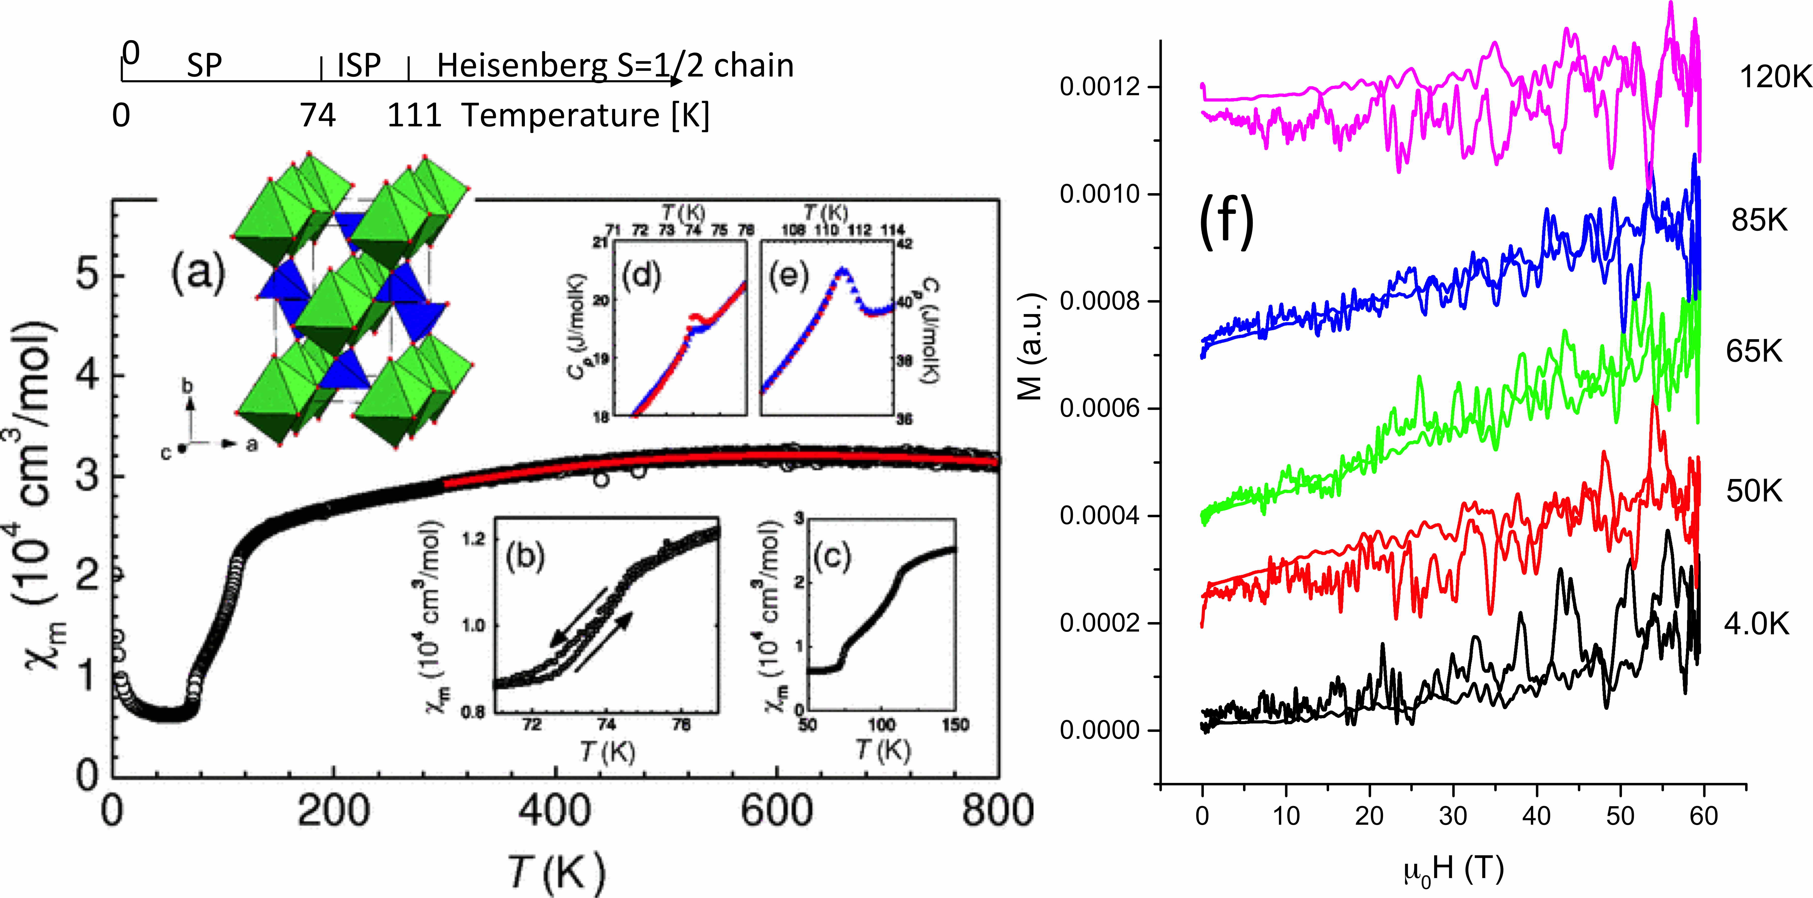
Figure 1: (a) Large T-range magnetic susceptibility and atomic structure of TiPO₄: PO₄ tetrahedra re in blue, TiO₆ octahedra in green. (b) Detail of the T_{SP} = 74.5(5) K transition (c) Detail of the susceptibility curve around T_{SP} = 74.5(5) K and T∗ = 111.6(3) K; Specific heat around (d) T_{SP} = 74.5(5) K and (e) T∗ = 111.6(3) K; (f) 5 representative 60T magnetization (field up and field down) measurement results at 5 different temperatures.

Experimental
Pulsed field magnetization experiments have been carried out at different temperatures between 2K and 120K: 4K, 50K, 65K, 85K, and 120K.

Results and Discussion
The main goal of these experiments was to do the mapping of the (H,T) phase diagram for TiPO₄.
Up to 60T, we only observed a very weak signal under the form of a quasi-linear behavior of the magnetization with the field, recorded for different temperatures and consistent with the above magnetic susceptibility. Unfortunately, we were not able to induce any magnetic order with fields up to 60T.

Conclusions
We were not able to resolve any features in (H,T) phase diagram for TiPO₄ and an investigation of the physics of this spin-Peierls system would require larger fields.

Acknowledgements
A portion of this work was performed at the National High Magnetic Field Laboratory, which is supported by National Science Foundation Cooperative Agreement No. DMR-1157490 and the State of Florida. Support by the Estonian Research Agency by grants PUT210 and IUT23-7 is highly appreciated.

