Pressure Dependence of the Exchange Anisotropy in an Organic Ferromagnet

Winter, S.M.; Oakley, R.T. (U. Waterloo, Canada, Chemistry); Thirunavukkuarasu, K.; Beedle, C.C.; Kovalev, A.E. and Hill, S. (NHMFL and FSU, Physics)

Introduction
The discovery of weakly correlated materials with nontrivial band topologies has recently brought into prominence the study of spin-orbit coupling (SOC) in the solid state. This interaction also plays an important role in magnetic insulators, where SOC manifests itself as anisotropic exchange interactions between local spin-orbital moments. These anisotropic terms, such as the celebrated Dzyaloshinsky-Moriya interaction, are instrumental in many magnetic phenomena including magnetic coercivity and spin canting, as well as the more exotic multiferroicity and topological spin phases. Engineering such states in real materials requires understanding the relationship between spin-orbit parameters and crystal structure, which requires both experimental and ab-initio probes of SOC. This report focusses on high-pressure ferromagnetic resonance (FMR) studies on the organic radical ClBPSSEt (Fig. 1(a)),¹ in which significant SOC induced anisotropic exchange has been identified.²

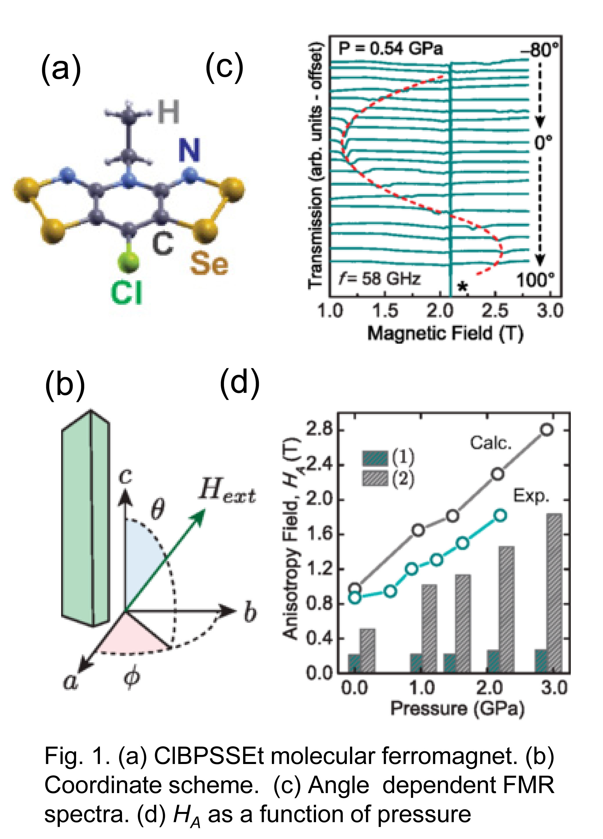
Experimental
Multi-frequency, high-pressure FMR measurements were performed using a plastic diamond anvil cell (DAC) placed inside a cylindrical resonator with dimensions matched to those of the DAC. Microwave losses were minimized by working at low temperatures (<10 K).

Results and Discussion
FMR spectra were recorded at different polar angles θ (Fig. 1(b)), the signal being seen as a dip in the transmission through the cavity. Changes in the anisotropy field H_{A} could then extracted from variations in the resonant field as a function of θ (Fig.1(c)).³ To provide a quantitative estimate of the anisotropic exchange parameters, an ab-initio theoretical scheme suitable for organic systems was developed. The resulting calculations correctly reproduced the pressure dependence of H_{A} and revealed that the enhancement is largely due to the increasing magnitude of interstack hopping integrals induced by changes in π-stack slippage occasioned by compression of the crystal. Taken together, the close agreement between the experimental and theoretical H_{A} values (Fig.1(d)) over the studied pressure range validates the magnitude of the calculated spin-orbit hopping parameters.

Conclusions
The combination of high-pressure ferromagnetic resonance methods and ab-initio calculations of spin-orbit mediated anisotropic exchange interactions in molecular materials have provided insight into the role of spin-orbit coupling (SOC) in this heavy atom radical ferromagnet. The FMR measurements reveal a continuous increase in the magnetic anisotropy with increasing pressure (up to 2.2 GPa), in excellent agreement with calculations based on the known pressure dependence of the structure. The large value of anisotropic exchange terms in this heavy atom organic ferromagnet emphasizes the important role of SOC in a wide range of organics where this effect is usually considered to be small.²

Acknowledgements
We thank the NSERC (Canada) and the US NSF (Grant Nos. DMR-1309463 and CHE-0924374) for financial support. S.M.W. acknowledges NSERC for a Graduate Scholarship. K.T. acknowledges support via Feodor-Lynen fellowship from Alexander von Humboldt foundation (Germany).The NHMFL is supported by the NSF (DMR-1157490) and by the State of Florida. Finally, we thank Stanley W. Tozer for his support in the development of the high-pressure EPR technique.

References
[1] Robertson, C.M., et al., J. Am. Chem. Soc., 130, 8414-8425 (2008).
[2] Winter, S.M., et al., Phys. Rev. B., 85, 094430 (2012).
[3] Thirunavukkuarasu, K., et al., Phys. Rev. B, 91, 014412 (2015).

