⁷⁷Se NMR Study of the Coupled Spin-Tetramer Compound CuSeO₃

Lee, W. –J.; Lee, S.; Choi, K.–Y. (Chung-Ang University, Physics); Reyes, A.P.; Kuhns, P.L. (FSU, NHMFL) and
Berger, H. (EPFL, ICMP)

Introduction
Coupled spin-tetrahedral systems have proven to be a promising platform to explore a coexistence of localized and collective magnetism in a single compound. When intra- and intertetrahedral interactions compete to each other, there emerge a plenty of interesting phenomena in low-energy excitations and spin dynamics [1]. CuSeO₃ (space group P2₁/n) is regarded as a three-dimensional network of tetramers [2]. The intratetramer exchange interaction is an order of J=200 K and intertetramer couplings establish antiferromagnetic (AFM) long-range order at T_{N} = 8 K. Electron spin resonance (ESR) and torque magnetometry studies [3] showed a variation of the magnetic principal axis and effective g-factor with temperature. However, not much is known about the evolution of magnetic correlations.

Experimental
⁷⁷Se NMR measurements were performed using a locally developed NMR spectrometer equipped with a high-homogeneity 17 T field-varying magnet.
Results and Discussion
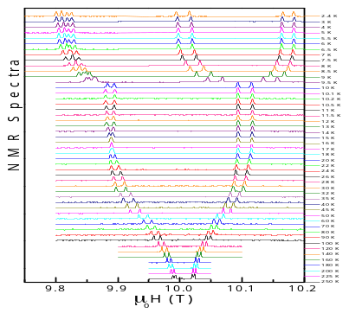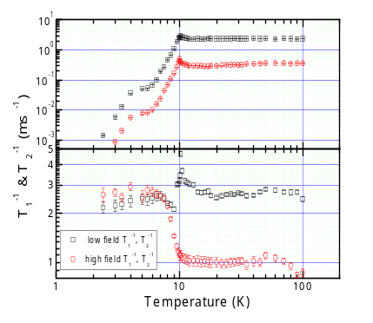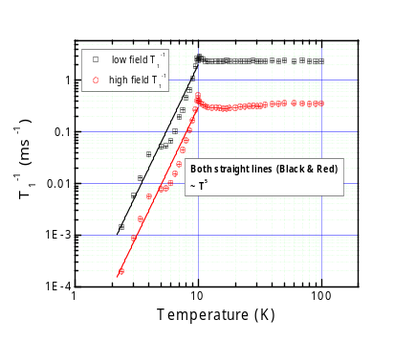
Fig. 1 (Left panel) Temperature dependence of field-swept NMR spectra measured at 81.49 MHz. (Middle panel) Temperature dependence of the nuclear spin-lattice (spin-spin) relaxation rates on a log-log scale. (Right panel) The power-law behavior of the nuclear spin-lattice relaxation rate for temperatures below T_{N}.

In Fig. 1 we present the temperature dependence of ⁷⁷Se NMR spectra of CuSeO₃. At T=250 K we observe four spectral lines, indicating the presence of four inequivalent Se sites. Upon cooling below T_{N}, each peak splits due to long-range AFM ordering and thus eight distinct peaks are observed. As summarized in the middle panel of Fig. 1, the spin-lattice relaxation, 1/T₁, is independent of temperature in the fast-fluctuating paramagnet state, for temperatures above 15 K and then shows a small divergence at T=10 K, confirming the magnetic ordering. For T<T_{N}, we find 1/T₁ ~ T⁵, being close to a power law. The T⁵ behavior is expected for a dominating three-magnon Raman process [4]. A close inspection discloses deviations from T⁵ law (see the right panel of Fig. 1). 1/T₂ also exhibits anomaly at the respective temperature. Noticeably, the similar magnetic anomaly was identified by the high-frequency ESR. This may be linked to a spin reordering, resulting from the competing intertetramer exchange interaction with an energy scale of 7 K.
Conclusions
⁷⁷Se NMR measurements of CuSeO₃ uncovers a magnetic anomaly around T = 7 K. This gives a hint for the occurrence of a spin reorientation possibly due to weak intertetramer coupling, which provides an efficient route to control a low-energy spin structure in a frustrated spin system.
Acknowledgements
A portion of this work was performed at the National High Magnetic Field Laboratory, which is supported by National Science Foundation Cooperative Agreement No. DMR-1157490 and the State of Florida.
References
[1] Furrer, A., et al., Rev. Mod. Phys. 85, 367 (2013).
[2] Zivkovic, I., et al., Phys. Rev. B 86, 054405 (2012).
[3] Herak, M., et al., Phys. Rev. B 89, 184411 (2014).
[4] Beeman, D. and Pincus, P., Phys. Rev. 166, 359 (1968).

