Characterization of Nickel Based Spin-One Antiferromagnets

Blackmore, W.J.A.; Brambleby, J.; Goddard, P.A. (U. Warwick, UK, Physics); Manson, J.L. (Eastern Washington U., Chemistry) and Ozarowski, A. (NHMFL, Tallahassee)

Introduction
Much work has been done on low-dimensional Ni²⁺ S = 1 anti-ferromagnetic coordination polymers, but issues still remain in extracting the anisotropy parameters D and E of compounds that contain magnetic interactions (J) [1,2]. To this end, molecular coordination polymers have been designed such that they contain negligible J enabling a much easier determination of D and E which can then be used to supplement the characterization of structurally similar materials that contain significant magnetic interactions.

Experiment Details
High-field, high-frequency ESR spectra at temperatures ranging from 5 to 30 K were recorded on a home-built spectrometer at the EMR facility of the NHMFL, Tallahassee, with the microwave frequencies ν = 52-416 GHz. The instrument is a transmission-type device and uses no resonance cavity. The microwaves were generated by a phase-locked Virginia Diodes source, generating frequency of 13 ± 1 GHz, and equipped with a cascade of frequency multipliers to generate higher harmonic frequencies. A superconducting magnet (Oxford Instruments) capable of reaching a field of 17 T was employed.

Results and Discussion
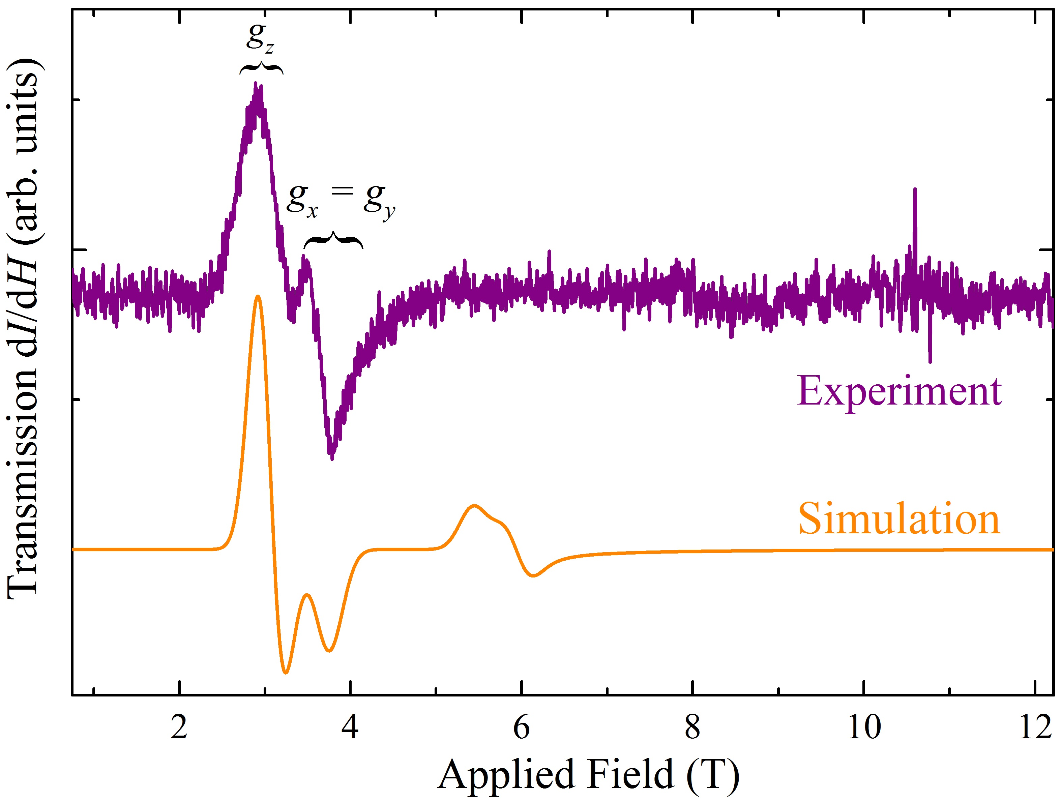
Continuous wave powdered ESR measurements (purple) made on the molecular [Ni(H₂O)₂(3,5-lut)₄](BF₄)₂ are shown in Fig. 1 along with a simulation (yellow) based on the Hamiltonian:
$\hat{H}=D{\hat{S}}_{z}^{2}+E\left({\hat{S}}_{x}^{2}-{\hat{S}}_{y}^{2}\right)+gμ_{\text{B}}μ_{0}H∙{\hat{S}}_{i},$ [1]
with an isotropic g = 2.21, D = 11.2 K and E = 0.27 K. The simulation captures the large resonance. The values of g, D and E are consistent with susceptibility and magnetization measurements. The simulated asymmetric peak centered at 6 T is not present in the measurement. This is believed to be a transition between the two higher energy states. At such low temperatures the lowered occupancy of these levels will correspond to a lowering of the transmission signal.
Fig. 1 Transmission ESR spectrum vs. applied field for [Ni(H₂O)₂(3,5-lut)₄](BF₄)₂ at 5 K with a 326.4 GHz source.
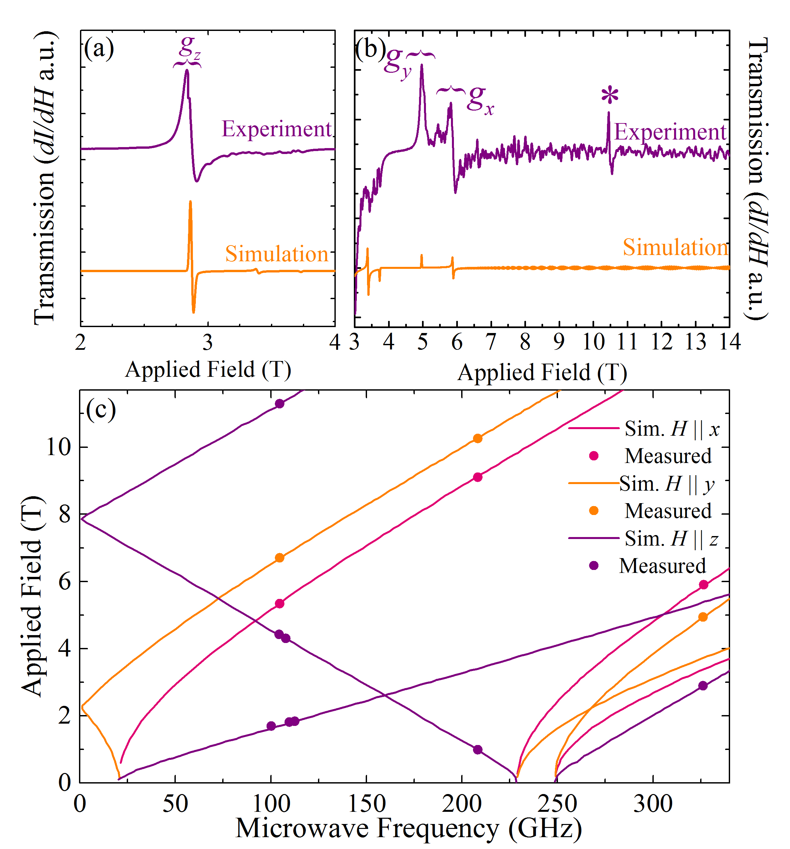
Powder transmission ESR measurements (purple) of NiSiF₆(4-mepz)₄(H₂O) are shown in Fig. 2(a) and (b) [the transmission axis in (b) is expanded 6x that in (a)] along with a simulation (yellow) based on the Hamiltonian in Eq. 1 with values of g_{x} = 2.234, g_{y} = 2.230, g_{z} = 2.160, D = 11.44 K and E = 0.469 K. The simulation successfully replicates the peaks that correspond to fields at which the separation of the energy levels in Ni²⁺ ions is equal to hν. The asterisk marks a paramagnetic impurity. The position of transitions [Fig. 2(c)] were fitted for S = 1 ions governed by the Hamiltonian in Eq.1 yielding parameters in excellent agreement with the simulation. These values are consistent with subsequent pulsed-field magnetization measurements that confirm NiSiF₆(4-mepz)₄(H₂O) exhibiting easy-plane anisotropy with D = 11.4 K and E = 0.5 K.

Acknowledgements
This work was performed at the National High Magnetic Field Laboratory, which is supported by National Science Foundation Cooperative Agreement No. DMR-1157490 and the State of Florida. WJAB, JB and PAG would like to thank EPSRC for funding. Work at EWU was supported by the NSF under grant no. DMR-1306158.
Fig. 2 (a), (b) Power transmission spectrum vs. applied field for NiSiF₆(4-mepz)₄(H₂O) at 5 K with 326 GHz source and (c) transitions in the ESR spectrum as a function of frequency.
References
[1] Liu, J., et al., arXiv: 1410.3077, (2015).
[2] Manson, J.L., et al., Inorg. Chem., 50, 5990 (2011).

