S/TEM Study of Magnesium-Copper Nano-Clusters by
Helium Droplet Mediated Deposition
Xin, Y. (NHMFL); Emery, S.B. (Naval Surface Warfare Center); Ridge, C.J.; Little, B.K. and Lindsay, C.M. (Air Force Research Laboratory)

Introduction
The production of pre-reactive bimetallic core-shell nanoclusters is a challenging undertaking with a high payoff for technologies that seek to exploit clusters and their unique physical and chemical properties [1]. Such properties are particularly promising for improving energy release rates in metastable intermetallic composite systems (MICs). The low energy release rates in bulk MICs limit their use to fuel and propellants. Helium droplet mediated deposition provides a means of assembling clusters atom-by-atom with well described size distributions, and then later those clusters land on substrates with impact energies lower than their cohesive energies. It is another alternative to assemble nano-clusters containing multi-elements.
Experimental
Core-shell clusters were produced in the helium droplet beam by capturing first magnesium atoms, and then later copper atoms. Both magnesium and copper atoms were effused from Knudsen-style cells loaded with 99.99% and ≥99.8% pure source materials, respectively, and separated by ~20 cm. After pick-up, clusters were landed intact onto room temperature substrates. We studied these Mg/Cu nano-clusters using the state-of-the-art probe-aberration corrected JEM-ARM200cF transmission electron microscope. Scanning transmission electron microscopy (STEM) high angle annular dark field (HAADF) imaging technique was used to image the clusters, and the distribution of Mg and Cu was determined by elemental mapping of the clusters through STEM electron energy loss spectrum (EELS) imaging (SI). The valance of Cu was determined by Cu L_{2,3} core loss EELS.
Results and Discussion
The helium droplets that landed on the TEM grids formed nano-clusters of 2-5 nm size. The Cu and Mg clusters can be distinguished by STEM-HAADF imaging as shown in Figure 1(a), where the brighter dots are the Cu clusters since Cu atomic number (Z=29) is heavier than Mg (Z=12). The color chemical map by STEM-EELS SI shown in Figure 1(b) reveals the core-shell structure of the Cu-Mg nano-cluster, with Cu at the core and Mg forming shell surrounding the Cu Core. The Cu and Mg are in un-alloyed chemical state. The materials were exposed to air so that the Cu and Mg are both oxidized. The EELS Cu core loss (Figure 1(c)) shows the Cu atoms having Cu⁺ valence, and they are oxidized to form Cu₂O.

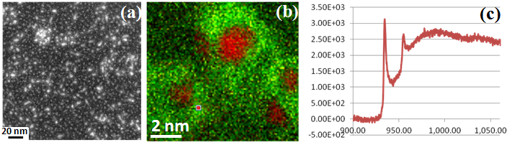
Figure 1 (a) STEM-HAADF image; (b) chemical map: Cu-red; Mg-green; (c) Cu L_{2,3} core loss EELS spectrum.

Conclusions
The rearrangement of the intended magnesium core and copper shell materials in the helium droplet was not expected, but a clear core-shell configuration was observed regardless. The Cu oxidized as Cu₂O with a Cu⁺ valence. Further experiments to examine Mg/Cu cluster samples produced at different temperature and Cu/Mg ratio are underway [2].
Acknowledgements
TEM work was performed at the TEM facility funded and supported by the Florida State University Research Foundation, and the National High Magnetic Field Laboratory (NSF Cooperative Agreement DMR-1157490), and the State of Florida.
References
[1] Castleman, A. W. et. al., J. Phys. Chem. C 113, 2664 (2009).
[2] Emery, S. B., et al., J. Chem. Phys., 142, 084307 (2015).

