Shubnikov–de Haas Oscillations in a 2D Electron Gas Under Subterahertz Radiation

Shi, Q.; Martin, P.D.; Hatke, A.T.; Zudov, M.A. (U. of Minnesota, Physics); Watson, J.D.; Gardner, G.C.; Manfra, M.J. (Purdue U., Physics); Pfeiffer, L.N. and West, K.W. (Princeton U., Electrical Engineering)

Introduction
When a 2D electron gas (2DEG) is subject to subterahertz radiation and low temperature, its magneto-resistivity exhibits, simultaneously, both Shubnikov-de de Haas oscillations (SdHO) and microwave-induced resistance oscillations (MIRO) [1]. Different theoretical predictions exist on how the SdHO amplitude should be affected by radiation [2]. Here, we report on experimental studies [3] which contradict existing theories.

Experimental
Our samples are Hall bars fabricated from GaAs/AlGaAs quantum wells with the density 3.1 x 10¹¹ (2.6 x 10¹¹) cm⁻² and the mobility 3.6 x 10⁶ (2.1 x 10⁷) cm²/Vs. Measurements were performed in SCM-2 and subterahertz radiation was generated by backward-wave oscillators.

Results and Discussion
In Fig. 1(b) we present normalized radiation-induced correction to the SdHO amplitude, $δA_{ω}/A_{0}$, along with normalized MIRO amplitude$δρ_{MIRO}/(2πϵλ^{2}ρ_{0})$, both obtained from magnetoresistivity shown in Fig. 1(a), as a function of $ϵ=ω/ω_{c}$, where $ω$ and $ω_{c}$ are the radiation and cyclotron frequencies, respectively. Remarkably, both quantities show excellent agreement in the period and phase, in contrast to theoretical predictions [2]. Even more surprising is the astonishing agreement between the amplitudes of the two quantities (no adjustable parameters have been used).
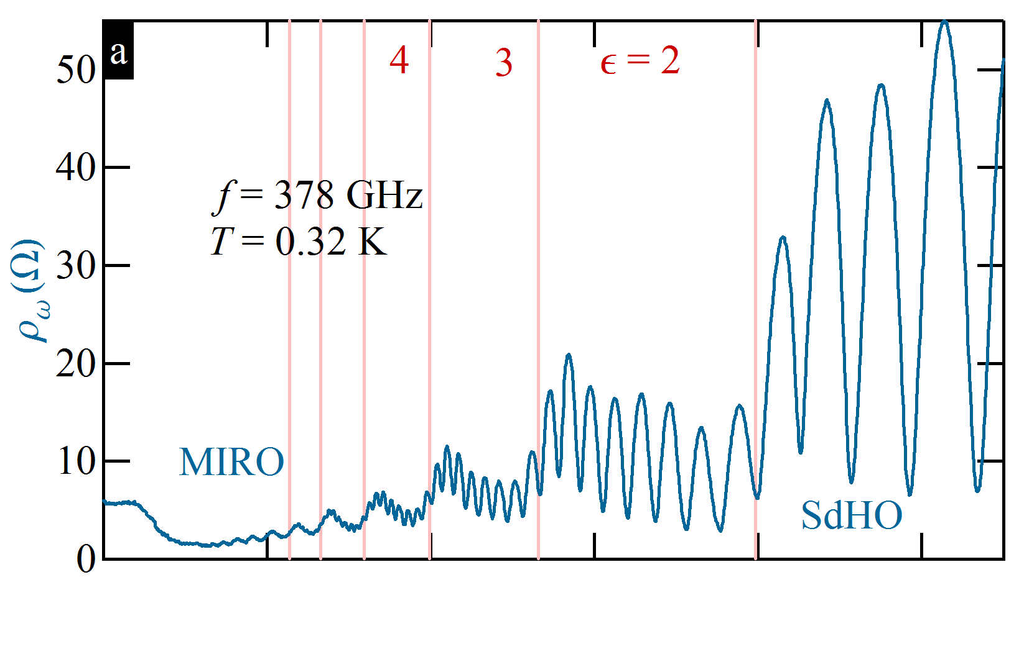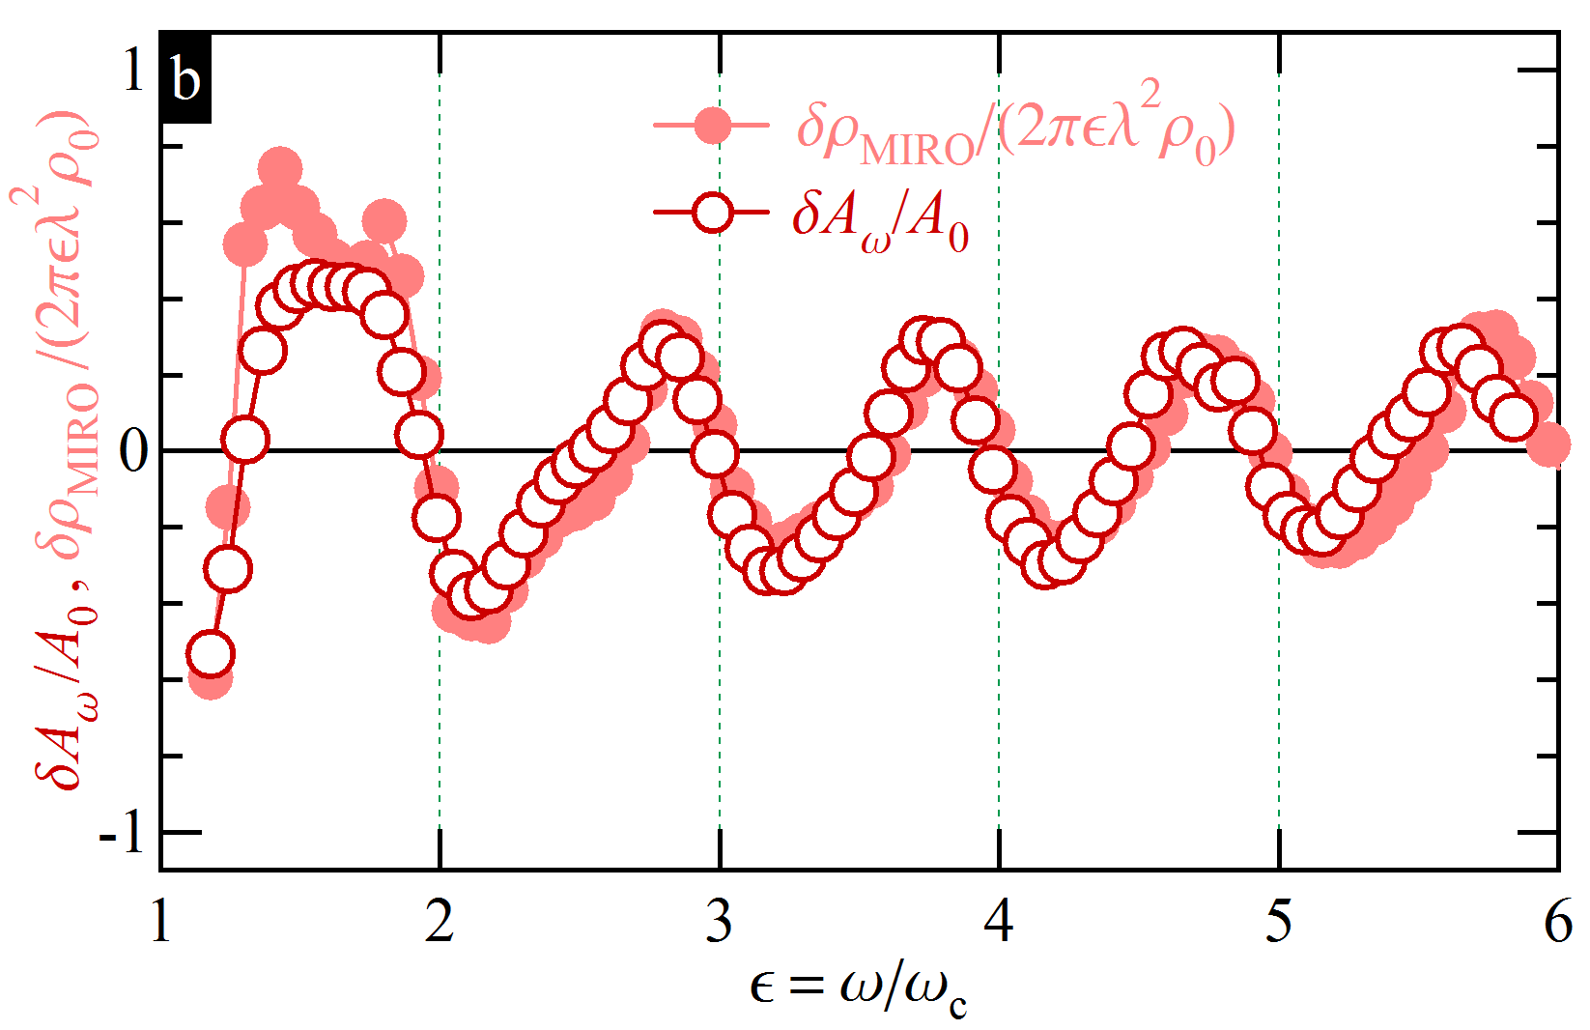
Fig. 1 (a) $ρ(B)$at $f$= 378 GHz and $T$ = 0.32 K. (b) $δAω/A$ and $δρ/(2πϵλ^{2}ρ_{0})$ versus $ϵ=ω/ω_{c}$.

Conclusions
We obtain an empirical relation for the radiation-induced correction to the SdHO amplitude, which is reminiscent of MIRO. The observed correlation between MIRO and SdHO calls for further studies.

Acknowledgements
A portion of this work was performed at the National High Magnetic Field Laboratory, which is supported by National Science Foundation Cooperative Agreement No. DMR-1157490 and the State of Florida. The work
at Minnesota (Purdue) was supported by the U.S. Department of Energy, Office of Science, Basic Energy Sciences, under Award No. ER 46640-SC0002567 (DE-SC0006671). The work at Princeton was partially funded by the Gordon and Betty Moore Foundation and by the NSF MRSEC Program through the Princeton Center for Complex Materials (DMR-0819860). Q.S. acknowledges support from Allen M. Goldman fellowship.

References
[1] Zudov, M. A. et al., Phys. Rev. B 64, 201311(R) (2001).
[2] Dmitriev, I. A. et al., Phys. Rev. Lett. 91, 226802 (2003), Phys. Rev. B 70, 165305 (2004); Lei, X. L. Phys. Rev. B 79, 115308 (2009); Dmitriev, I. A., J. of Phys.: Conf. Ser. 334, 012015 (2011).
[3] Shi, Q. et al. Phys. Rev. B 92, 081405(R) (2015).

