Spinless Composite Fermions in an Ultrahigh-Quality Strained Ge Quantum Well

Shi, Q.; Zudov, M.A. (U. of Minnesota, Physics); Morrison, C. and Myronov, M. (U. of Warwick, Physics)

Introduction
Fractional quantum Hall (FQH) effect has been realized only in a few select materials since its first discovery in a two-dimensional gas in GaAs/AlGaAs heterostructure [1]. FQH states in these materials are usually strongly influenced by spin and/or valley degrees of freedom, due to comparable energy scales. Here we report on observation of FQH states in an ultrahigh-quality Ge/SiGe quantum well [2] which can be described in terms of composite fermions with only the orbital degree of freedom.

Experimental
Our sample is fabricated from a Ge/SiGe quantum well with the density 2.9 x 10¹¹ cm⁻² and the mobility 1.3 x 10⁶ cm²/Vs. Measurements were performed in SCM-2.

Results and Discussion
Longitudinal resistance $R_{xx}$ and Hall resistance $R_{yy}$ demonstrate fully-developed FQH states at fractional filling factors $ν=$ 2/3, 4/3 and 5/3, see Fig.1(a). The data in Fig.1(b) further reveal that the resistances at the $R_{xx}$ minima at $ν=$ 5/3 and 4/3 grow with increasing T in a very similar fashion. This behavior suggests that the energy gaps at these filling factors are close to each other, indicating anticipated full spin polarization of both FQH states. From the T-dependence of Shubnikov-de Haas oscillations at composite fermion filling factor $ν^{*}=$ 5/2 and 3/2 (the closest resistance maxima to $ν=$ 5/3 and 4/3 at smaller effective fields), see Fig.1(c), we obtain the effective mass of the composite fermions, $m^{*}≈0.4 m_{e}$, where $m_{e}$ is the free electron mass. 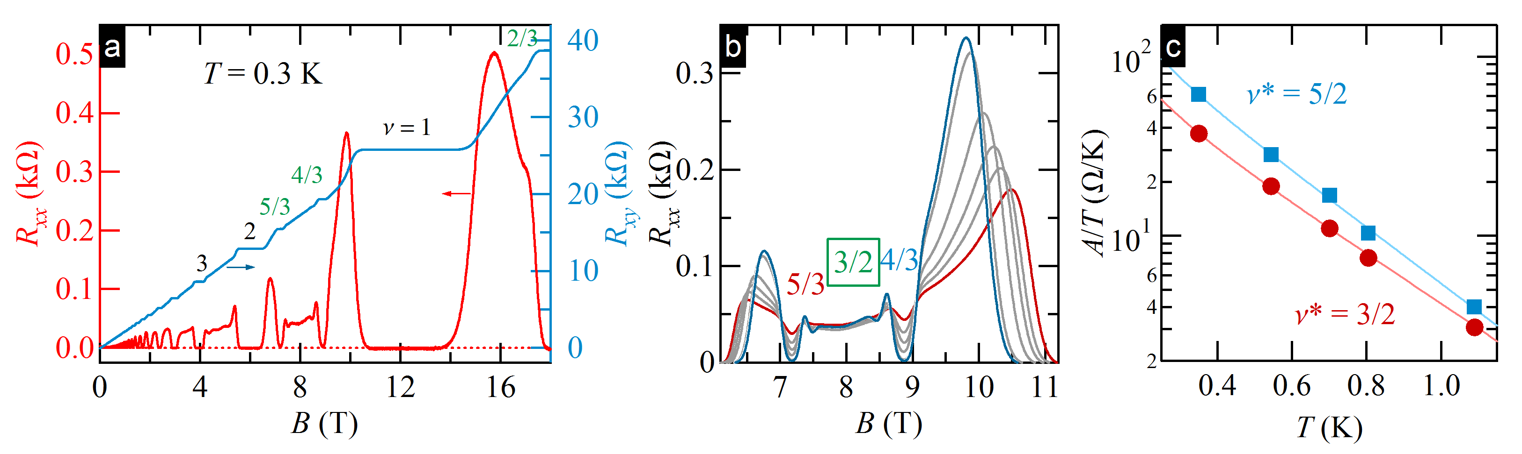
Fig. 1 (a) $R_{xx}$ and $R_{yy}$ vs. $B$. Integers and fractions next to the traces mark filling factors. (b) $R_{xx}$ vs. $B$, at different temperatures from 0.3 K to 1.1 K. (c) Resistance oscillation amplitude $A$ normalized to temperature $T$, at $ν^{*}=5/2$ and $3/2$, as a function of $T.$ Solid lines are fits with $A/T∼1/sinh⁡(2π^{2}k_{B}T/ℏω_{c}^{*} )$ , where $ω_{c}^{*}=eB/m^{*}$ is the cyclotron frequency of composite fermions.

Conclusions
We have observed and investigated the fractional quantum Hall effect in an ultrahigh-quality 2D hole
gas hosted in strained Ge quantum well. Due to large Zeeman energy, all observed states are spin polarized and can be described in terms of spinless composite fermions.

Acknowledgements
A portion of this work was performed at the National High Magnetic Field Laboratory, which is supported by National Science Foundation Cooperative Agreement No. DMR-1157490 and the State of Florida. The work at Minnesota was funded by the U.S. Department of Energy, Office of Basic Energy Sciences, under Grant No. ER 46640-SC0002567. Q.S. acknowledges support from Allen M. Goldman fellowship. The work at Warwick was supported by a EPSRC funded “Spintronic device physics in Si/Ge Heterostructures” EP/J003263/1 and
“Platform Grant” EP/J001074/1 projects.

References
[1] Tsui, D. C. et al., Phys. Rev. Lett. 48, 1559 (1982).
[2] Shi, Q. et al., Phys. Rev. B 91, 241303(R) (2015).

