Magneto-Optical Studies of Er Optical Centers in GaN at High Magnetic Fields

Vinh, N.Q. and George, D. (Virginia Tech, Physics)

Introduction
The research provides comprehensive information on the microscopic structure of erbium centers in the large-bandgap semiconductor GaN.[1] Erbium-doped GaN has attracted much attention due to its potential impacts on display technology, solid state lasers, optical amplifiers, and optical communication systems. However, the GaN:Er system remains poorly understood and even controversial in regard to the microscopic structure of the erbium optical centers, which constitutes a barrier to further increases of device emission efficiency and thermal stability. Using optical Zeeman spectroscopy in magnetic field strength up to 17.5 T combined with a high resolution monochromator, our results shed light on the current understanding of the microscopic structure of erbium optical centers in GaN. Especially, result of the research may lead to a new class of magneto-optical devices based on erbium doping of the wide bandgap GaN semiconductor.

Experimental
We have done the photoluminescence (PL), PL excitation, excitation dependence of PL intensity measurements under band-to-band and resonant excitation, time-resolved spectroscopy with the temperature of our sample from 4.2 K to 300 K,[1] and magneto-optical measurements of erbium optical centers in GaN with magnetic field up to 17.5 T. We have employed a tunable wavelength Ti:Sapphire laser around 809 nm (1.533 eV) with a repetition rate of 80 MHz for the resonant excitation from ⁴I_{15/2} to ⁴I_{9/2} of Er³⁺ in GaN, an Argon laser operating at 351.1 nm (3.531 eV), UV diode laser with wavelength at 375 nm, HeCd laser with UV line at 325 nm for the over bandgap excitation of GaN:Er material. We have applied the magneto-optical techniques to probe the microscopic structure of erbium optical centers in GaN with the magnetic fields rotates in (1100) and (1120) planes. The magnetic fields up to 17.5 T has been used for the measurements in the 17.5 T Superconductor for optical measurements (SCM-3) and 10 T Superconductor (SCM-1).
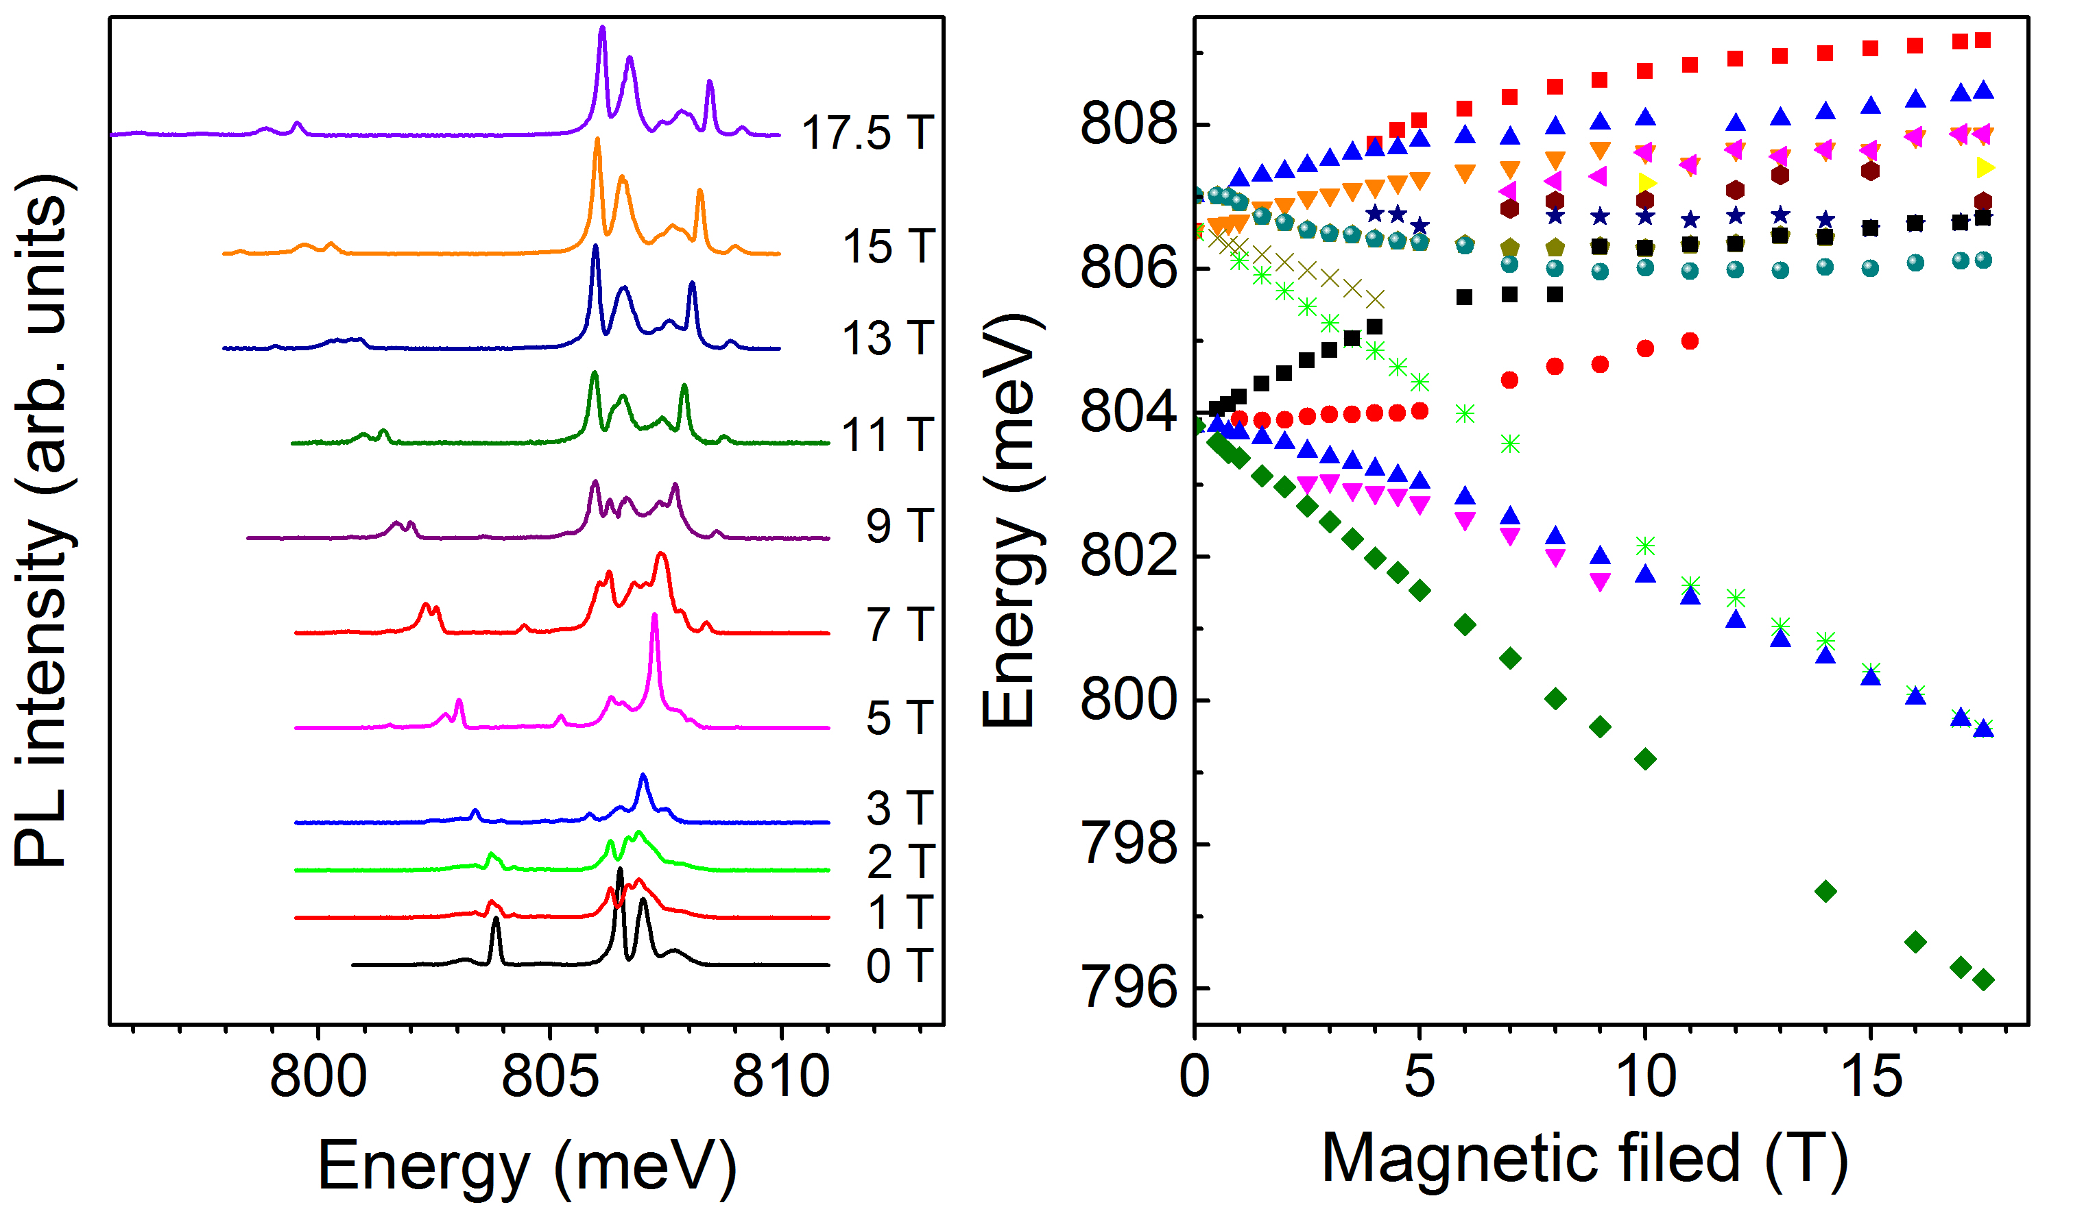
Results and Discussion
In the hexagonal crystal system the ⁴I_{13/2} first excited state of the 4f¹¹ shell of the Er³⁺ ion splits into a series of 2Γ₆+Γ₇+2Γ₈ sublevels and the ⁴I_{15/2} ground state splits into the sequence Γ₆+Γ₇+3Γ₈.[2] Consequently, at low tempera-tures five PL lines are expected. A lower symmetry crystal field splits the remaining quartets into doublets. In this case eight spectral components will appear, with each PL line corresponding to a transition between effective spin doublets. Application of a magnetic field splits the doublets further due to the Zeeman effect, in a pattern reflecting the symmetry of the Er³⁺ optical center. Fig. 1 shows the Zeeman effect for B||<0001> of the PL lines in magnetic fields up to 17.5 T. Keeping the magnetic field fixed at 9 T and rotating its direction in the (1100) and (1120) planes, we observe a pronounced angular dependence of the line positions. From the Zeeman splitting pattern, we conclude that the center possesses orthorhombic I (C_{2v}) symmetry.
Fig.1 Magnetic field induced splitting of the PL lines from GaN:Er epilayer at 4.2 K for B||<0001>.

Conclusions
In summary, we have provided the most direct microscopic information on the structure of a prominent center responsible for optical activity of Er in GaN epilayers. From a clear Zeeman effect observed on the main PL lines, the lower than cubic symmetry of the emitting center is confirmed and conclusively identified as orthorhombic I.

Acknowledgements
A portion of this work was performed at the National High Magnetic Field Laboratory, which is supported by National Science Foundation Cooperative Agreement No. DMR-1157490 and the State of Florida. The optical characterization work was supported by NSF (ECCS-1358564).

References
[1] George, D.K., et al., Applied Physics Letter, 107, 171105 (2015).
[2] Vinh, N.Q., et al., Physical Review Letters, 90, 066401 (2003).

