Strong Transport Anisotropy in Ge/SiGe Quantum Wells in Tilted Magnetic Fields

Shi, Q.; Zudov, M.A. (U. of Minnesota, Physics); Morrison, C. and Myronov, M. (U. of Warwick, Physics)

Introduction
Transport anisotropies in a high-mobility two-dimensional electron gas in GaAs/AlGaAs heterostructures subject to strong perpendicular magnetic fields and low temperatures have been discovered more than 15 years ago [1]. Here we report on strong transport anisotropy in a two-dimensional hole gas in Ge/SiGe quantum wells, which emerges only when both perpendicular and in-plane magnetic fields are present [2,3].

Experimental
Our samples are squares fabricated from Ge/SiGe quantum well with the density 2.8 x 10¹¹ cm⁻² and the mobility 1.3 x 10⁶ cm²/Vs. Measurements were performed in SCM-2 using a rotator probe.

Results and Discussion
When an in-plane magnetic field $B_{x}$ is applied in addition to the perpendicular field $B_{z}$, longitudinal resistance $R_{xx}$ grows, while $R_{yy}$ decreases, see Fig. 1(a). At $T$ $= 0.35$K, the ratio $R_{xx}/R_{yy}$ could exceed $3×{10}^{4}$, see Fig. 1(b). Remarkably, the anisotropy $A = (ρ_{xx}–ρ_{yy})/(ρ_{xx}+ρ_{yy})$ at different filling factors scales with $B_{x}/B_{z}$, and not with $B_{x}$ alone, see Fig. 1(c). When the in-plane field is applied along $y$ direction, the hard and easy axes switch places. Moreover, the anisotropy persists to high temperatures and low magnetic fields, even in the absence of quantum oscillations, exhibiting the same “scaling rule” with $B_{x}/B_{z}$. However, strong anisotropy disappears in the absence of a perpendicular magnetic field [3].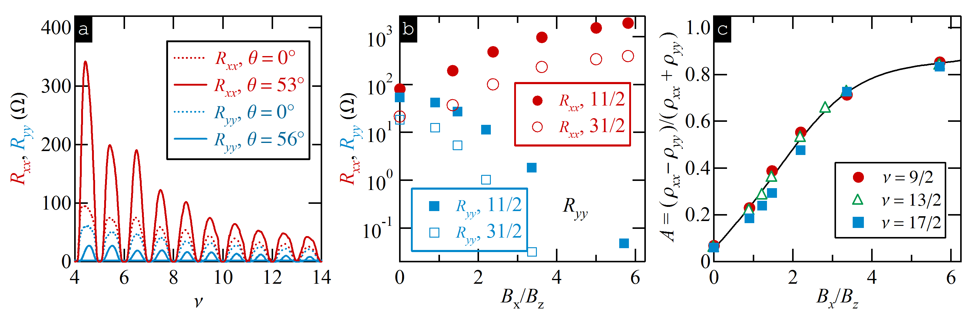
Fig. 1 (a) $R_{xx}/R_{yy}$ versus $ν$ at θ $= 0^{∘}$and θ $= {53}^{∘}$ (θ $= {56}^{∘}).$ (b) $R_{xx}$ (circles) and $R_{yy}$ (squares) vs $B_{x}/B_{z}$ at $ν = 11/2$ (solid) and $ν = 31/2$ (open). (c) Anisotropy $A = (ρ_{xx}–ρ_{yy})/(ρ_{xx}+ρ_{yy})$ vs $B_{x}/B_{z}$ at $ν = 9/2$, $13/2$, $17/2$, as marked.

Conclusions
The lack of significant anisotropy without an in-plane field, easy tunability, and persistence to high temperatures and filling factors set the strong anisotropy observed in Ge/SiGe quantum wells apart from nematic phases in GaAs/AlGaAs. In addition, observed anisotropy cannot be explained by other known mechanisms.

Acknowledgements
A portion of this work was performed at the National High Magnetic Field Laboratory, which is supported by National Science Foundation Cooperative Agreement No. DMR-1157490 and the State of Florida. The work at Minnesota was funded by the U.S. Department of Energy, Office of Basic Energy Sciences, under Grant No. ER 46640-SC0002567. Q.S. acknowledges support from Allen M. Goldman fellowship. The work at Warwick was supported by a EPSRC funded “Spintronic device physics in Si/Ge Heterostructures” EP/J003263/1 and
“Platform Grant” EP/J001074/1 projects.

References
[1] Lilly, M. et al., Phys. Rev. Lett. 82, 394 (1999); Du, R. et al., Solid State Commun. 109, 389 (1999).
[2] Shi, Q. et al., Phys. Rev. B 91, 201301(R) (2015).
[3] Shi, Q. et al., Phys. Rev. B 92, 161405(R) (2015).

