Wigner Solid of Quasiholes of the ν = 1/2 Fractional Quantum Hall Effect State

Hatke, A.T.; Engel, L.W. (NHMFL); Liu, Y.; Shayegan, M.; Pfeiffer, L.N.; West, K.W. and Baldwin, K.W. (Princeton University)

Introduction
In GaAs wide quantum wells (WQWs), at sufficiently high carrier density, n, the growth-direction carrier distribution can separate into two layers. If the disorder is low and the intralayer and interlayer interaction are comparable, a fractional quantum Hall effect (FQHE) can form, centered at Landau filling ν = ½ [1].
Microwave spectroscopy is ideal for investigation of solid phases, since these phases exhibit a pronounced rf or microwave resonance. This resonance is understood as a pinning mode, a collective mode of a Wigner solid in which pieces of the solid, which oscillates within the pinning potential. Studies of pinning modes have revealed solidification of quasicarriers of the 1/3 FQHE liquid [2]. Here we find a pinning mode that signifies the solidification of quasiholes 1/2 FQHE state in a GaAs based WQW.

Experimental
We obtain diagonal conductivity of the carriers in the WQW from the measured loss and phase shift of a transmission line on the sample surface.
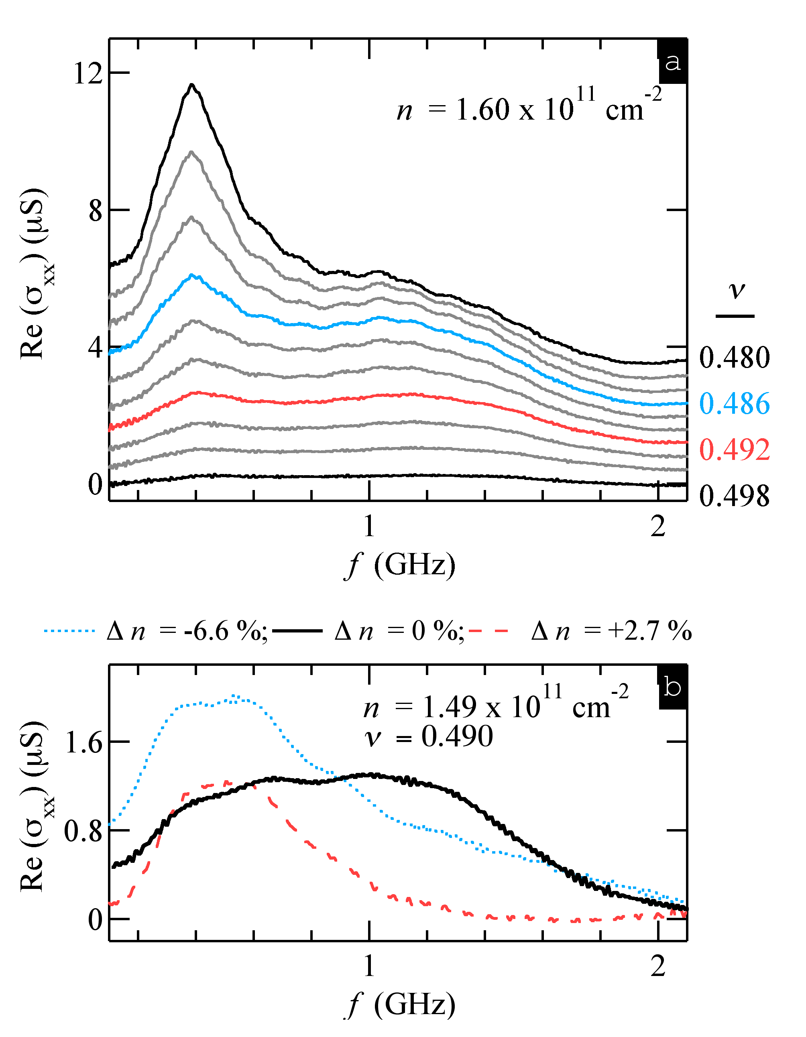
Figure 1: (a) Microwave spectra, Re (σ_{xx}) vs f, at fixed n and various ν for symmetric charge distribution. (b) Spectra under different charge distributions about the well center.

Results and Discussion
In Fig. 1 (a) we present microwave spectra, Re (σ_{xx}) vs f, obtained with a symmetric growth-direction charge distribution for density n = 1.60 x 10¹¹ cm⁻². For ν = 0.480, we observe a well-developed resonance at f_{pk} ~ 0.4 GHz. This is the same frequency as the pinning mode seen at much lower ν (much less than ½) and was ascribed to a bilayer solid [3] that is not associated with the ½ FQHE, but is a generic low-ν state of low disorder quantum Hall systems. With increasing ν in the data set, we observe the development of a second resonance with a peak frequency of f_{pk} ~ 1.1 GHz. By extracting two resonances with a two-peak fit function and analyzing the signal strength, we have shown that the higher f_{pk} resonance arise from a solid of quasiholes of the 1/2 FQHE [4].
This solid is highly sensitive to the charge distribution within the well, consistent with its association with the ½ FQHE, which is likewise sensitive. We highlight this observation in Fig. 1 (b) where the spectra obtained at fixed ν and n are shown for three charge configurations. For Δn = 0 % the charge distribution is symmetric about the well center and we observe the high f_{pk} resonance. Forced charged imbalance in either direction through asymmetric gating of the top and bottom of the sample destroys the high f_{pk} resonance with concurrent strengthening of the low f_{pk} resonance.

Conclusions
Our microwave measurements demonstrate the existence of a Wigner solid formed from the quasihole excitations of the ν = 1/2 fractional quantum Hall. These quasiholes are expected to be of charge ¼, and to be of a dipole nature, with positive charge in one layer and negative charge in the other.

Acknowledgements
This work was supported by DOE BES award DE-FG02-05ER46212

References
[1] Y. Suen et al., PRL 68, 1379-1382 (1992).
[2] H. Zhu et al., PRL 105, 126803 (2010).
[3] A. T. Hatke et al., Nature Commun. 6, 7071 (2015).
[4] A. T. Hatke et al., Submitted to PRX (2015).

