Melting Temperatures of Different Solid Phases Near ν=1

Hatke, A.T.; Engel, L.W. (NHMFL); Liu, Y.; Shayegan, M.; Pfeiffer, L.N.; West, K.W. and Baldwin, K.W. (Princeton University)

Introduction
At the termination of the fractional quantum Hall effect (FQHE) series below Landau filling factor ν =1/5 a two- dimensional electron system forms a Wigner solid (WS). In high magnetic field, such a solid exhibits a microwave or rf pinning mode, which is a collective oscillation of pieces of the solid about their pinned positions. Using the pinning mode to study the melting temperature, T_{m}, of the ν<1/5 WS, ref. [1] showed that T_{m} decreases with ν. In the ν-region of an integer quantum Hall effect (IQHE) plateau the microwave spectrum of a two-dimensional electron system exhibits the pinning mode of an insulating WS of quasiparticles and –holes [2], in the presence of one or more full Landau levels. Recent microwave measurements in wide quantum wells (WQWs) [3] have revealed a solid-solid phase transition between a WS (which we call S1) that is found with ν nearest to ν = 1, and a second WS (S2) associated with a reentrant integer quantum Hall effect, and existing at ν further from 1. Here we report an investigation of the melting temperature of these two solids, carried out by study of the pinning mode.

Experimental
We obtain diagonal conductivity of the carriers in the WQW from the measured loss and phase shift of a transmission line which is patterned onto the sample surface and which is capacitively coupled to the electron system.

Results and Discussion
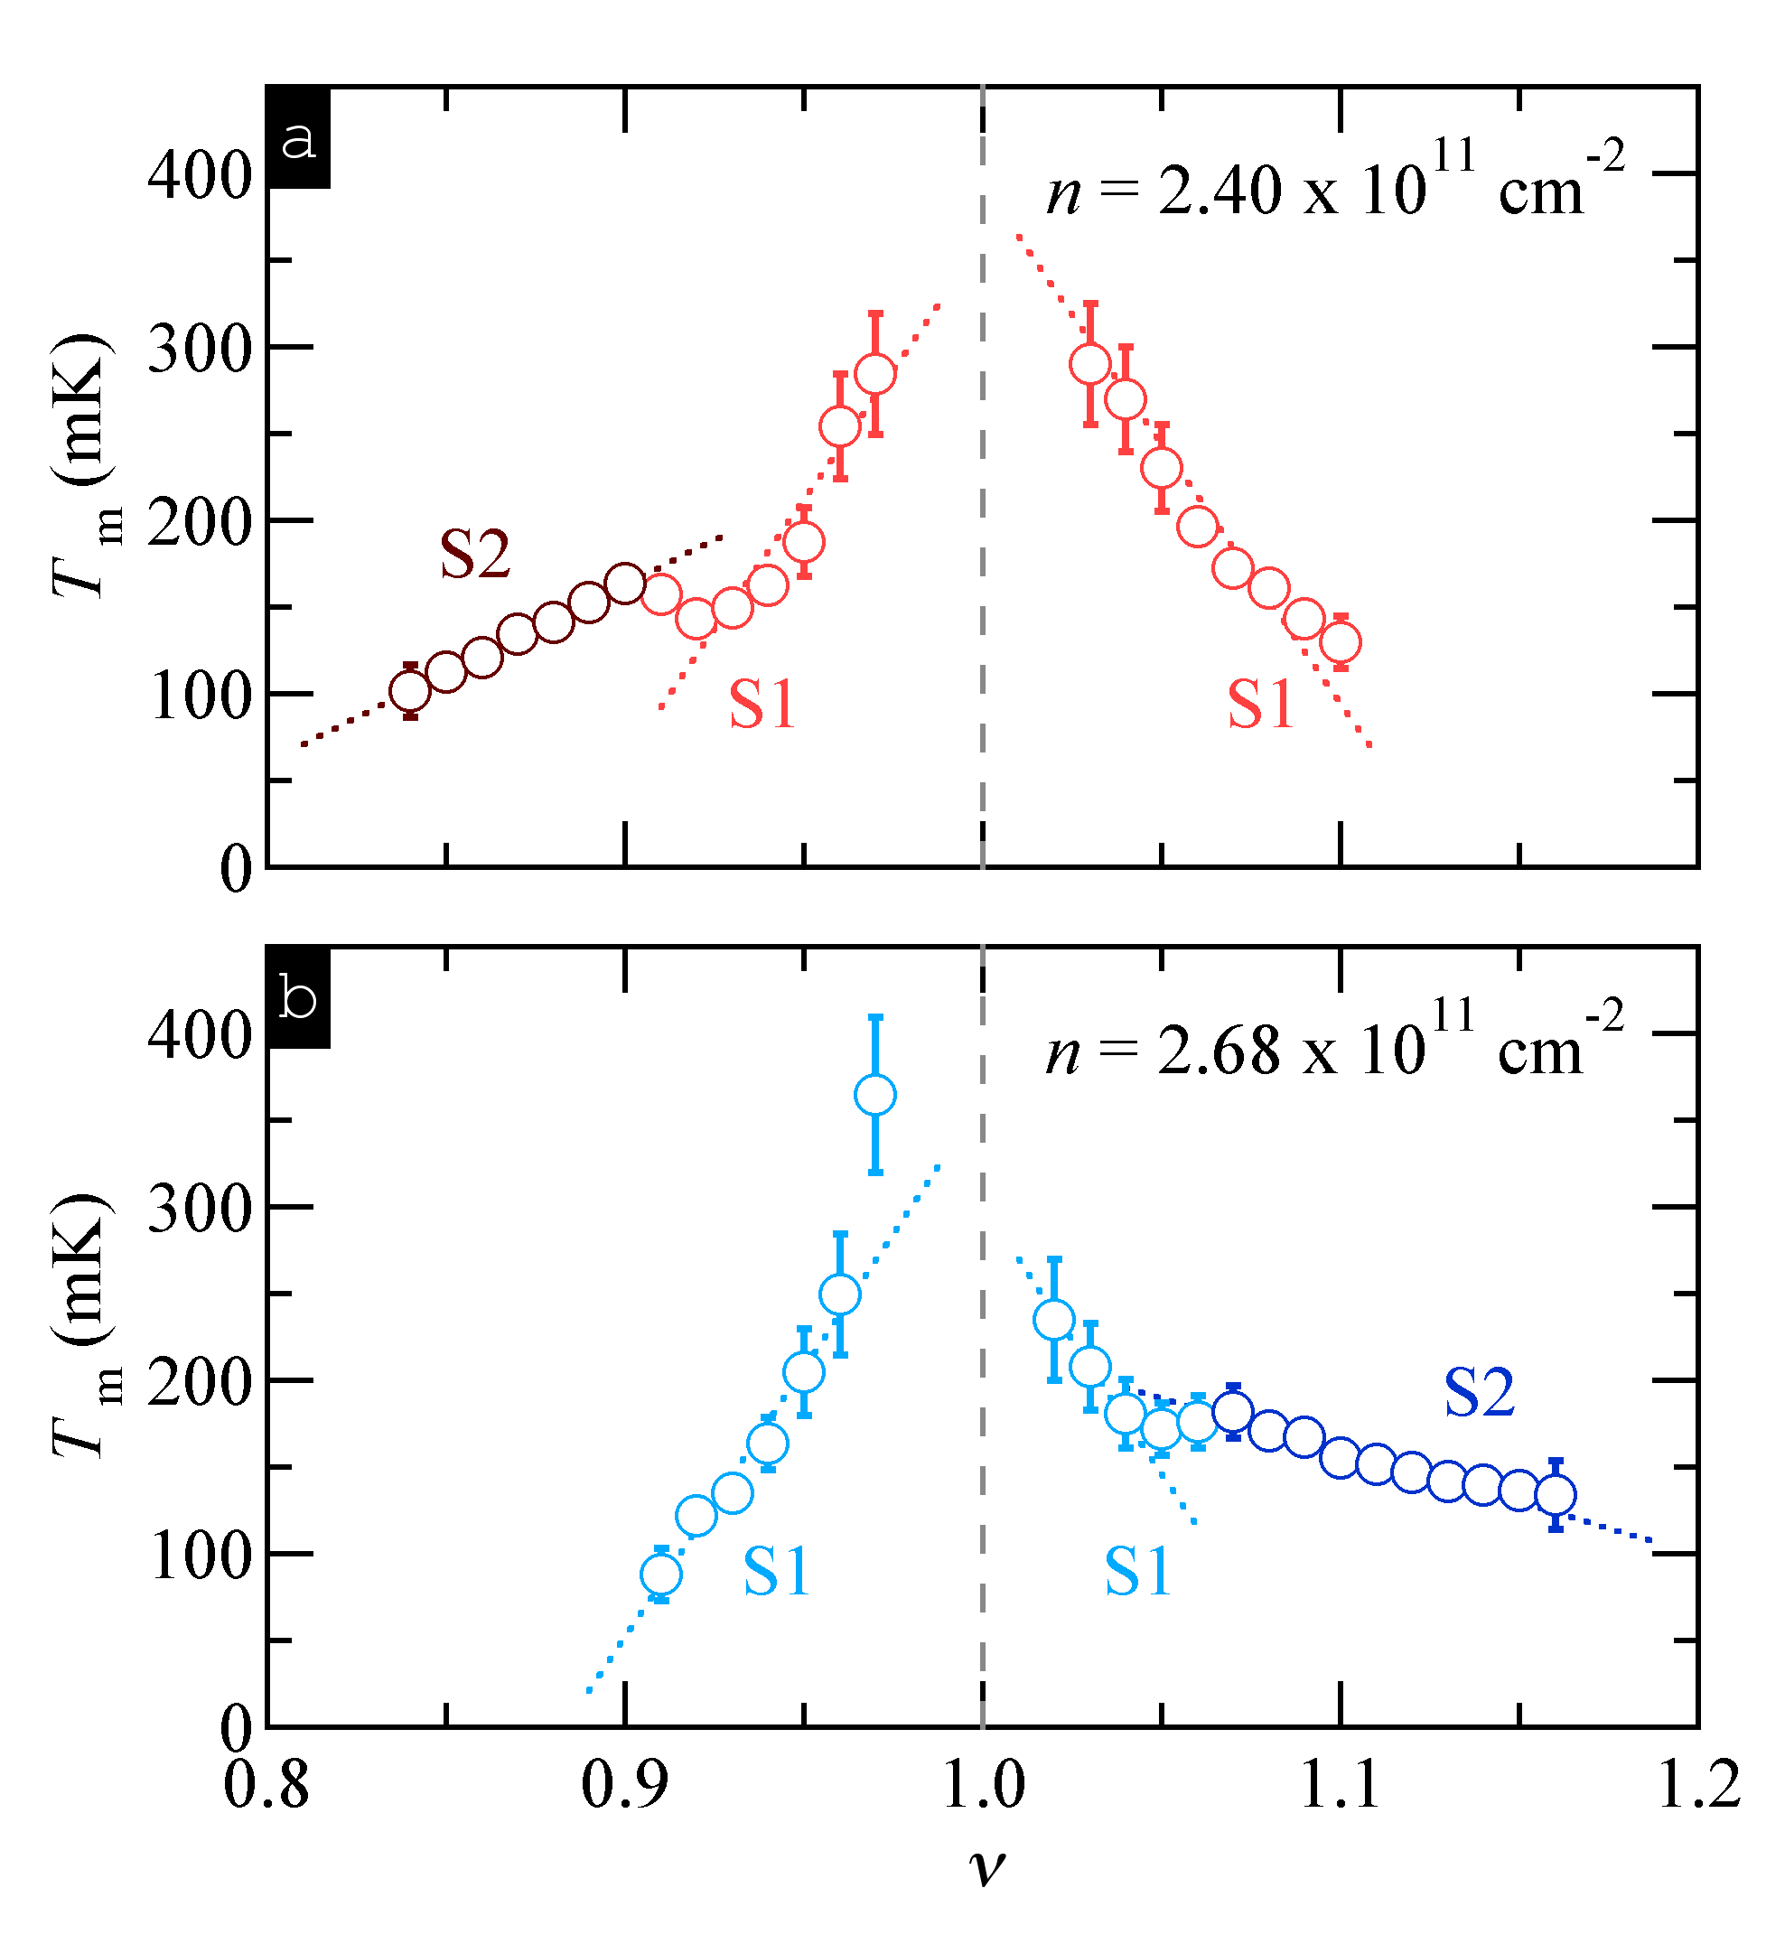
To obtain the melting temperature, T_{m}, of the Wigner solid, we obtained microwave spectra, Re (σ_{xx}) versus f, at fixed ν at two different densities (n) at various temperatures. At each ν we extract the peak Re (σ_{xx}) as a function of temperature. We define T_{m} as the temperature at which the peak Re (σ_{xx}) extrapolates to zero. Fig. 1 (a) and (b) show T_{m} vs ν for the two different densities as marked. S2 is present only for ν < 1 in Fig. 1(a), and for ν > 1 in Fig. 1(b). T_{m} vs ν for S1 and S2 have different characteristics.
Figure 1: Melting temperature near ν=1 vs ν for two different densities, n in a 65 nm wide quantum well.

While T_{m} increases as ν =1 is approached for both solids, T_{m} for S1 increases more rapidly. The different slope of T_{m} ν underscores that the two solids are distinct, microscopically different phases. The presence of a transition was previously gathered from peak frequency vs ν measurements [3]. The solids are likely made up of different types of carriers, with S2 containing 2-flux composite fermions, (CFs) in the presence of one completely full CF Landau level [4]. S1 may contain 4-flux composite fermions. The different interactions between the constituent carriers of the two solids then can give rise to the observed different melting behaviors.

Acknowledgements
This work was supported by DOE BES award DE-FG02-05ER46212. A portion of this work was performed at the National High Magnetic Field Laboratory, which is supported by National Science Foundation Cooperative Agreement No. DMR-1157490 and the State of Florida.

References
[1] Y. P. Chen et al., Nature Phys. 2, 452 (2006).
[2] Y. P. Chen et al., Phys. Rev. Lett. 91, 016801 (2003).
[3] A. T. Hatke et al., Nature Commun. 5, 4154 (2014).
[4] Yang Liu et al., Phys. Rev. Lett. 113,246803 (2014).

