Probing the Rashba Spin-Splitting in BiTeCl from Angle Dependent SdH Oscillations

Martin, C. (Ramapo College); Winter L.E.; McDonald R.D.; Zapf, V.S. (LANL) and Tanner, D.B. (UF, Physics)

Introduction
The layered semiconductors BiTeX (X = I, Br, Cl) were found to have a giant Rashba spin splitting of both bulk and surface electronic bands, making them promising candidates for the field of spintronics [1]. One of the consequences of a Rashba split conduction band is that the Fermi surface has the shape of a ring, horn or spindle torus, depending whether the chemical potential is situated below, at, or above the crossing point, respectively. Therefore, it is expected that angle dependent SdH oscillations, which directly map the Fermi surface geometry, should be able to probe the Rashba spin splitting in BiTeX materials.

Experimental
Angle dependent SdH oscillations were measured on a single crystal of BiTeCl in pulsed magnetic field up to 65 Tesla, at LANL. To avoid potential problems with non-ohmic contacts, due to low carrier concentration of the sample, a contactless technique, based on a tunnel diode resonator was involved.

Results and Discussion
Figure 1(a) shows SdH oscillations in BiTeCl for different angles θ between the magnetic field and the normal to sample surface, as sketched in the inset. Oscillations are observed for all angles, suggesting a 3D Fermi surface. For angles 0° ≤ θ ≤ 75°, a Fourier transform of data reveals only one frequency. For a Rashba split conduction band, this would imply that the Fermi level is situated below the crossing point. Angular dependence of the frequency, shown in Fig. 1(b), confirms the hypothesis. As it can be observed, with tilting magnetic field, the frequency increases, peaks at θ = 70°, then it start decreasing and has a dip at θ = 90°. This behavior is consistent with the area of the Fermi surface crossed by a plane perpendicular to the applied magnetic field, i.e. the area of the extreme orbit of precessing electrons, shown in the inset of Fig. 1(b). With increasing angle, the cross section area first increases then, as the orbit passes through the hole of the FS, it starts decreasing again. A numerical calculation seems to reproduce well the data [2], except for the magnitude of the dip at θ = 90° (Fig 1(b)). For this orientation, we also observed an unusual scaling of the Landau Levels with magnetic field, which is under further investigation.

Conclusions
In conclusion, we found that the angular dependence of the SdH oscillations in BiTeCl is consistent with a torus Fermi surface, due to Rashba spin splitting. Further analysis of the data will allow extracting both the Rashba parameters and the anisotropy of the Fermi surface.

Acknowledgements
A portion of this work was performed at the National High Magnetic Field Laboratory, which is supported by National Science Foundation Cooperative Agreement No. DMR-1157490 and the State of Florida.

References
[1] S. V. Eremeev et al., Phys. Rev. Lett. 108, 246802 (2012)
[2] C. R. Reeg and D. L. Maslov (private communication).
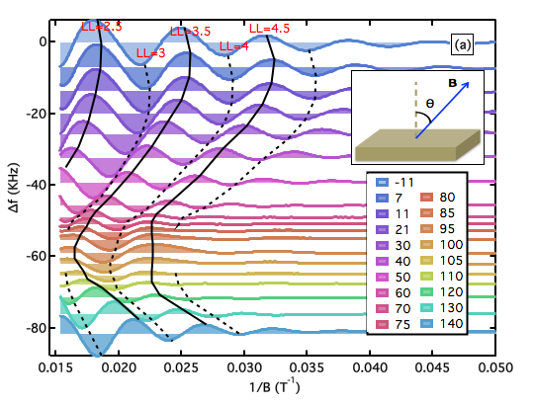
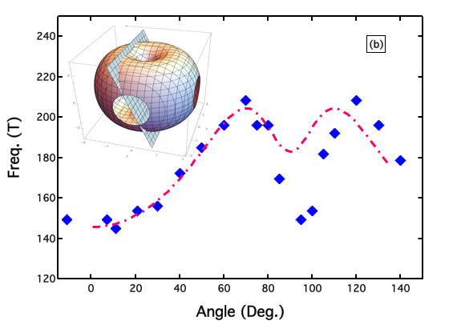

Fig.1: a) Shubnikov-de Haas oscillations in single crystals of BiTeCl for several angles between the magnetic field and sample surface, as illustrated in the inset. The continuous and dashed lines follow the position of different Landau Levels with angle. b) Angular dependence of the SdH frequency (symbols) and a theoretical calculation based on a geometrical model sketched in the inset.

