g⁽²⁾ Measurement of Superfluorescence from a Two-Dimensional Electron-Hole System

Cong, K. (Rice U., Physics & ECE); Noe, G.T. (Rice U., ECE); McGill, S.A. (NHMFL); Wang, Y.; Belyanin, A. (TAMU, Physics) and Kono, J. (Rice U., ECE, Physics & MSNE)

Introduction
In our prior work at the National High Magnetic Field Laboratory (NHMFL), we studied light emission dynamics as well as carrier population dynamics in an undoped multiple quantum well (MQW) structure consisting of InGaAs quantum wells with GaAs barriers. At sufficiently low temperatures and sufficiently high magnetic fields, we observed superflourescence (SF) [1,2]. SF is a many-body process in which a large number of (initially incoherent) dipoles (i.e., electron-hole pairs in our case) recombine collectively, emitting bursts of coherent radiation. It represents one of the unusual examples of self-organization processes where macroscopic coherence spontaneously develops through many-body interactions among the individual dipoles. Our measurements in the Fast Optics Facility of the NHMFL have provided the first convincing evidence for SF in a solid-state environment.

Experimental
In order to create the required conditions for SF from our InGaAs MQW sample, we must use a unique combination of an intense femtosecond laser (amplified Ti:sapphire laser) to create high-density electron-hole pairs in a strong perpendicular magnetic field (17.5 T superconducting magnet) to laterally confine the electrons and holes and increase the density of states through Landau quantization.
In May 2015, we performed correlation measurements on the output beam of the Ti:sapphire amplifier laser. Using the correlation algorithm developed in November 2014, we found that the 1 kHz signal from the Evolution laser is unsynchronized with the 80 MHz signal from the Vitesse laser. This imposed a severe limitation on any correlation measurements with the amplifier laser system. We therefore purchased a laser pulse ‘countdown’ box from Coherent, Inc., to solve this problem. During the summer of 2015, we tested the countdown box, and it solved the unsynchronization problem. We also measured g⁽²⁾(0,t) as a function of magnetic field, temperature, and emission wavelength to investigate the photon statistics of emitted SF bursts.
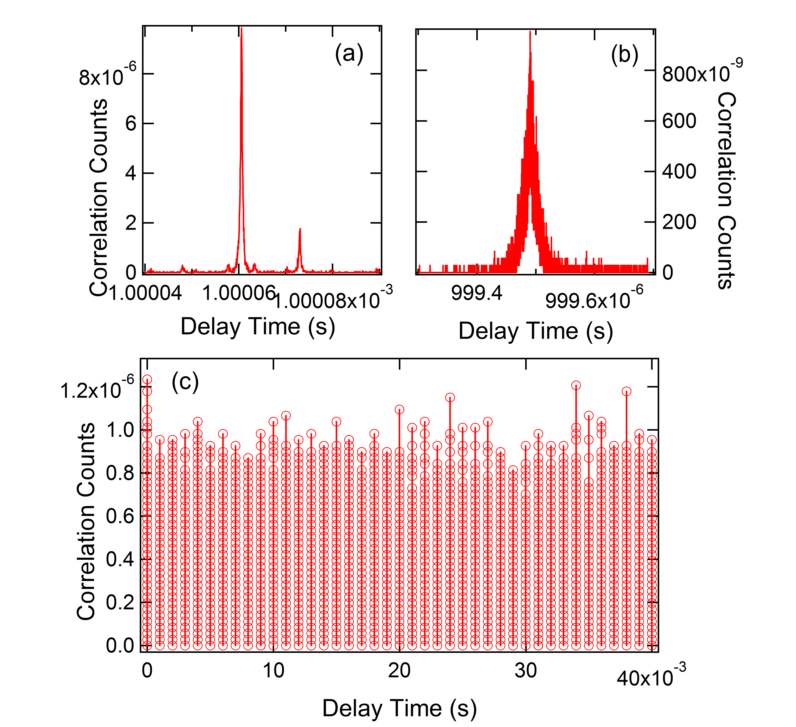
Results and Discussion
Figure 1 shows second-order correlation results for the 1 kHz Ti:sapphire amplifier system before [Fig. 1(a)] and after [Figs. 1(b) and (c)] the laser pulse countdown box was installed. In Fig. 1(a), the correlation result at delay time ~1 ms is characterized by two peaks, a main peak with a larger magnitude and a side peak with a smaller magnitude. The side peak appears at 12.5 ns later than the main peak, which is caused by unsynchronization between the 1 kHz signal from the Evolution laser and the 80 MHz signal from the Vitesse laser. After the countdown box was installed, the correlation peak at delay time ~1 ms only showed a single peak, indicating a well-synchronized laser system. Fig. 1 (c) shows correlation results in a broader delay time range, from 0 ms to 40 ms, with a correlation intensity fluctuation ~20%.
Fig. 1 Second-order correlation results at time delay around 1 ms for a 1 kHz amplifier system (a) before and (b) after a ‘countdown’ box was installed. (c) Correlation results in a 0-40 ms time delay range.
Conclusions
We have demonstrated that it is possible to carry out g⁽²⁾ measurements with the 1 kHz amplifier system at NHMFL in Tallahassee.

Acknowledgements
This work was supported by the NSF through grants DMR-1006663,
DMR-1310138, and ECS-0547019. A portion of this work was performed at the National High Magnetic Field Laboratory, supported by NSF Co-operative Agreement No. DMR-1157490 and by the State of Florida. We thank G. S. Solomon at NIST for providing us with the InGaAs/GaAs quantum well sample used in this study.

References
[1] Noe, G. T., et al., Nature Phys. 8, 219 (2012).
[2] Kim, J. H., et al., Sci. Rep. 3, 3283 (2013).
[3] Cong, K., et al., Phys. Rev. B 91, 235448 (2015).

