Unusual Landau Level Pinning and Correlated Quantum Hall States in 2D Hole Systems

Liu, Y.; Hasdemir, S.; Pfeiffer, L.n.; West, K.W.; Baldwin, K.W. and Shayegan, M. (Princeton U., Electrical Engineering)

Introduction
A strong perpendicular magnetic field B applied to a 2D electron/hole system (2DES/2DHS) quantizes the particles’ kinetic energies into discrete Landau levels (LLs), and give rise to novel correlated quantum phases such as quantum Hall states (QHSs). In our work, we study 2DESs/2DHSs confined in wide GaAs quantum wells (QWs), where multiple electric subbands are occupied. Via changing the angle θ between the sample normal and magnetic field (see Fig. 1(a)), we study multi-component QHSs with spin and subband degrees of freedom at 1 < ν < 3 through their pseudo-spin polarization transitions [1], and the two-component QHSs at ν = 1/2 and 1 when the two lowest-energy LLs become nearly degenerate [2, 3].

Experimental
Each of our samples consists of a high-quality GaAs QW bounded on its sides by undoped AlGaAs spacer and symmetric Si/C δ-doping layers. We carefully control the density and charge distribution by applying front- and back-gate voltages. The measurements were carried out in SCM1.

Results and Discussion
Figure 1(c) highlights our discovery of the unusual LL pinning (or near-pinning, see Fig. 1(b)) and the correlated ν = 1 QHS in 2DHSs [3]. It shows the longitudinal (R_{xx}) and Hall (R_{xy}) magneto-resistance traces measured from a 2DHS confined to a 40-nm-wide GaAs QW at p ≈ 1.28 × 10¹¹ cm⁻² and θ ≈ 35°.
At lower and higher θ (data not shown here), the ν = 1 QHS is strong (excitation gap Δ ≥ 10 K) and fractional QHSs appear at ν = i/(2i ± 1) fillings (i > 0 is an integer). The Fig. 1(c) data, however, are similar to what is seen in bilayer 2DESs with extremely small energy separation between the lowest two LLs, and thus are consistent with a LL crossing occurring near θ ≈ 35°. The ν = 1 QHS becomes unusually weak (Δ ≈ 0.2 K), and strong QHSs develop at the even numerator fillings ν =4/3, 6/5, 6/7, and 4/5. This implies that these are two-component QHSs, each component having half of the total filling. In Fig. 1(c) we also observe QHSs at very unusual fillings such as ν = 19/15 and 29/35. Such states were only seen when the two lowest-energy LLs are nearly degenerate, and were interpreted as “imbalanced” two-component QHSs: for example, the ν = 19/15 QHS has fillings 2/3 and 3/5 for its two components.
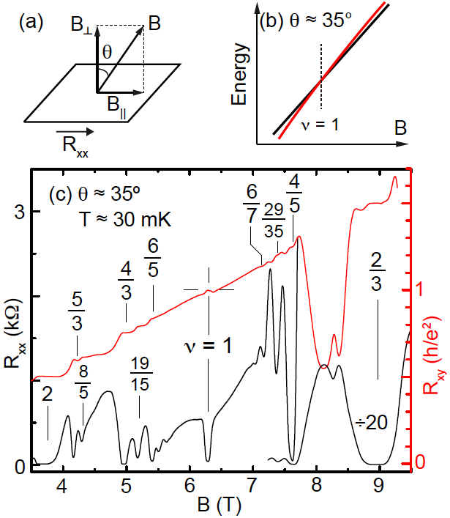

Fig. 1: (a) Experimental setup. (b) Schematic diagram, showing the crossing of the two lowest-energy Landau levels at θ ≈ 35° near ν = 1. (c) Longitudinal (R_{xx}) and Hall (R_{xy}) resistances measured in a 40-nm-wide QW at 2D hole density p ≈ 1.28 × 10¹¹ cm⁻².
We perform extensive studies on this unusual LL crossing and the stability of the ν = 1 QHS at the crossing, and find that:
1) The two lowest-energy LLs can only cross when the 2DHS is confined in wide, symmetric QWs and its density is large.
2) The crossing, if it happens, is always seen near a magic angle θ ≈ 35°, which is independent of the 2DHS density, the QW well-width and the filling factors.
2) At the crossing, the ν = 1 QHS turns into a compressible Fermi sea if the density and well-width are very large.

Acknowledgements
A portion of this work was performed at the National High Magnetic Field Laboratory, which is supported by National Science Foundation Cooperative Agreement No. DMR-1157490 and the State of Florida.
We also acknowledge support through the NSF, DOE, the Gordon and Betty Moore Foundation, and the Keck Foundation.

References
[1] Yang Liu et al., Phys. Rev. B 92, 201101(R) (2015).
[2] S. Hasdemir et al., Phys. Rev. B 91, 045113 (2015).
[3] Yang Liu et al., Phys. Rev. B 92, 195156 (2015).

