High Trapped Fields from Reinforced Bulk Superconductors

Durrell, J.H.; Dennis, A.R.; Ainslie, M.D.; Palmer, K.G.B.; Shi, Y.-H.; Campbell, A.M.; Cardwell, D.A. (University of Cambridge); Jaroszynski, J.; Hellstrom, E. (NHMFL); Hull, J. and Strasik, M. (Boeing Company)

Introduction
We have recently achieved a field of 17.6 T in a Bulk Superconductor at 26 K [1]. This is about 0.4 T in excess of the previous record field obtained by Tomita et al. [2]. The limiting factor to the high field performance of such bulks is, as one of the previous record holders explains [3] it is the tensile strength of the superconductor that limits performance. The strains inside a Bulk Superconductor during charging to 17 T can reach ~100 MPa with the strain scaling as B². We have developed, with The Boeing Company, a strength improved Bulk Superconducting material. In May this year we sought to test this material using a 30T magnet at NHMFL. Following somewhat disappointing results in May we used SCM-2 in December to understand

Experimental
We characterize our materials by cooing them in a high magnetic field to ~25 K and then slowly ramping down the external field. At the end of this process field remains trapped inside the superconducting, acting as a quasi permanent magnet. It is the magnitude of this trapped field that describes the performance of this engineering material.
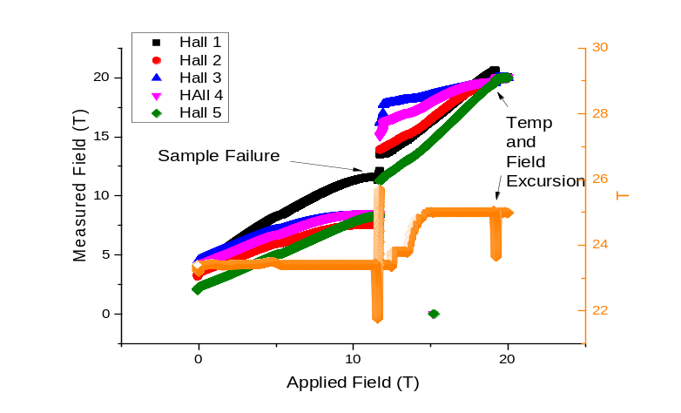Figure 1. Recent results showing both normal sample failure and related temperature rise as well as the temperature instability that was repeatedly observed in our experimental system at about 19.3 T

Results and Discussion
Our July run using a 30T magnet was fairly unsuccessful with most samples showing some sort of flux jump. Post measurement examination of the samples showed that many exhibited reduced performance rather than a single crack, suggesting that our new reinforcement technique was partially successful.
One major experimental issue with the single wall can used in our recent high field measurement was a sharp step in cooling power at about 19.3 T (See Figure 1). It has been suggested that this was due to some sort of helium bubble forming in the insert.
In December we returned to NHMFL to conduct measurements in SCM-2. These revealed that while the strengthening technique we are using mitigates the effects of cracks such that samples are not destroyed it does not currently allow us to reach higher trapped fields than previously.

Conclusions
We were unable to recover or better our previous results using the 30 T system, even using the new strength enhanced materials that we have recently developed. Very recent results from our December run indicate that while the reinforcement technique has improved the resilience of the samples, as yet it is not improving the maximum trapped field.

Acknowledgements
A portion of this work was performed at the National High Magnetic Field Laboratory, which is supported by National Science Foundation Cooperative Agreement No. DMR-1157490, the State of Florida, and the U.S. Department of Energy. This work was additionally supported by the Boeing Company and by the Engineering and Physical Sciences Research Council (Grant number EP/K02910X/1).

References
[1] Durrell, J.H., Dennis A. R., Jaroszynski J., Ainslie, M. D., Palmer, K. G. B., Shi Y-H, Campbell, A. M., Hull, J., Strasik, M., Hellstrom, E., Cardwell, D. A. Supercond. Sci. Technol., 2014. 27: 082001.
[2] Tomita, M. and M. Murakami, Nature, 2003. 421(6922): p. 517-520.
[3] Murakami, Supercond. Sci. Technol., 2014. 27: 080501.
[4] Fuchs, G., et al., Applied Physics Letters, 2000. 76(15): p. 2107-2109.

