Greatly Enhanced Strain Margins in Strongly Reinforced Bi-2223 HT-NX

Godeke, A.; Abraimov, D.V.; Arroyo, E.; Bird, M.D.; Hahn, S.; Hellstrom, E.E.; Jaroszynski, J.; Johnson, Z.; Kim, Y.; Larbalestier, D.C.; Markiewicz, W.D.; Marks, E.L.; Marshall, W.S.; McRae, D.M.; Noyes, P.D.;
Richardson, D.E.; Viouchkov, Y.L.; Walsh, R.P.; Weijers, H.W. and White, J.M. (NHMFL)

Introduction
Superconducting solenoids beyond 23.5 T need to be constructed using high temperature superconducting (HTS) insert coils. Multi-filamentary Bi₂Sr₂Ca₂Cu₃O_{x} / Ag-alloy (Bi-2223) HTS tape conductors are a candidate material for such solenoids but the bare Bi-2223 conductor (type H) is mechanically weak due to the soft Ag-alloy matrix. The bare type H conductor is therefore often reinforced by laminating it with copper-alloy (HT-CA) or stainless-steel (HT-SS) tape. This process yields conductors with stress and strain margins up to 250 MPa and 0.35%, respectively, and a 60 mm safe bending diameter [1,2]. A new version, named Bi-2223 HT-NX, has recently become available [3]. This version is laminated with a high strength Ni-alloy tape. The new high strength Bi-2223 HT-NX has a specified 400 MPa tensile strength, 0.5% strain margin, and a 40 mm safe bending diameter [2], but these specifications were surpassed in tests by our collaborators [1,4]. Here we demonstrate that bending causes a substantial amplification of the strengthening, resulting in even larger limits.

Experiments, results, and discussion
We performed a 9-month feasibility study on Bi-2223 NX-HT, using basic conductor mechanical analyses (e.g. Fig. 1), hard way and easy way bend tests using small coils, double and single bend tests, high field tests of critical current (I_{c}) up to 31 T (cell 7) in various field directions, and high field tests up to 17 T (cell 4) on four 4 layer, 20 turn coils (Fig. 2) with layer transitions, splices, etcetera, i.e. all the basic building blocks for larger coils.
The results in Fig. 1 show that the stress and strain limits of high strength Bi-2223 NX-HT are 515 MPa and 0.57%, respectively, leading to an effective whole conductor Young modulus of 90 GPa. I_{c} collapse occurs when the support yields. In single bend tests, however, it was found that the onset of I_{c} degradation occurs between 25 and 22 mm diameter, which corresponds to an elastically calculated strain of 0.8 and 0.85% on the Bi-2223 filaments. Hoop stress tests on two single layer coils in 31 T field showed an onset of filament breakage between 0.8 and 0.85% strain, and tests of the 20 turn coils also identified a similarly high strain limit in bent tapes when bending strain and hoop strain are added (Fig 2: Irreversible damage occurs between the green and red circles).

Conclusions
A 0.8% strain limit was found for Bi-2223 HT-NX in coil-relevant configurations using three independent experiments. This high strain limit can simplify the construction of 30 to 40 T class superconducting magnets.

Acknowledgements
This work was performed at the National High Magnetic Field Laboratory, which is supported by National Science Foundation Cooperative Agreement No. DMR-1157490 and the State of Florida.

References
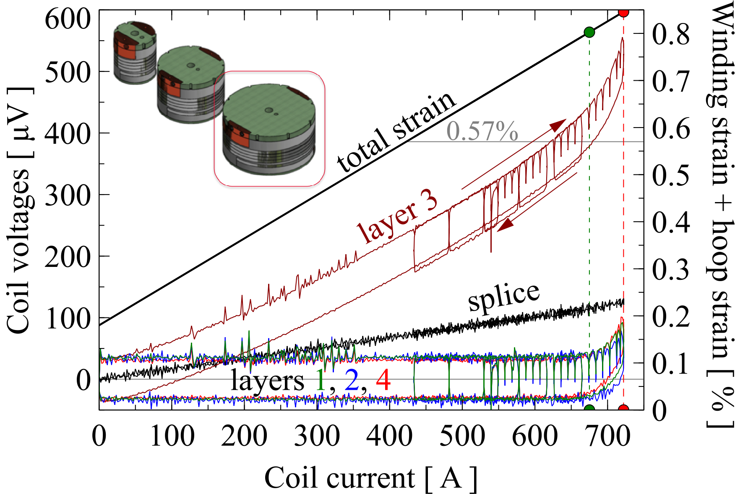
Fig. 2 Coil voltages and total strain as a function of coil current at 4.2 K and 17 T background field for a 114 mm ID, 4 layer, 20 turn coil wound from Bi-2223 HT-NX.
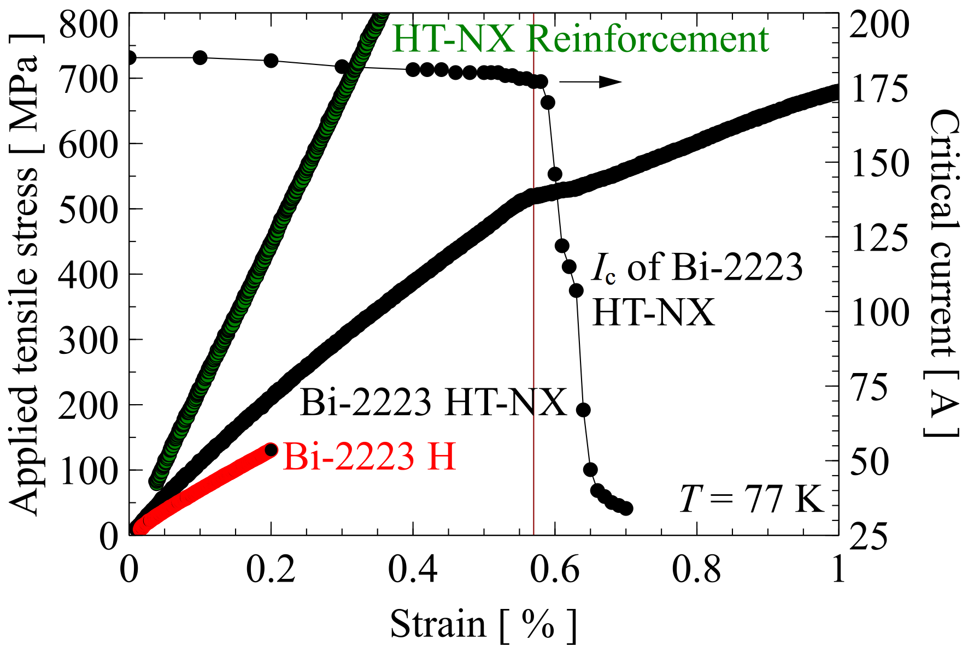
Fig. 1 Strain and critical current as a function of applied stress at 77 K of non-reinforced Bi-2223 type H, reinforced type HT-NX, and the Ni-alloy reinforcement tape from type HT-NX.
[1] Miyoshi, Y., Nishijima, G., Kitaguchi, H., and Chaud, X., Supercond. Sci. Techn., 28, 075013 (2015)
[2] Kikuchi, M., et al., Presented at the 24th Magnet Technology conference, Seoul, South Korea (2015)
[3] Nakashima, T., et al., IEEE Trans. Appl. Supercond., 25, 6400705 (2015)
[4] Yanagisawa, Y., et al., Supercond. Sci. Techn., 28, 125005 (2015)

