I_{c} Study of Thick MOCVD REBCO Coated Conductors for
High Field Magnet Applications

Xu, A. (UH, TcSUH); Jaroszynski, J.; Abraimov, D.; Larbalestier, D.C. (FSU, NHMFL) and Selvamanickam, V. (UH, Mechanical Engineering)

Introduction
Our previous work at the NHMFL has demonstrated that Zr incorporation can significantly increase critical current density J_{c} and substantially reduce J_{c} anisotropy of REBCO coated conductors which is highly beneficial for very high field magnet applications. Growing thicker REBCO layer is a more direct strategy to reach higher critical current I_{c}. However, thickness increment has long been obstructed due to microstructure degradation with increasing REBCO layer thickness. Recently, by modifying the MOCVD process, we have successfully grown ∼3 μm thick, 20% Zr-added REBCO coated conductor with much reduced microstructure degradation.

Experimental
High density of BZO nanorods was self-assembled in the epitaxial REBCO films by 20 mol.% Zr-doping. ∼3.0 μm thick REBCO layer was grown using a three-pass MOCVD process. I_{c}(H||c) characterization was conducted at 4 K and magnetic fields up to 31 T at the NHMFL.

Results and Discussion
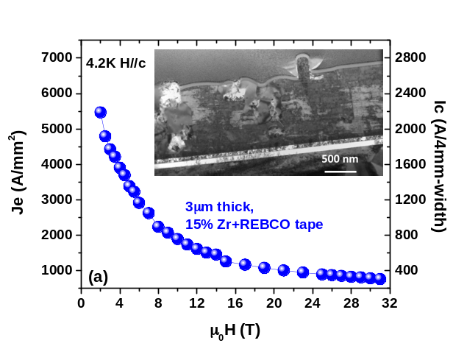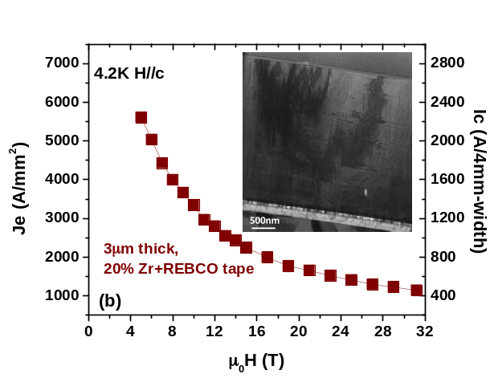
Fig. 1 J_{e}(H||c) (left vertical axis) and the corresponding I_{c}(H||c) for 4 mm wide tape (right vertical axis) for (a) an early ∼3 μm thick, 15% Zr + REBCO coated conductor, and (b) a ∼3 μm thick, 20% Zr + REBCO coated conductor. The TEM images in the insets show substantially reduced microstructure degradation in the ∼3 μm thick, 20% Zr-added sample.
As shown in the insets of Fig. 1, the microstructure degradation, including high density a-axis grains, big second phase particles, and degraded BZO nanorod growth is present in a previously-made ∼3 μm thick 15% Zr-added coated conductor. Such microstructure degradation is significantly reduced in the recent ~3 µm thick 20% Zr-added tape, leading to more than 60% higher J_{e} and I_{c} enhancement, where J_{e}, an important parameter for magnet design, is defined by dividing I_{c} by the whole cross section of REBCO tape.

Conclusions
We attribute this excellent I_{c} partially to the thicker REBCO layer and partially to the pinning enhancement owing to the higher Zr-addition.

Acknowledgements
A portion of this work was performed at the National High Magnetic Field Laboratory, which is supported by National Science Foundation Cooperative Agreement No. DMR-1157490 and the State of Florida. The work at the University of Houston was partially funded by Advanced Research Projects Agency-Energy (ARPA-E) award DE-AR0000196 and Argonne National Laboratory award 4F-30201.

References
[1] Selvamanickam, V., et al., Appl. Phys. Lett. 106, 032601 (2015)
[3] Selvamanickam, V., et al., Supercond. Sci. Technol. 28, 072002 (2015)

