Significant Enhancement of Compositional and Superconducting Homogeneity in Ti Rather Than Ta-doped Nb₃Sn

Tarantini, C.; Sung, Z.H.; Lee, P.J.; Larbalestier, D.C. (ASC, NHMFL) and Ghosh, A.K. (BNL, Magnet Division)

Introduction
We investigated RRP® Nb₃Sn wires of the same design but with different Sn:Nb ratios and different dopants (Ti or Ta) in order to understand what determines their different performance (J_{c}(12T,4.2K)= 3035, 2927, 2952 A/mm² and μ₀H_{irr}= 25.45, 25.47, 23.84 T for Ti-standardSn, Ti-reducedSn and Ta-standardSn respectively).

Experimental and Results
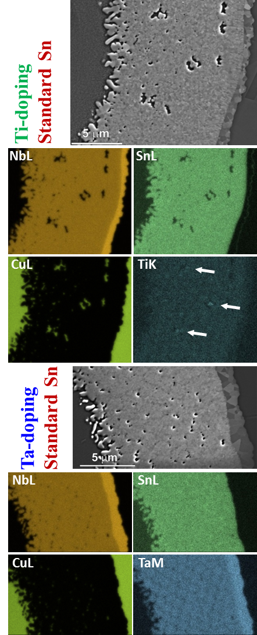
We performed microstructural/microchemical (Fig.1) and specific heat (Fig.2) characterizations. We found that Ti-doped wires have a very homogeneous A15 layer without significant Sn gradients independent of the initial Sn content. In contrast, the Ta-doped wire shows both Ta and Sn inhomogeneities at both filament and whole sub-element level. The in-field T_{c}-distributions do not depend on the Nb:Sn ratios (3.4:1 and 3.6:1) for the Ti-doped wires which have a more uniform and higher temperature in-field distribution with respect to Ta-wire. The Ti-wires also have a 2 T larger upper critical field. The basis for the better properties seems to be the ability of Sn to sit on Ti sites and to diffuse preferentially to the centers of each filament within the sub-element

Conclusions
Reduced-Sn, Ti-doped wires have better magnet application because they have better in-field performance and prevent poisoning of the Cu-stabilizer, they are electromagnetically more stable.

Acknowledgements
Work was performed at the NHMFL (National Science Foundation Cooperative Agreement DMR-1157490 and State of Florida and by the US Department of Energy (DOE) Office of High Energy Physics under FG02-07ER41451 and DE-SC0012083) and by US-DOE (DE-AC02-98CH10886) at BNL.

References
[1] Tarantini, C. et al., to appear Appl. Phys. Lett. (2016).
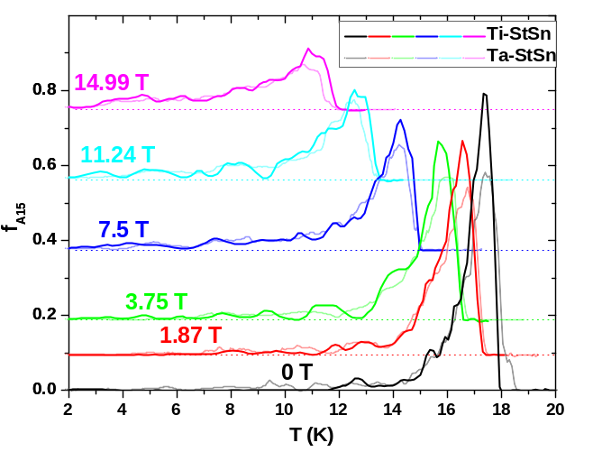
Fig.2 In field T_{c}-distribution of the A15 phase, f_{A15}, for (a) Ti-stdSn and Ta-stdSn RRP® wires. The curves are vertically shifted proportionally to the applied field. The Ti wire ismore peaked dis

Fig.1 FESEM-BSE images and qualitative (brighter=higher atomic composition) maps [Nb(L), Sn(L), Cu(L), Ti(K) or Ta(M)] obtained by FESEM–EDS for Ti-stdSn (top 5 images) and Ta-stdSn (lower 5 images) RRP® wires.

