Development of a Procedure to Mitigate Loss of Bi₂Sr₂CaCu₂O_{x} (2212) Round Wire End Closure during Overpressure Processing of Large Coils

Matras, M.R.; Jiang, J.; Larbalestier, D. and Hellstrom, E. (NHMFL, ASC)

Introduction
Using overpressure (OP) processing at 100 atm, the engineering current density (J_{E}) of 2212 wire was increased by about a factor 6 using an OP pressure of 100 atm compared to wires processed at 1 atm [1]. The increase in J_{E} is due to the increase in density of the 2212 powder. Sealing the ends of the wire is critical for high densification. We study here the effect of an open end due to a bad seal on I_{C} and wire diameter along the length of the open-ended wire to determine how far from the open ends the wire fully densifies.

Experimental
A 2.2 m long 2212/Ag wire made by Oxford Superconducting Technology (OST), with a diameter of 1.302 ± 0.001 mm, was heat treated with both ends fully open at 100 atm OP following the standard heat treatment but without the 48 h soak at 832 °C. Wire diameter was measured before and after the heat treatment to determine the change in wire diameter along the wire length. I_{C} was measured using the four-lead technique with a 1 µV/cm criterion at 4.2 K and 5 T. As reference, several short samples with sealed ends were fully heat treated following the standard heat treatment at 100 atm OP.

Results and Discussion
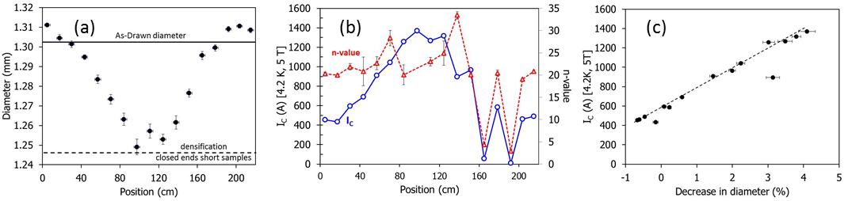
Figure 1: (a) diameter as a function of position for 2.2 m wire heat treated at 100 atm with both ends open. (b) I_{C} and n-value as a function of position for the same wire. (c) Data from (a) replotted to show I_{C} at 4.2 K and 5 T as a function of the decrease in wire diameter. Note that in (c) the negative of the change in wire diameter has been plotted so the plot shows I_{c} with increasing change in the wire diameter (i.e., with increasing densification).
Figure 1(a) shows that the center of the wire densifies as much as the sealed-end short samples, which means that the open-ended wire was fully densified 1 m from the open ends. Figure 1(b) shows that the I_{C} curve is the inverse of the diameter curve with the lowest I_{C} at the ends of the wire, and the highest I_{C} value at the center. The n-value of the samples is relatively constant at 21.7 ± 2.4. The two samples located at 165 cm and 192 cm show very low n-values (4.4 and 2.9 respectively) most probably indicating that the samples were damaged by handling. Figure 1(c) shows a strong linear trend between I_{C} and the change in wire diameter, which is directly linked to the filament density. The two damaged samples are not shown in this graph.

Conclusions
These results show that at least 1 m of extra wire has to be added to each end of a long coil to make sure the coil itself is densified if the seal is bad. The extra wire is then removed after the OP heat treatment. The strong linear relationship between I_{C} and change in wire diameter suggests that I_{C} can be predicted from the wire diameter after OP.

Acknowledgements
This work was supported by the BSCCO strand and cable collaboration (BSCCo), a grant of the US Department of Energy (DOE: DE-SC0010421) and by the NHMFL, which is supported by the NSF under NSF/DMR-1157490 and by the State of Florida.

References
[1] D. C. Larbalestier et al., Nature Material., vol. 13, no. 4, pp. 375–381, Apr. 2014.

