Test Plans Based on Finite Element Analysis of Bi-2212 Round Wire Prototype Coils

Bosque, E.S.; Hilton, D.K.; Trociewitz, U.P.; Kim, Y.; Davis, D.; Chen, P.; Miller, G.E.; Larbalestier, D.C. (NHFML)

Introduction
The Bi₂Sr₂CaCu₂O_{8-x} (Bi-2212) round HTS wire program (Platypus) at the NHMFL takes full aim toward the lab goal of using high temperature superconductors to develop high field quality magnets beyond 30 T (1.3 GHz) for application in NMR [1]. During the past year, finite element analysis contributed to developing test plans for several prototype coils (Platypups), built to demonstrate the suitability of Bi-2212 round wire technology for high field magnets.

Experimental
COMSOL Multiphysics provides a numerical test-bed to evaluate many design ideas and settle on prototype coil parameters. Detailed wire-by-wire models allow incorporation of full material properties for each of the several constituents in the Platypups. Because the coils operate in a 4.2 K LHe bath, thermal stresses generated by the many coupled materials are examined first. Then, electro-mechanical physics are superimposed onto the models. The generated Lorentz forces are coupled with structural mechanics to compute the engineering stresses and strains on the individual Bi-2212 wires. The principal task is to determine the envelope within which the relatively weak conductor can perform. After successive tests in the (now decommissioned) 20 T Cell-4 ultra wide bore resistive magnet, innovative stress management schemes were developed and respective models were updated, providing subsequent prototype test plans.

Results and Discussion
Figs. 1 and 2 illustrate the model geometry for Platypup3 and its respective computed operating envelope. The conductor superconductivity is known to rapidly diminish when put under axial strains near 0.6% [2], which is reflected by the upper-limit cutoff in Figure 2. The plot was developed by numerically sweeping through operating currents for the coil as well as background fields in the Cell-4 magnet.

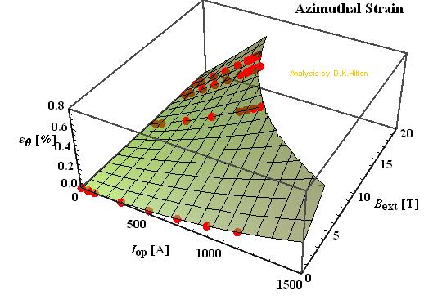
Fig.1 Geometry of Platypup3, featuring wire-by-wire detail. This prototype coil was wound with 1.3 mm round wire, epoxy impregnated, with an innovative stress/strain management system.
Fig.2 The computed operating envelope for the Platypup3 prototype coil.

Conclusions
Successive prototype tests have provided encouraging results. Platypup3 was operated at a much higher current than the similarly-sized strain-limited Platypup1, and the in-situ strain measurements were well predicted by the models. New prototype coils are being designed to fit into other available outsert magnets to achieve similar operating conditions and further investigate the mechanical performance limits of this conductor technology.

Acknowledgements
This work is supported by the National Science Foundation under DMR-1157490, by the State of Florida and by a grant from the National Institute of Health under 1 R21 GM111302-01.
[1] D. Larbalestier, et al., Nature Materials, 13, 375-381 (2014).
[2] R. Bjoerstad, et al., Superconductor Sci. and Tech., 28.6, (2015).

