Spin Fluctuation Pairing, Nematicity, and Orbital Order in FeSe
Hirschfeld, P.J. (U. Florida); Andersen, B.M. and Kreisel, A. (Niels Bohr Inst.)

Introduction
Iron selenide is at once the simplest of the Fe-based superconductors, and one of the most mysterious. Its T_{c} is only 8K, but this increases under pressure or intercalation to 40K, and to 70K or above when deposited as a single layer on strontium titanate. It is not magnetic, unlike most of the Fe-based superconducting parent compounds, but displays a very strong electronic nematic order below a transition to an orthorhombic structure at 90K. In Ref. 1 we argued that the nematic ordering is due to magnetic correlations frustrated by ordering tendencies at several competing wavevectors.

Results and Discussion
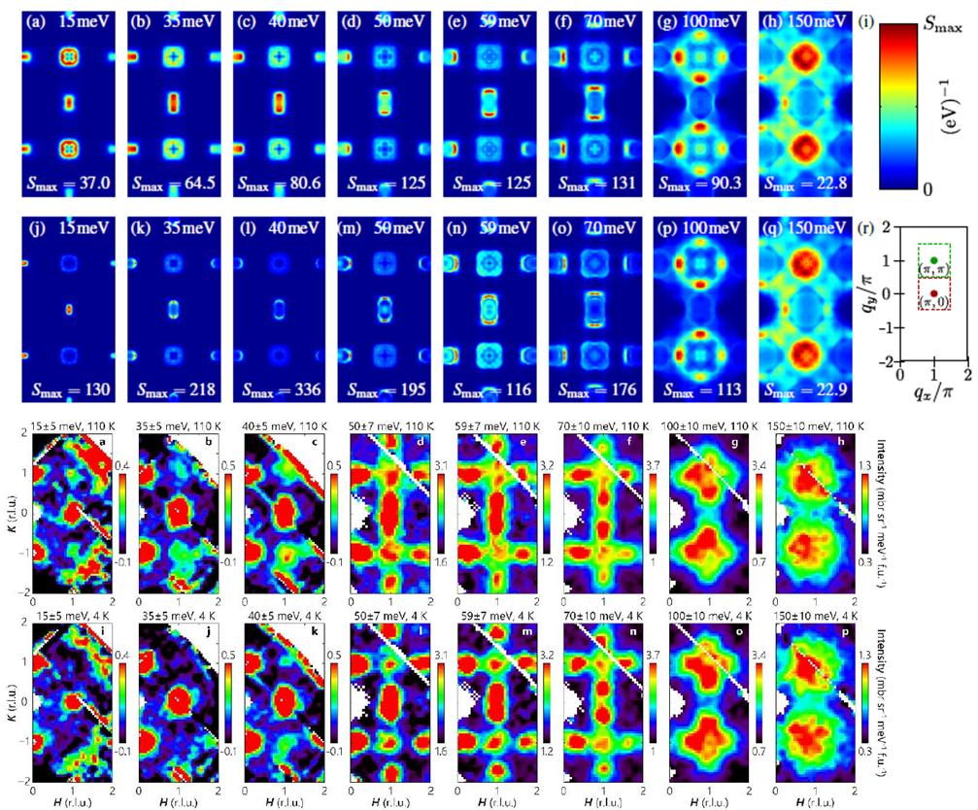 | We proposed a microscopic model in Refs. 2,3, using a standard 5-orbital Hubbard-Hund approach with phenomenological orbital ordering term, and found that it reproduces many features of experiment (ARPES,QO,STM,NMR), including most recently the detailed energy and temperature dependence of the inelastic neutron scattering intensity (left). This shows the inelastic neutron scattering intensity at different temperatures and energies, comparison of theory (Row 1 - 110K; row 2 - 10K. From Kreisel et al., Ref. 3 ) and experiment (Row 3 - 110K; row 4 - 4K. From Wang et al., arXiv:1511.02485, Ref. 4). In Ref. 3 we showed that the orbital ordering is responsible for transfer of spectral weight from π,π to π,0 at low energies.

Conclusions
Bulk FeSe, despite significant electronic correlations, can be described within the usual framework appropriate for other Fe-based superconductors, if the orbital ordering and competing magnetic ground states are properly accounted for.

Acknowledgements
Supported by DOE DE-FG02-05ER46236

References
- ``Effect of magnetic frustration on superconductivity and nematicity in Fe chalcogenides", J. K. Glasbrenner, H. O. Jeschke, R. Valenti, P. J. Hirschfeld, and I. I. Mazin, Nat. Phys. 11, 953 (2015).
- "Model of Electronic Structure and Superconductivity in Orbitally Ordered FeSe", S. Mukherjee, A. Kreisel, P.J. Hirschfeld and B.M. Andersen, Phys. Rev. Lett. 115, 026402 (2015).
- "Spin excitations in a model of FeSe with orbital ordering", A. Kreisel, S. Mukherjee, P. J. Hirschfeld and B.M. Andersen, arXiv:1510.02357.
- “Magnetic Ground State of FeSe”, Q. Wang et al, arXiv:1511.02485.

