Determination of the Upper Critical Field of Cuprates by Electrical Transport under
High Magnetic Field

Wu, J.; Bozovic, I. (Brookhaven National Laboratory) and Boebinger, G.S. (National High Magnetic Field Laboratory)

Introduction
The upper critical magnetic field (H_{c2}), defined as the strength of the magnetic field that breaks the Cooper pairs, is one of the most characteristic parameters of a high temperature superconductors (HTS). Intense efforts have been devoted to determine H_{c2} for different materials and different dopings. The reported results in the literature, however, are still highly controversial. We propose to perform the magneto-transport measurement on the best La_{x}Sr_{2-x}CuO₄ samples and retrieve the doping-dependent, temperature-dependent and magnetic-field-dependent longitudinal resistivity and Hall resistivity. Our goal is to identify H_{c2} for different doping levels and further the nature of superconducting fluctuations of HTS.

Experimental
The high quality single crystalline La_{x}Sr_{2-x}CuO₄ thin films were synthesized by the Atomic-Layer-by-Layer Molecular Beam Epitaxy (ALL-MBE) technique located at Brookhaven National Laboratory. Then we brought our samples together with home-built electronics to NHMFL to perform magneto-transport measurements at temperatures as low as 300 mK. We used both the 31 T DC electromagnet and the 60 T long pulse AC magnet to suppress the superconductivity. With our unique combinatorial sample synthesis technique [1], we performed 30-channel resistance/Hall effect measurement simultaneously to retrieve resistance/Hall resistance signal on 30 different dopings at the same time, greatly enhancing the output of the limited magnet time.

Results and Discussion
We have obtained a huge amount of magneto-transport data at the dopings covering the whole doping range from optimal to extremely overdoped LSCO samples. Here is one representive set of magneto-resistance measurements performed at systematically-varying temperatures for one particular doping.
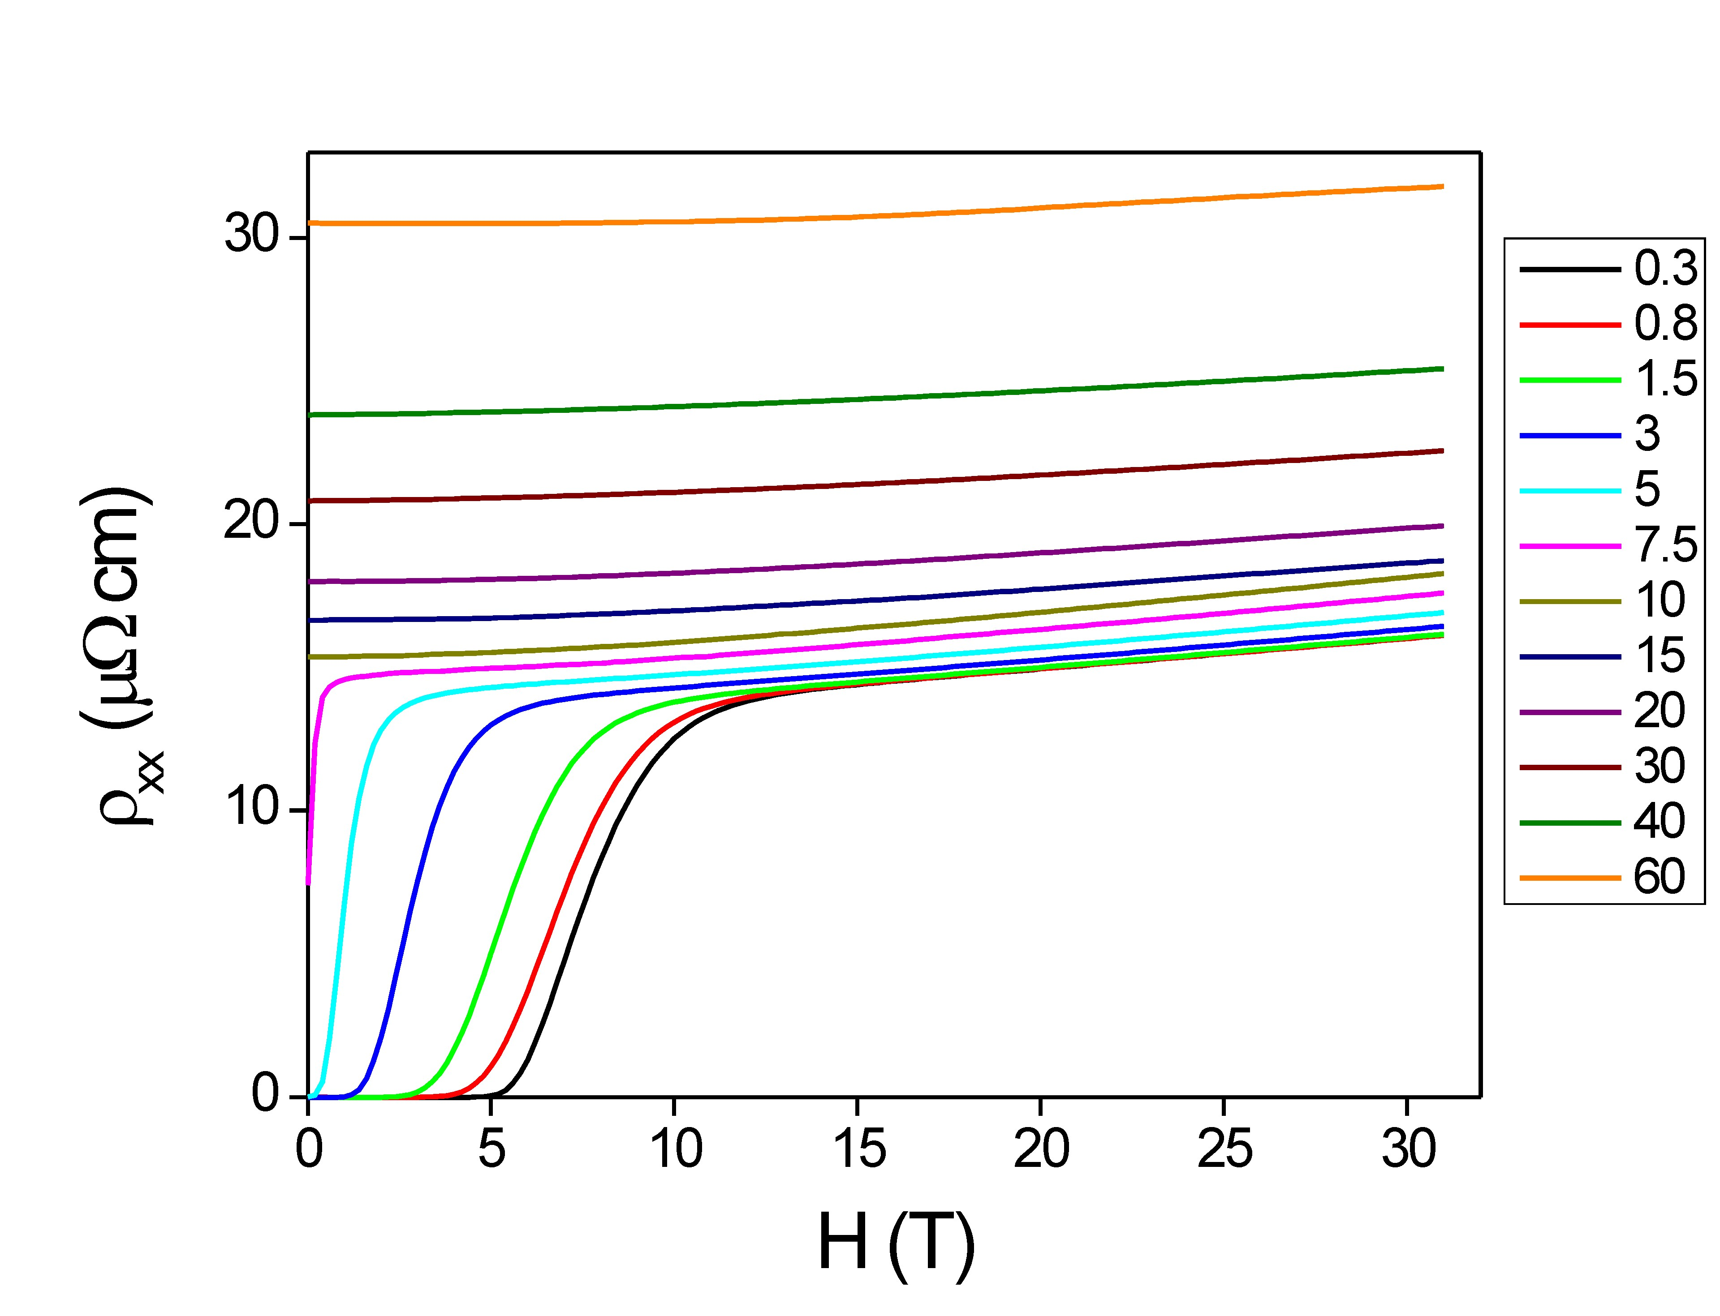
Fig. 1: The magneto-resistance of overdoped La_{x}Sr_{2-x}CuO₄ film at systematically-varying temperatures.

The magneto-resistance of a normal metal is expected to show B² dependence. Thus this dependence could be used as an indicator of the recovery of Fermi-liquid like behavior of cuprate. The critical field H_{c2} can be directly identified as the threshold field where the recovery occurs.

Conclusions
By studying the temperature- and doping- dependence of H_{c2}, we may find clues about the mechanism of the superconducting fluctuations and further the nature of the superconducting state.

Acknowledgements
A portion of this work was performed at the National High Magnetic Field Laboratory, which is supported by National Science Foundation Cooperative Agreement No. DMR-1157490, the State of Florida, and the U.S. Department of Energy. Our research is also supported by the U.S. Department of Energy, Basic Energy Sciences, Materials Sciences and Engineering Division.

References
[1] Wu, J., et al., Nature Materials, 12, 877 (2013).

