Anomalous High-Field-Induced Phase in Underdoped La_{1.7}Eu_{0.2}Sr_{0.1}CuO₄

Shi, Z.; Baity, P.G.; Popović, D. (FSU,NHMFL) and Sasagawa, T. (Tokyo Inst. of Tech.)

Introduction
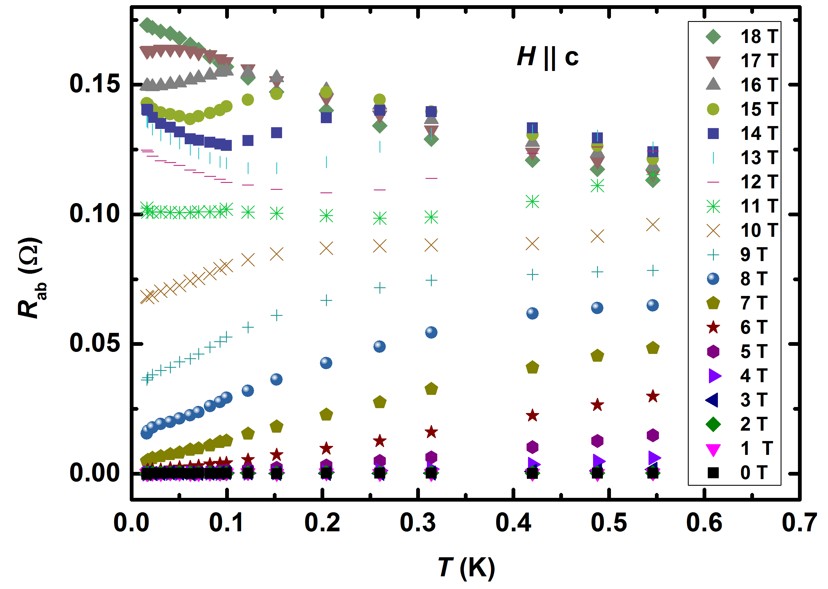
Our recent study [1] on underdoped (T_{c} ≈ 4 K) La_{2-x}Sr_{x}CuO₄ (LSCO) has revealed a two-stage magnetic-field-driven superconductor-insulator transition (SIT) with an intermediate phase between two quantum critical points (QCPs) that separate the superconductor and the insulator. It is important to extend similar studies to other underdoped cuprates in order to explore the universality of this behavior. We have investigated the magneto-transport properties of La_{1.8}Eu_{0.2}Sr_{0.1}CuO₄ (LESCO), which is known to have both spin- and charge-density-wave orders at low temperatures (T) [2], allowing us to investigate the relevance of competing orders to the high-temperature superconductivity.
Experimental
The in-plane and out-of-plane resistances of the LESCO single crystal with T_{c} ≈ 5 K were measured at 0.016 ≤ T (K) ≤ 40 and in perpendicular fields (H || c axis) up to 18 T in SCM-1 and SCM-2 magnets in the DC Field Facility, using a standard four-probe ac technique in the Ohmic regime. Figure 1 shows the in-plane resistance R_{ab}(T) of LESCO up to 18 T. At low T (≤ 0.06 K) and high H (> 11 T), we observed the emergence of a novel, high-field-induced phase (HFIP) that has not been reported in cuprates before. Studies of the nonlinear differential resistance and the angle dependence of the MR were also performed in the HFIP regime.
Fig 1. In-plane resistance R_{ab} vs. T for H up to 18 T in a LESCO (x=0.10) single crystal.

Results and Discussion
In LESCO, R_{ab} measurements have revealed the emergence of a HFIP between ~ 11 T and ~ 17 T at very low T (≤ 0.06 K). The HFIP exhibits signatures of glassiness, such as hysteretic behavior and memory of magnetic history. Differential resistance studies reveal nontrivial, non-Ohmic behavior, suggesting the possible presence of a vortex glass in the HFIP. The study of the angle dependence of the MR shows that the in-plane magnetic field becomes relevant in the HFIP. Similar observations have been made in the out-of-plane resistance R_{c}. Further data analysis and measurements at higher H are planned to explore the evolution of the HFIP into the high-field resistive state, and complete the (H, T) phase diagram of this material.

Conclusions
An anomalous low-temperature, high-field-induced phase is observed in the vicinity of the H-field-driven superconducting transition in cuprates for the first time. More measurements are needed to provide an insight into the nature of this phase, and into the effects of spin- and charge stripes on the field-driven destruction of high-T_{c} superconductivity in the T=0 limit.

Acknowledgements
This work was performed at the National High Magnetic Field Laboratory, which is supported by National Science Foundation Cooperative Agreement No. DMR-1157490 and the State of Florida. This work is also supported by NSF DMR-1307075.

References
[1] Shi, X., et al., Nature Phys. 10, 437- 443 (2014).
[2] Autore, M., et al., Phys. Rev. B 90, 035102 (2014).

