Torque Magnetometry of High Temperature Superconductors in Pulsed Magnetic Fields

Yu, F.; Li, G.; Lawson, B.J.; Asaba, T.; Li, L. (Univ. Michigan) and Singleton, J. (LANL)

Introduction
High temperature superconductivity discovered in Fe-based [1, 2] and Cu-based materials [3] has been a treasure trove for condensed matter physicists. Many key issues are under debate: for cuprates, whether they are a normal Fermi liquid with a hidden ordering state or an exotic phase coming out of a doped Mott Insulator; for Fe- based materials, what catches the essential physics in the parent compound, the “bad metal” seen in early discovered materials or “Mott Insulator”? Direct answers to these questions will essentially determine the right approach to understanding their superconducting mechanism, i.e. whether it is a weak-coupling phenomenon or a strongly correlated effect. Precise measurement of the magnetization M in ultrahigh magnetic fields will shed light on the magnetic ground state and the superconducting property. High-resolution torque magnetometry was used to measure the magnetic moment of the samples [3-8]. Torque is measured as the change of the capacitance between the metal cantilever and a nearby metal plate.
Experimental
High-resolution torque magnetometry was used to measure the magnetic moment of the samples [4]. Torque is measured as the change of the capacitance between the metal cantilever and a nearby metal plate.
Results and Discussion
We used torque magnetometry to measure the magnetic torque of superconducting underdoped ortho-II phase YBa₂Cu₃O_{6+δ} (YBCO) with the superconducting Tc around 61 K. An example of the magnetization curve is shown in the left panel of Fig. 1, taken at T ~ 12 K. At low field, we observed the hysteresis due to flux pinning. Well above the melting field 10 T, a kink is observed at ~ 26 T. Further measurements show the kink field value is almost independent with the sample temperature, consistent with the recent observed field-driven charge density wave transition in YBCO of the same phase [5,6].
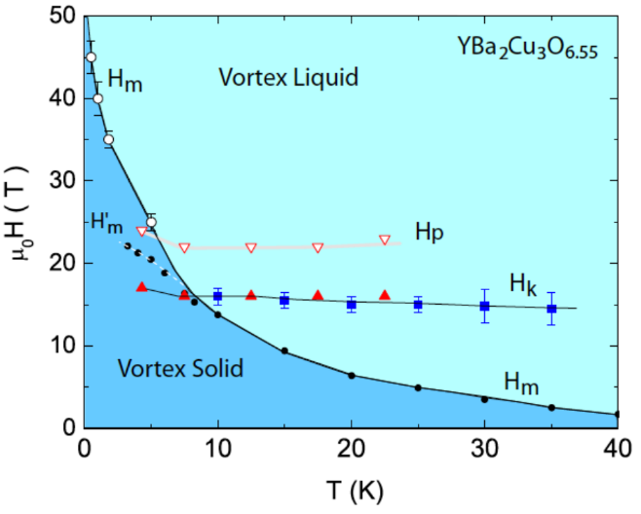
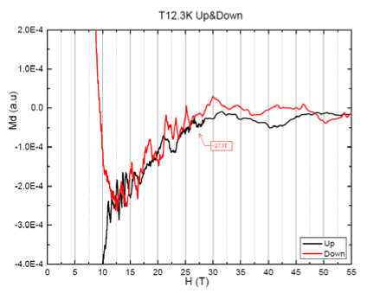

Fig.1 (Left) Magnetic torque of the underdoped YBa₂Cu₃O_{6+δ} (YBCO) The superconducting transition temperature is 61 K.
(Right) Phase diagram of the underdoped YBCO showing the temperature dependence of the kink field.
Conclusions
The magnetic torque measurements on the ortho-II phase YBCO revealed signatures of magnetic field driven CDW transition. Further experiments show that the CDW field does not change much with temperature [7].

Acknowledgements
A portion of this work was performed at the National High Magnetic Field Laboratory, which is supported by National Science Foundation Cooperative Agreement No. DMR-1157490 and the State of Florida. We thank the support from Department of Energy (12-PAF02864),

References

[1] Kemihara, Y. et al., JACS 130, 3296 (2008).
[2] Chen, X. H. et al., Nature 453,761 (2008).
[3] Bednorz & Muller, Z. Phys. B 64, 189 (1986)
[4] Li, L. et al. Nat. Phys. 3, 311(2007).
[5] Wu, T. et al., Nature 477, 191 (2011).
[6] Ghiringhelli, G. et al., Science 337, 821 (2012).
[7] F. Yu, et al. arXiv:1402.7371 (2014). Under review.

