Superconductivity and Quantum Transport in Asymmetric and Symmetric SrTiO₃ Structures

Merz, T.A.; Chen, Z.; Yoon, H. (Stanford U.); Hikita, Y. and Hwang, H.Y. (Stanford U. & SLAC Nat. Acc. Lab)

Introduction
The ground state of two-dimensional (2D) electron systems are often functions of disorder, carrier density, strain, and magnetic field. 2D systems involving SrTiO₃ (STO) have proven to be a particularly rich playground for the study of unique ground states of matter. We have implemented dual-gated LaAlO₃/SrTiO₃ (LAO/STO) devices and continuously tunable strained delta-doped STO quantum wells. The dual gated structure allows independent and continuous tuning of disorder and carrier density while strain tuning accesses structural order.

Experimental
The experiments presented here are completed in part in the SCM-1 dilution refrigerator at the NHMFL. Both sets of devices are grown via pulsed laser deposition. The dual gate device is fabricated by applying a Au electrode on top of the LAO layer and a Ag electrode from the back of the STO substrate.

Results and Discussion
Strained delta-doped STO: By applying only tiny amount of strain on the substrate, T_{C} changes.
Dual-gate LAO/STO: In addition to modulating the superconducting transition temperature, T_{C}, strikingly different interface conducting states are accessible in a single device—zero resistance (superconductor), saturating small finite resistance (“metal”), and increasing resistance (insulator), when approaching zero temperature.
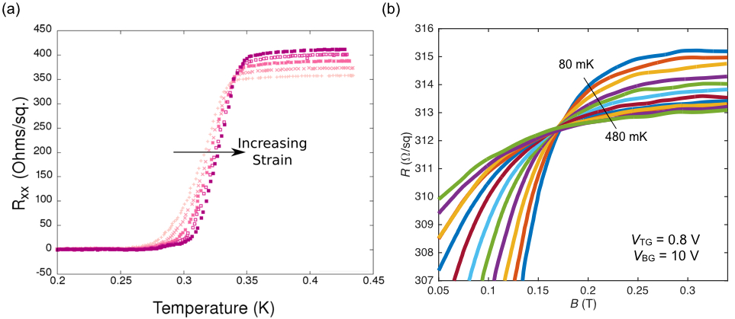
Fig.1 (a) Superconducting transition a function of strain in delta-doped STO. (b) An example of magnetic field induced superconductor to insulator transition in dual-gated LAO/STO interface under a fixed top and back gate voltages.

Conclusions
The dual-gate LAO/STO and strained delta-doped STO devices provide a unique platform for investigating ground state transitions of 2D electron system under various continuously tunable parameters.

Acknowledgements
A portion of this work was performed at the National High Magnetic Field Laboratory, which is supported by National Science Foundation Cooperative Agreement No. DMR-1157490 and the State of Florida.

References
[1] Caviglia, A. D., et al., Nature 456, 624 (2008).
[2] Bell, C., et al., Phys. Rev. Lett. 103, 226802 (2009).
[3] Kozuka, Y., et al., Nature 462, 487 (2009).

