Majorana Bands, Berry Curvature, and Thermal Hall Conductivity in a Chiral P-Wave Superconductor

Murray, J. M. (NHMFL) and Vafek, O. (NHMFL, FSU)
____________________________________________________________________________________

Introduction
It has long been known that Majorana quasiparticle states form in the vortex cores of a chiral p-wave superconducting state, which may be realized in Sr₂RuO₄. We study the effects of these modes in a vortex lattice induced by an applied magnetic field, where the zero-energy states hybridize to form quasiparticle bands, with a particular focus on the Berry curvature of these bands [1]. This purely quantum mechanical effect leads to an intrinsic contribution to the thermal Hall conductivity, which we calculate explicitly (Fig. 1).

Results and Discussion
In order to obtain a full understanding of the Berry curvature and its effects on the topological nature of the ground-state, we proceed along two complementary routes. First, we numerically solve the full microscopic Hamiltonian describing electrons on a lattice and use our knowledge of the resulting wavefunctions to calculate the Berry curvature of each band and thermal Hall conductivity explicitly. Second, we construct localized Wannier functions corresponding to the low-energy Majorana modes, and then derive a simple tight-binding model by computing the overlap of these Wannier functions. The signs of these hopping parameters turn out to determine the Berry curvatures of the Majorana bands, and the simple effective Hamiltonian allows us to obtain a detailed understanding of the low-energy bands, including their associated edge states and contributions to the thermal Hall conductivity.

Conclusions
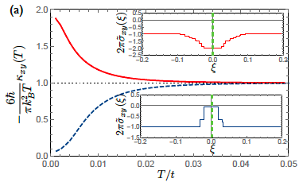
Due to the fact that the chiral p-wave superconducting condensate--even in the absence of vortex-related quasiparticle bands--is topologically nontrivial, the topological nature of the low-energy state turns out to depend in a subtle way on the interplay of multiple distinct sources of Berry curvature. Using both the low-energy effective theory and the full microscopic solution, we show that the energy gap between the Majorana bands may be either topologically trivial or nontrivial, depending on whether the Berry curvature contribution from the Majorana bands adds constructively or destructively with the contribution from the background superconducting condensate.

Fig. 1 Temperature-dependent thermal Hall conductivity in the vortex state of a chiral p-wave superconductor. Insets show the energy-dependent Berry curvature from the quasiparticle bands. Depending on the sign of the Berry curvature contributed by the Majorana bands near zero energy, the thermal Hall conductivity may be either enhanced (solid red line) or diminished at low temperatures.

Acknowledgements
This work was performed at the National High Magnetic Field Laboratory. In addition, this work was supported by the NSF CAREER award under Grant No. DMR-0955561.

References
[1] Murray, J. M. and Vafek, O., Phys. Rev. B 92, 134520 (2015).

