**Strong Correlations Elucidate the Electronic Structure and the Phase Diagram of the LaAlO3/SrTiO3 Interface**

Dagan, Y.; Maniv, E.; Ben Shalom, M.; Ron, A.; Mograbi,M.; Palevski, A. and Goldstein, M. (Tel-Aviv University)

**Summary**

The interface between the two band insulators SrTiO3 and LaAlO3 unexpectedly exhibits the properties of a two-dimensional electron gas. It is even superconducting with a transition temperature, Tc, that can be tuned using gate bias Vg, which controls the number of electrons added or removed from the interface. The gate bias–temperature (Vg, T) phase diagram is characterized by a dome-shaped region where superconductivity occurs, that is, Tc has a non-monotonic dependence on Vg, similar to many unconventional superconductors. In our work, we measured the Shubnikov de-Haas frequency for various Vg. This frequency follows the same non-monotonic behavior as Tc; a similar trend is seen in the low field limit of the Hall coefficient. We theoretically show that electronic correlations result in a non-monotonic population of the mobile band, which can account for the experimental behavior of the normal transport properties and the superconducting dome.

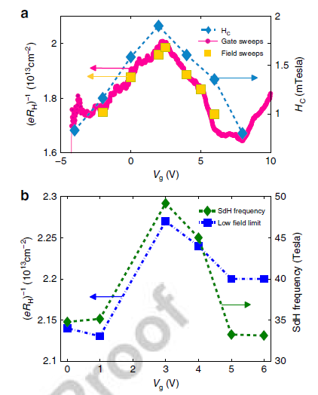 

**Fig.1** **Non-monotonic behavior of the transport and superconducting properties**. (a) (Sample A) left axis (indicated by yellow and magenta arrows): the inverse of the Hall coefficient is plotted as a function of the gate bias for a fixed magnetic field of 3T (magenta circles). The Hall coefficient was also extracted by measuring the Hall resistance as a function of the magnetic field from 0 to 3T and using a linear fit (yellow squares). Right axis (indicated by a blue arrow): superconducting critical magnetic field Hc, defined as R(T=60mK, Hc)=1/2R(T=800mK, H=0), plotted for different fixed gates bias values at T=60mK (blue diamonds). (b) (Sample B) left axis (indicated by a blue arrow): the inverse of the Hall coefficient inferred from a linear fit to the data in Supplementary Fig. 1c up to 2T is plotted as a function of the gate bias (blue squares). Right axis (indicated by a green arrow): the SdH frequency is plotted as a function of the gate bias (green diamonds). The SdH frequency is calculated from FFT

analysis of the data in Fig. 2b in the paper.

**Acknowledgements**

A portion of this work was performed at the National High Magnetic Field Laboratory, which is supported by National Science Foundation Cooperative Agreement No. DMR-1157490 and the State of Florida. Magnets used were (SCM1) and (Cell 12).

**References**

[1] Maniv, E. *et al*. Strong correlations elucidate the electronic structure and phase diagram of LaAlO3/SrTiO3 interface. *Nat. Commun.* **6**:8239 doi: 10.1038/ncomms9239 (2015).