High Field Transport Properties of Ni-doped BaFe₂As₂ Thin Film

Iida, K. (Nagoya Univ.); Kurth, F.; Richter. S.; Hühne, R. (IFW Dresden); Hänisch, J. (KIT); Tarantini, C. and Jaroszynski, J. (NHMFL-FSU)

Introduction
We have investigated the high field transport properties of epitaxial Ni-doped BaFe₂As₂ (Ba-122) thin films in order to reveal various physical properties. The main purpose of this study is to clarify the dominant pinning mechanism.

Experimental
The epitaxial Ni-doped Ba-122 thin film with 70 nm thickness was prepared by pulsed laser deposition at IFW Dresden. Fully epitaxial growth was proven by means of x-ray diffraction. A small bridge of 90 μm width and 2 mm length was prepared by laser cutting at NHMFL for the measurements of transport properties by a four probe method. DC magnetic fields of up to 35 T were applied in maximum Lorentz force configuration.

Results and Discussion
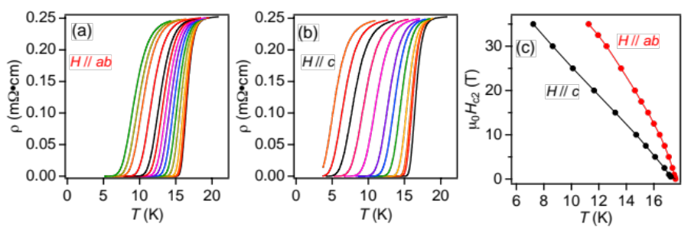
The resistivity of Ni-doped Ba-122 thin films is shown in figs. 1(a) and (b) for H||ab and H||c. Based on those data, the upper critical field is summarized in fig. 1(c).
Fig.1 Resistivity as a function of temperature for (a) H || ab and (b) c measured in field up to 35 T at the NHMFL. (c) The extracted H_{c2} for both major direction.
The activation energy U₀(H) for vortex motion can be estimated by the model of thermally activated flux flow. In figs. 2 (a) and 2(b), the slope of linear fits corresponds to U₀ for vortex motion. Figure 2c shows the relationship between ln[ρ] and U₀ for H||c and ab. The linear fitting for H||c and ab yields T_{c}=16.4 K and 16.9 K. Figure 2(d) shows U₀ as a function of H for both major directions. U₀(H) shows a power law for both crystallographic directions. In the range of 1<μ₀H<7.5 T, α=0.49 is observed for H||c, whilst a similar field dependence of U₀ reaches 12 T for H||ab. In higher fields for both H||c and ab α =1.2 is obtained, which is close to 1, suggesting a crossover from plastic to collective pinning at around 7.5 and 12 T for H||c and H||ab, respectively.
Fig. 2 In-field resistivity ρ measurements of Ni-doped Ba-122 thin film up to 35 T and the analyses of the activation energy of pinning potential.
Conclusions
We have explored the electro-magnetic properties of epitaxial Ni-doped Ba-122 thin films prepared by PLD on a CaF₂ (001) substrate by measuring the angular field dependence of transport properties up to 35 T. We determined the crossover field where the dominant pinning mechanism changes for both crystallographic directions (μ₀H=7.5 T for H||c and μ₀H=12.5 T for H||ab).

Acknowledgements
A portion of this work was performed at the National High Magnetic Field Laboratory, which is supported by National Science Foundation Cooperative Agreement No. DMR-1157490 and the State of Florida.
The research leading to these results has received funding from European Union's Seventh Framework Programme (FP7/2007-2013) under grant agreement number 283141 (IRON-SEA) and 283204 (Super Iron). The work was also supported by the German research foundation (GRK1621).

