Theoretical Visualization of STM Images in Inhomogeneous Superconductors

Hirschfeld, P.J.; Choubey, P. (UF Physics); Kreisel, A.; Andersen, B.M. (N.Bohr Inst.) and Berlijn, T. (ORNL)

Introduction
Theoretical calculations of STM images on cuprate superconductors have been confined almost exclusively to models of electrons hopping on a square lattice corresponding to the Cu sites in the CuO₂ plane; this is a clear disadvantage, for example when the elusive charge order is seen to correspond to local density of states modulations primarily on the O sites.

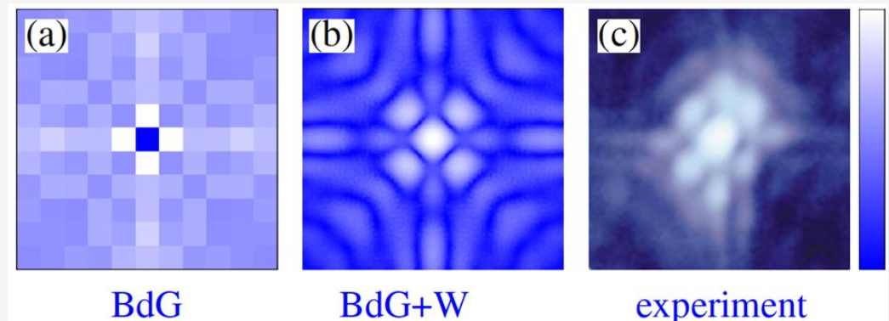
Calculation of Zn impurity in BSCCO-2212: a) traditional Bogoliubov-de Gennes (BdG) solution; (b) BdG+W [1] approach; (c) experiment from Ref. [2].

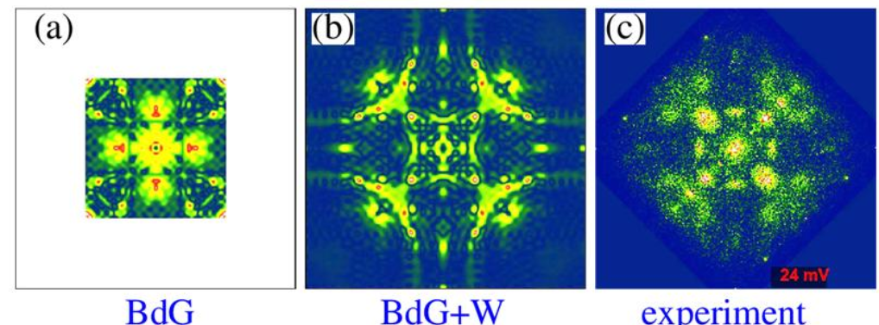
Quasiparticle interference patterns Fouier transformed density of states (q,) for =24meV for weak scattererer: (a) BdG; (b) BdG+W; [2] (c) experiment from Ref. [3].

Results and Discussion
We developed a method [1,4] that started with the lattice calculations that we and others had already performed, and simply used the Wannier functions generated in the process of downfolding a renormalized DFT band structure onto a tight-binding model to calculate the continuum instead of the lattice Green’s function.

Conclusions
The crucial aspect was found to be the tails of the Cu Wannier functions, which include significant weight on apical O sites in neighboring unit cells. The results compare nearly perfectly to experimental findings that have puzzled the community for more than 10 years.

Acknowledgements
Supported by DOE DE-FG0205ER46236.

References
[1] P. Choubey et al, Phys. Rev. B 90, 134520 (2014); A. Kreisel et al, Phys. Rev. Lett. 114, 217002 (2015)
[2] S. Pan et al, Nature 403, 746 (2000).
[3] K. Fujita et al. Science 344, 612 (2014).

