Quantum Hall and Magneto-Photoluminescence Measurements in WSe₂

Jauregui, L.A., Joe, A.Y., Pistunova, K. (Harvard, Physics); Lu, Z. (FSU, Physics, NHMFL); Smirnov, D. (NHMFL); Kim, P. (Harvard, Physics)

Introduction
Single layer, 2-dimensional (2D) transition metal dichalcogenides (TMDs), such as WSe₂, are direct bandgap atomically thin semiconductors that provide a unique platform for novel optoelectronic devices and device physics. Due to broken inversion symmetry in the single-layer limit, TMDs have spin-valley locking physics that can be explored for and utilized in such devices. Using a stamp-on-contacts method, we fabricate high quality, dual-gated WSe₂ devices passivated with boron nitride (BN) (Fig.1a-b). The fabricated devices have transparent contacts down to cryogenic temperatures that allow for observation of Shubnikov de Haas (SdH) oscillations and the quantum Hall effect. When electrostatically doped WSe₂ is optically excited at low temperatures, photoluminescence (PL) spectra show both exciton and trion species. In a perpendicular magnetic field, the g-factors of the exciton and trion peaks can be extracted from the Zeeman splitting.

Experimental
Quantum hall measurements were performed with magnetic fields up to 31 T in Cell 9 at DC Facility. Magneto-PL measurements were performed with magnetic fields up to 14 T with the 15/17 T magnet at the EMR Facility.

Results and Discussion
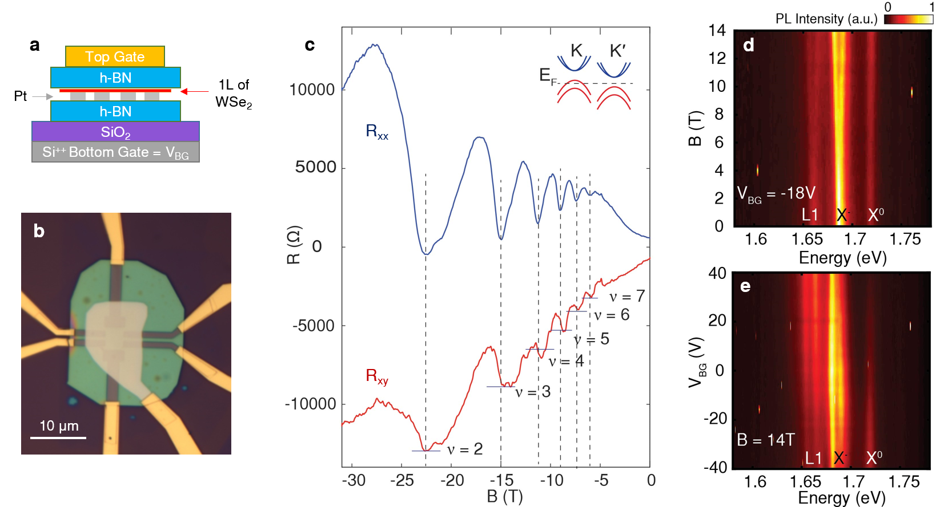
Fig.1 (a) Cartoon of WSe₂ device with platinum contacts, encapsulated by BN layers. (b) Optical image of a characteristic device. (c) SdH at T = 300 mK and at n = 1.1X10¹² cm⁻² shows integer filling factors, indicating the lifting of degeneracy. All integer filling factors from ν = 7 down to ν = 2 are indicated. Inset: band diagram of WSe₂ for low doping when the Fermi level is above one of the spin split valence bands. (d) Magnetic field dependence of PL under excitation by unpolarized 660nm laser at V_{BG}= -18V. Splitting of charged exciton (X⁻) and defect peak (L1) is observed at high B with a trion g-factor ~11. X⁰ indicates the neutral exciton. (e) V_{BG} dependence of PL at B = 14T shows X⁻ splitting and varies with applied V_{BG}.

Acknowledgements
A portion of this work was performed at the National High Magnetic Field Laboratory, which is supported by National Science Foundation Cooperative Agreement No. DMR-1157490 and the State of Florida. The experimental work at the magnet lab is supported by DOE (DE-SC0012260). Device fabrication and optical characterization is supported by AFOSR MURI (FA9550-17-1-0002). P.K. acknowledges partial support from the Gordon and Betty Moore Foundation's EPiQS Initiative through Grant GBMF4543.

References
[1] Fallahazad, B., et al., Phys. Rev. Lett., 116, 086601 (2016).
[2] Movva, H.C.P., et al., ACS Nano, 9 (10), 10402-10410 (2015).

