Surface Transport and Quantum Hall Effect in Ambipolar Black
Phosphorus Double Quantum Wells

Tran, S., Yang, J., Bockrath, M., Chen, R., Lau, C.N. (The Ohio State University); Gillgren, N., Espiritu, T., Shi, Y. (University of California, Riverside); Watanabe, K., Taniguchi, T. (NIMS); Moon, S., Baek, H., Smirnov, D. (NHMFL)

Introduction
Quantum wells (QW) constitute one of the most important classes of devices in the study of 2D systems. In a double layer QW, the additional “which-layer” degree of freedom gives rise to celebrated phenomena such as Coulomb drag, Hall drag and exciton condensation. Traditional QWs are fabricated based on GaAs/AlGaAs heterostructures. More recently, QWs based on graphene have been demonstrated. However, wide QWs, in which the Coulomb repulsion spontaneously causes electrons to reside on the opposite walls, have not been realized in two-dimensional (2D) materials, due to the lack of high mobility 2D semiconductors with sizeable band gaps.

Experimental
We study the electronic transport in hBN-encapsulated black phosphorus devices up to 31T at NHMFL.

Results and Discussion
We demonstrate a simple yet facile realization of wide QWs with a double layer of charge carriers in few-layer black phosphorus (BP) devices, with mobility up to 6500 cm²/Vs. In contrast to traditional GaAs/AlGaAs QWs, BP-based wide QW devices are ambipolar and highly tunable – by independently adjusting top and back gate voltages, we can tune the system into the single or double quantum well regime with unipolar or bipolar charge distributions. Fully spin-polarized integer QH plateaus are observed on both surface states. From temperature and density-dependent measurements, an enhanced Landé g-factor of 2.7 is observed.

Conclusions
Our work opens the door for using 2D semiconductors as ambipolar single, double or wide QWs with unusual properties, and phenomena such as Landau level hybridization, inter-well Coulomb interactions, or multi-component QH ferromagnetism in this highly anisotropic system await investigation.
Acknowledgements
This work is supported by FAME center, one of six centers of STARnet, a Semiconductor Research Corporation program sponsored by MARCO and DARPA, and by NSF/ECCS 1509958. A portion of this work was performed at the National High Magnetic Field Laboratory, which is supported by National Science Foundation Cooperative Agreement No. DMR-1157490 and the State of Florida. K.W. and T.T. acknowledge support from the Elemental Strategy Initiative conducted by the MEXT, Japan and JSPS KAKENHI Grant Numbers JP26248061, JP15K21722 and JP25106006.

References
1. S. Tran, J. Yang, N. Gillgren, T. Espiritu, Y. Shi, K. Watanabe, T. Taniguchi, S. Moon, H. Baek, D. Smirnov, M.W. Bockrath, R. Chen, C. N. Lau, “Surface Transport and Quantum Hall Effect in Ambipolar Black Phosphorus Double Quantum Wells,” Science Advances, 3, e1603179 (2017).
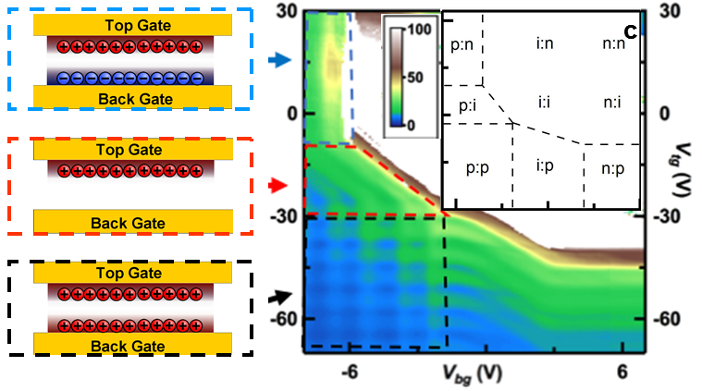
Fig. 1. Right panel: R(V_{bg}, V_{tg}) at T=0.5 K and B=18 T, featuring a complicated quantum oscillations pattern. The color scale is in kΩ. Left panels: schematics of the charge distributions that correspond to bipolar double layer, single layer, and unipolar double-layer regimes, respectively. (inset). Charge types for top and bottom surfaces at different combinations of gate voltages. p: hole doped; n: electron doped i: intrinsic insulating state.

