Magneto-Optics of Exciton Rydberg States in a Monolayer Semiconductor

Stier, A.V., Crooker, S.A. (NHMFL-Los Alamos); Velizhanin, K.A. (Theory Division, Los Alamos); Wilson, N.P.,
Xu, X. (University of Washington, Physics); Kono, J. (Rice University, Physics)

Introduction
Electron-hole interactions play an essential role in semiconductor physics. They dictate the detailed size and binding energy of bound electron-hole pairs (excitons). In conventional, bulk 3D semiconductors, these Coulomb interactions follow a screened hydrogenic (~1/(ε r)) potential that is characterized by a single dielectric constant ε.
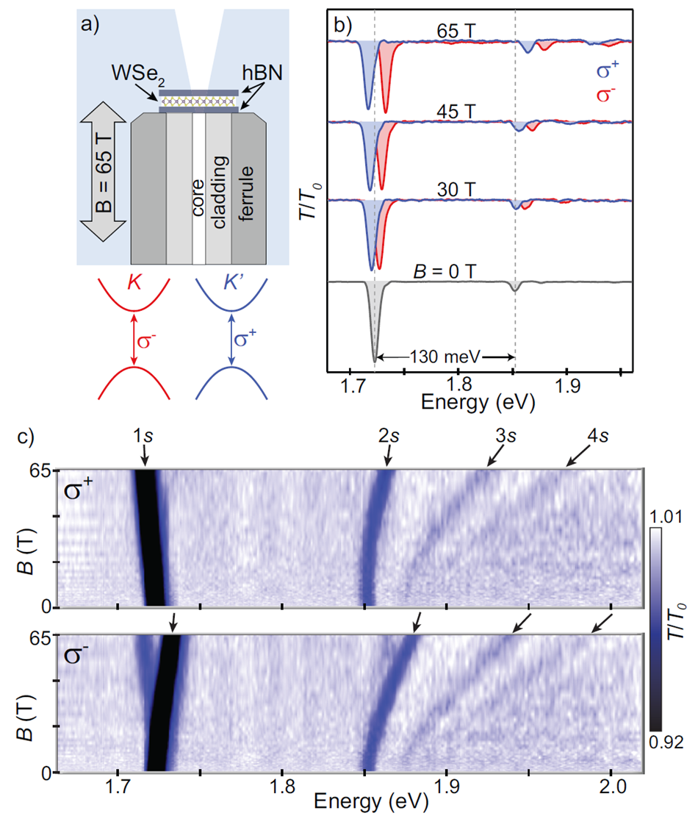
In the class of monolayer semiconductors, such as MoS₂ or WSe₂, the dielectric screening is in general much weaker and importantly depends on the distance between the electron and hole. For example, a well-separated electron and hole are essentially unscreened (because the electric field lines connecting the two charged particles lie mainly outside the 2D slab), while for electron-hole separations of order the slab thickness many more field lines lie within the slab, which therefore partially screens the electrostatic potential. This leads to a situation in which the excited states of the exciton experience a different effective dielectric constant due to the drastically different distance between electron and hole for the respective states. Therefore, the size and energetic separation of these Rydberg states differ from that of the conventional screened hydrogenic potential.

Experimental
Here we show that the size-dependent dielectric screening manifests itself in the uniquely different sizes of the first four (1s-4s) Rydberg states as measured via the distinct diamagnetic shift of those states in high magnetic fields (Fig. 1c). Using very clean, exfoliated and encapsulated WSe₂ monolayers affixed to single-mode optical fibers, we perform polarized low-temperature magneto-absorption studies to 65 tesla [1] (Fig. 1a&b).
We find that the systematic increase of the Rydberg states and concurrent reduction in binding energy (also inferred from these measurements), is significantly different from expected values of a 2D hydrogenic Coulomb potential, but very high quantitative agreement is found compared with a leading theoretical model for monolayer semiconductors.
Moreover, the nearly linear shift of the weakest bound states (3s and 4s) has been used to experimentally determine the reduced exciton mass for any 2D semiconductor for the first time: m_{r}(WSe₂)=0.2 m_{e}.

Conclusions
These results give quantitative and internally consistent insight into the details of Coulomb interactions in 2D semiconductors. We show that very high magnetic fields are a necessary tool in order to determine fundamental exciton parameters, such as effective masses, in this material class.
Fig.1 (a) Experimental schematic: a WSe2 monolayer,
sandwiched between hBN slabs, is positioned over the 3.5 µm diameter core of a single-mode optical fiber. Circularly polarized transmission spectra are acquired to 65 T at 4 K. (b) Normalized transmission spectra,
T/T₀, at selected magnetic fields B from 0 to 65 T. The
1s ground state appears at 1.723 eV. Its 2s excited state is also clearly visible at 1.853 eV (130 meV higher in energy); it exhibits a much larger diamagnetic blueshift in accord with its much larger spatial extent.(c) Intensity plots showing all the spectra from 0-65 T. The weaker 3s and 4s states are also readily apparent.
All data taken at the National High Magnetic Field Laboratory, which is supported by National Science Foundation Cooperative Agreement No. DMR-1157490 and the State of Florida. Work at the University of Washington was supported by the Department of Energy, Basic Energy Sciences, Materials Sciences and Engineering Division (DE-SC0018171)

Reference
[1] Stier, A.V., et al., arXiv:1709.00123, Phys. Rev. Lett. in press (2018)

