Phase transitions of 2D Fermionic condensate in strong and weak coupling regime

Liu, X. (Harvard, Physics); Li, J.I.A. (Columbia University); Watanabe, K. (NIMS); Taniguchi, T. (NIMS); Halperin, B.I. (Harvard, Physics); Dean, C.R. (Columbia University); Kim, P. (Harvard, Physics);

Introduction
In an electronic double-layer system under strong magnetic fields, electron-like and hole-like carriers of different layers can bind by Coulomb interaction to form excitons, which condense into superfluidic phases at low temperatures. Recent observations of robust exciton condensate phases in graphene double-layer under high magnetic fields [1, 2] create a unique opportunity to study new physics in 2D Fermionic condensate, such as Berezinskii–Kosterlitz–Thouless (BKT) transition and BEC-BCS crossover.

Experimental
We performed Coulomb drag and counterflow resistance measurements to probe the interlayer correlation and superfluidic exciton flow at various temperatures and under different magnetic fields (5-36T).

Results and Discussion
Phase transitions of a 2D condensate are described by the BKT transition, which is caused by unbinding of topological excitations: merons and anti-merons. For temperature $T<T_{BKT}$, the merons and anti-merons are tightly paired and superfluidity are preserved (Fig. 1a). When $T>T_{BKT}$, the merons became free and cause resistance. This BKT transition is characterized by the current-voltage (I-V) relationship: $V∝I^{α}$, in which $α=1+2T_{BKT}/T$. In Fig. 1d, we experimentally demonstrate this characteristic power law behavior, where the power $α$ grows as temperature drops and transition temperature ~3.2K can be identified.
More interestingly, we could change the nature of the condensate by controlling the density of excitons through changing magnetic fields. When the density of the excitons is low (electron separation l_{B} >> interlayer distance d), the electrons and holes are spatially paired (BEC condensate); while at high densities (l_{B}∼d), the pairing is in momentum space (BCS condensate, Fig. 1b). In Fig. 1c, under low magnetic fields, the activating resistance behavior indicate excitons exist even above T_{C} (BEC). In contrast, under high magnetic fields, there is a sharp transition of resistance, showing the two layers are independent Fermi liquid at above T_{C} (BCS).
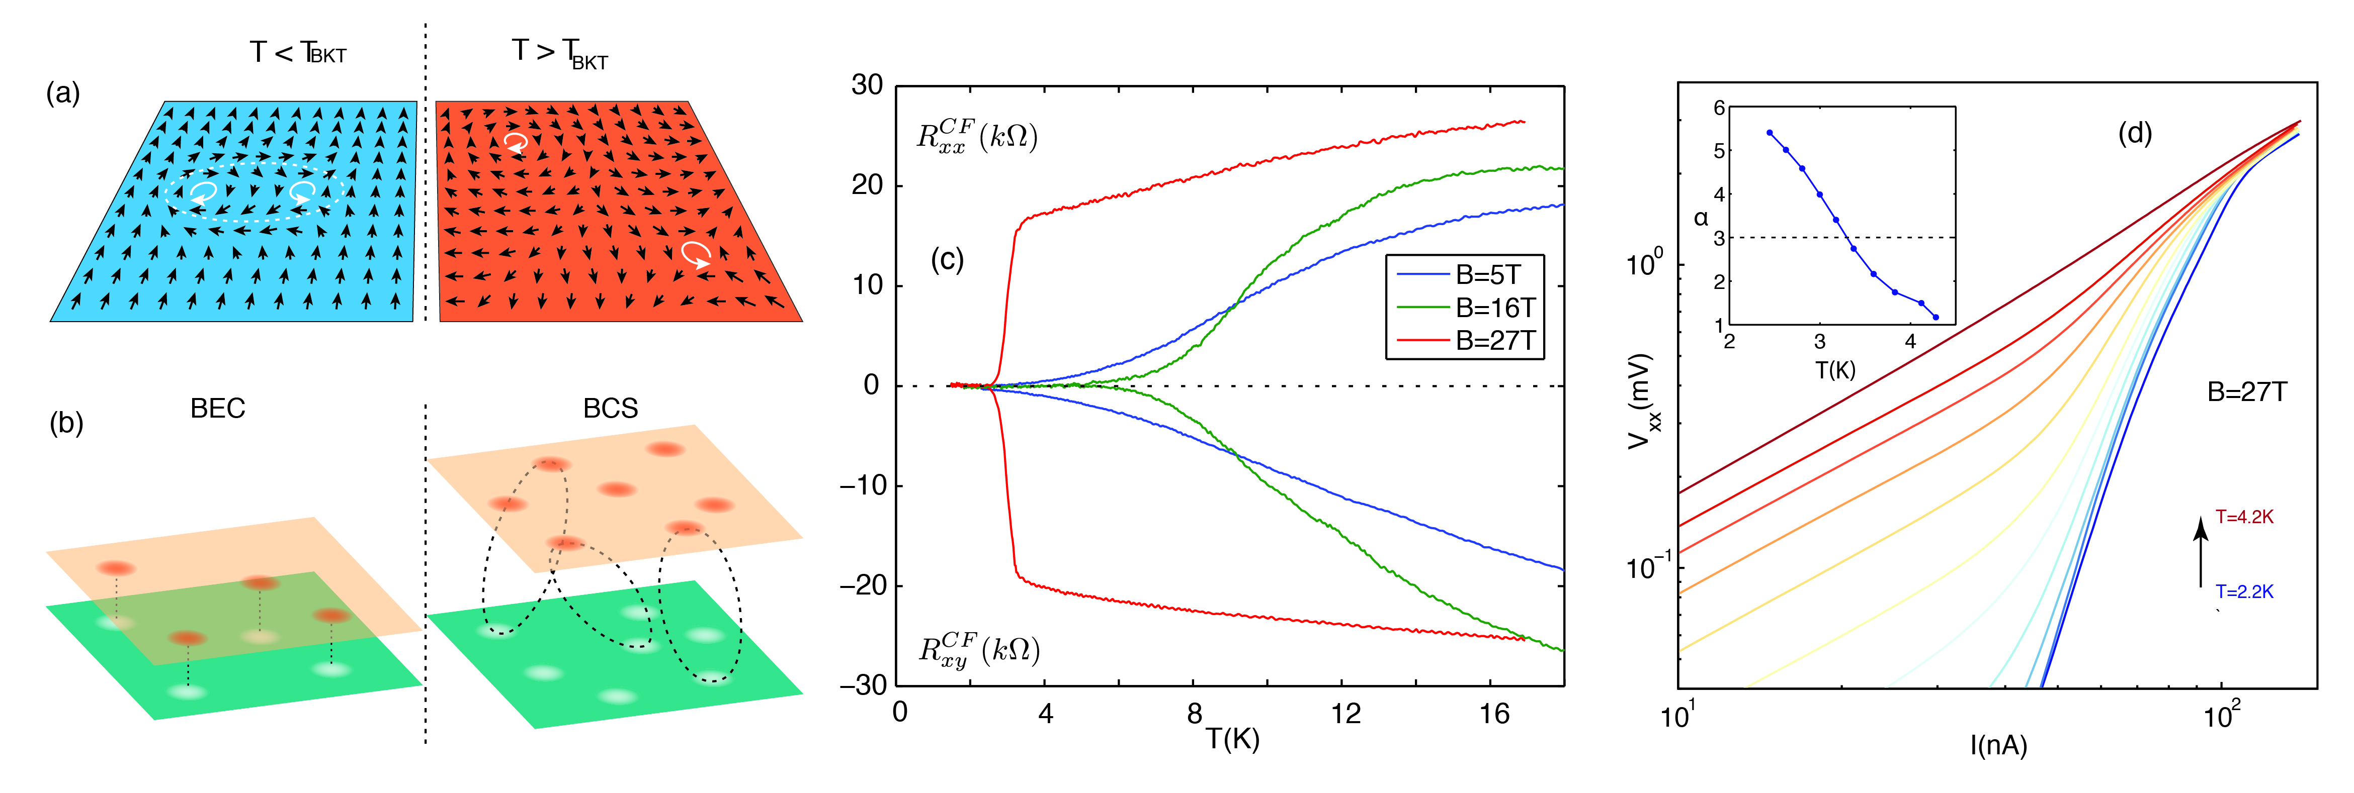
Fig.1 (a) Illustration of BKT transition. (b) Illustration of BEC-BCS crossover. (c) Temperature dependence of counterflow resistance at different magnetic fields. (d) Current (I)- voltage (V) curve in log scale under B=27T. (inset) Power $α$ as a function of temperature under B=27T.
Acknowledgements
A portion of this work was performed at the National High Magnetic Field Laboratory, which is supported by National Science Foundation Cooperative Agreement No. DMR-1157490 and the State of Florida.
The experimental work is supported by DOE (DE-SC0012260). P.K. acknowledges partial support from the Gordon and Betty Moore Foundation's EPiQS Initiative through Grant GBMF4543.

References
[1] Liu, X., et al., Nature Physics, 13, 746-750 (2017).
[2] Li, J.I.A, et al., Nature Physics, 13, 751-755 (2017).

