EPR Study of the Biosynthesis of the MoFe Cofactor of Nitrogenase

Hales, B.J. (Louisiana State U., Chemistry)

Introduction – MoFe cofactor Biosynthesis
Nitrogen fixation, the bioproduction of ammonia from dinitrogen, is one of the most important biological processes on earth. The enzyme, nitrogenase, contains two of the most complex metal clusters seen in Nature, the P-cluster (8Fe7S) and the MoFe cofactor or FeMoco (Mo7Fe9SC-homocitrate), where FeMoco serves as the enzyme’s active site (Fig. 1). Because of its importance and complexity, it is of great interest how FeMoco is biosynthesized. Our lab has available to it all of the enzymes required for the biosynthesis of FeMoco as well as different variant forms. Using the techniques of W-band EPR and ENDOR spectroscopy, we will probe the formation of FeMoco.

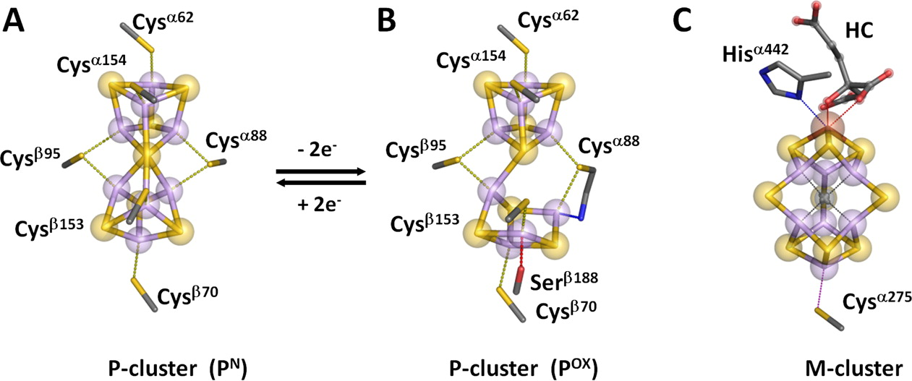
Fig.1 Structure of the P-cluster in the (A) reduced and (B) oxidized states and the M-cluster (FeMoco) (C).

Experimental
NifB is an important enzyme in the biosynthesis of FeMoco. As isolated it contains one [4Fe4S] cluster associated with a radical S-adenosyl methionine (SAM) reaction. To initiate the synthesis of FeMoco, two additional [4Fe4S] clusters are transferred to NifB. Upon addition of SAM, the two added clusters are fused and a carbide is added. This cluster is then transferred to NifEN where Mo and homocitrate are added to complete the synthesis.
The mechanism of this synthesis is, however, unknown. Our lab possesses variant proteins that represent different forms of NifB where each contains one or two of the different [4Fe4S] clusters. Adding SAM to these proteins induces changes in the EPR spectrum associated with the proteins [4Fe4S]⁺ cluster. W-band EPR, ENDOR and ELDOR (using H2 and C13 labeled SAM) data have been recorded on the HiPER and 12.5 T spectrometers at the NHMFL to elucidate the interaction of SAM with the different clusters and the mechanism of the NifB enzyme.

Results and Discussion
W-band EPR and ELDOR spectra were obtained on several of the NifB proteins and revealed some surprising and interesting facts. First, the spectra showed that presence of overlapping signals suggesting more then two paramagnetic FeS clusters. Second, in conjunction with the magnetic circular dichroism (MCD) spectra obtained in the lab of the PI, ELDOR spectra showed the presence of a hydrocarbon interacting with the paramagnetic FeS clusters, possibly a SAM molecule.

Conclusions
The results currently obtained at NHMFL are an important step in the elucidation of the mechanism for the formation of FeMoco. To date this mechanism has been much sought after but little understood.

Acknowledgements
A portion of this work was performed at the National High Magnetic Field Laboratory, which is supported by National Science Foundation Cooperative Agreement No. DMR-1157490 and the State of Florida.

