Structure Determination of β-Amyloid Oligomers and Investigation of Their Formation Pathways

Wi, S. and Wang, X. (NHMFL) and Paravastu, A.K. (Georgia Tech, Chemical and Biomolecular Engineering)

Introduction
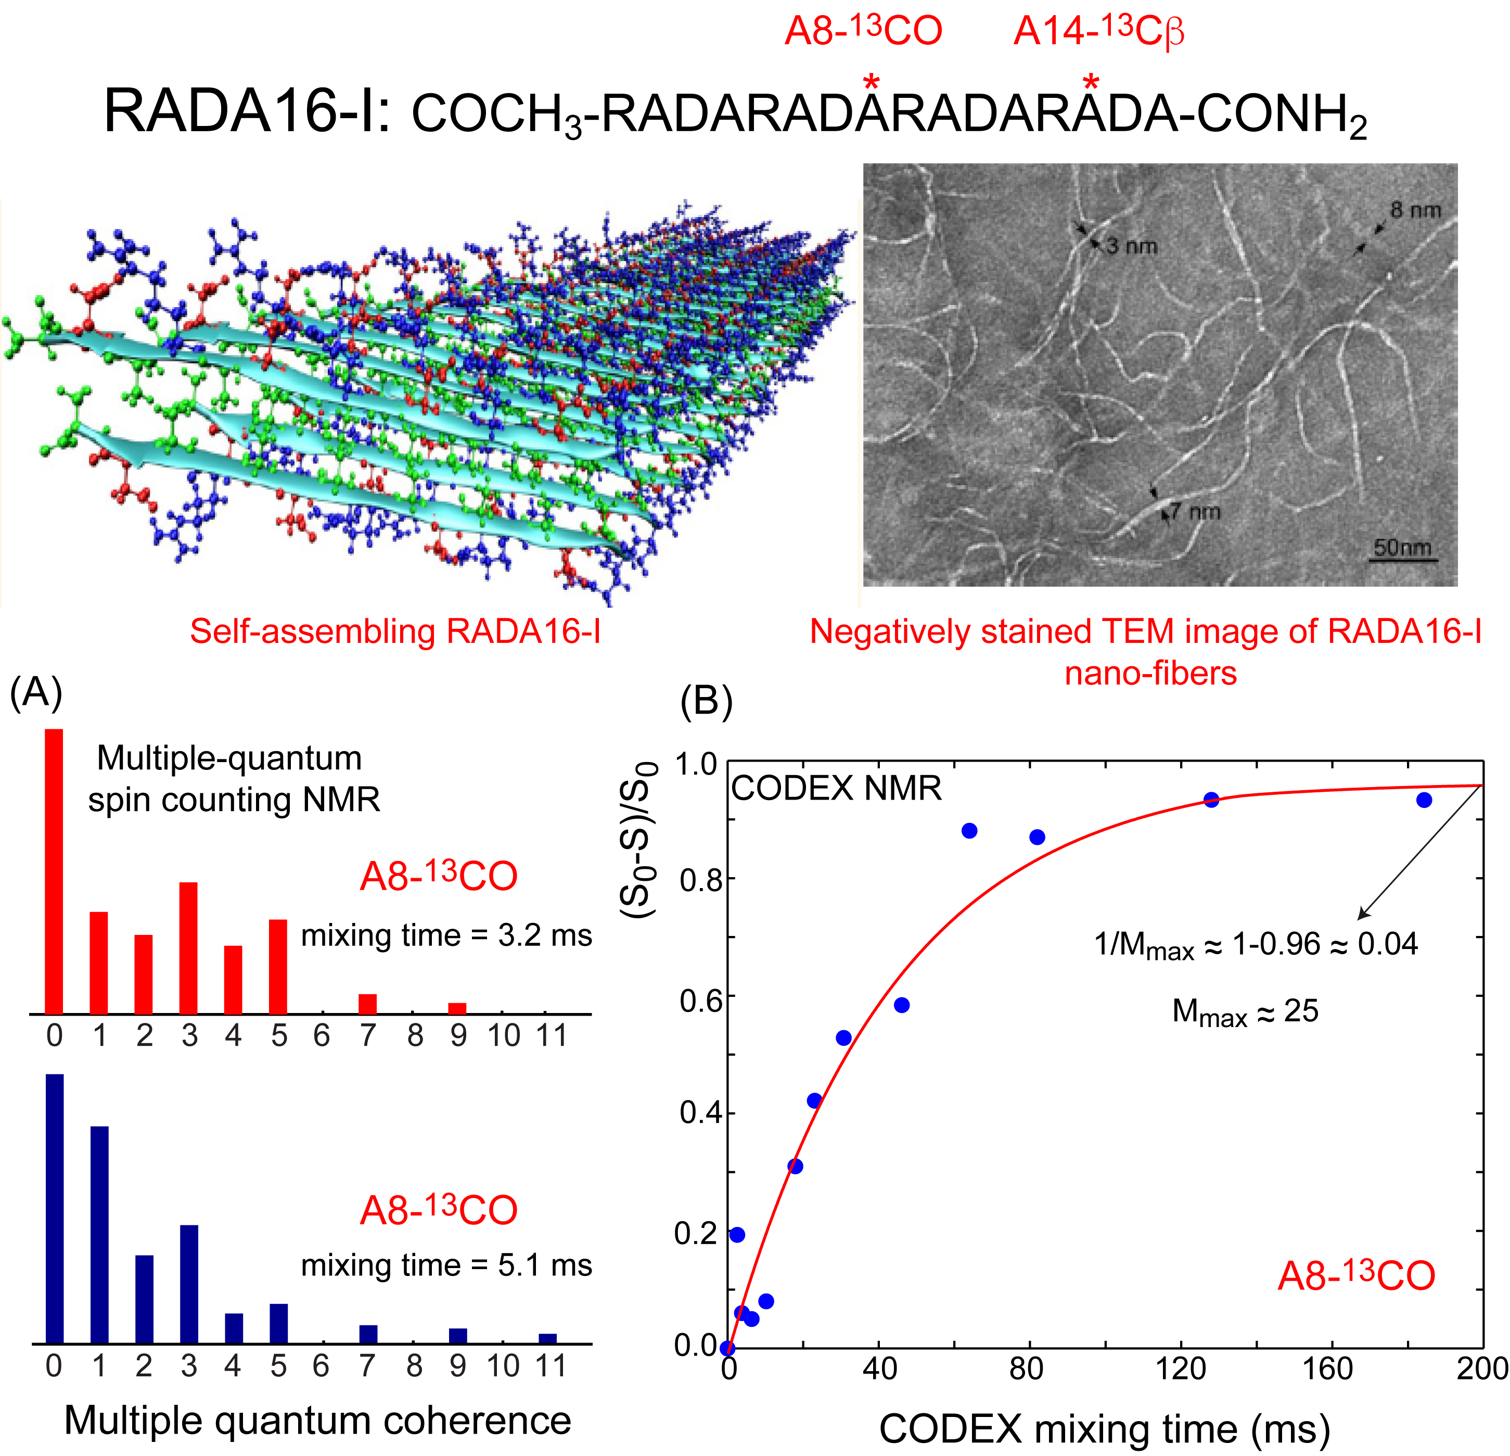
A great promise will be given in the areas of regenerative medicine and three-dimensional cell culture if one understands how peptides self-assemble and utilizes the structures and properties of self-assembled nanofiber matrices in biomedical applications. In addition, research areas of interest that also benefit from this type of knowledge are to understand the aggregation mechanism or process of pathological proteins or peptides that are shared by human diseases, such as diabetes, Parkinson's disease, and Alzheimer's disease. We have utilized solid-state NMR spectroscopic methods to examine as an example the self-assembling structure of [A8-¹³CO, A14-¹³Cβ]-labeled RADA16-1, COCH₃-RADARADARADARADA-CONH₂, a harmless degradation peptide for biomedical applications.^{1,2}
Experimental
We have employed ¹³C-¹³C multiple quantum (MQ)³ and centerband-only detection of exchange (CODEX)⁴ NMR spectroscopy to measure the spin cluster and geometry of multiple ¹³C spin pairs formed in the self-assembled RADA16-1 (Fig. 1). The sample was packed into a 2.5 mm rotor that spun at 25 kHz in a doubly tuned (¹H and ¹³C) Bruker magic-angle spinning (MAS) probe installed at the NHMFL’s wide-bore ¹H 500 MHz (11.7 T) solid-state NMR spectrometer operating with a Bruker Avance III console.
Results and Discussion
The number of ¹³C spin pairs detected from our MQ spin counting method was 11 (both intra- and intermolecular), with a mixing time of 5.1 ms. The maximum number of ¹³C spin pairs involved in an equilibrium state reached by multiple ¹³C-¹³C spin diffusion in the CODEX NMR experiment by employing an extremely long mixing time (> 120 ms) was 25. These results provide new information on the supramolecular structure of self-assembling RADA16-1 that are complementary to the information that had been obtained by a conventional NMR method of measuring multiple ¹³C-¹³C distances in a pairwise manner.⁵ Currently, we are carrying out computer simulation calculations to reproduce these MQ and CODEX spectral data based on some tentatively suggested trial structures of RADA16-1 to fine-tune the previously suggested structure.
Fig.1 Figures shown are the ¹³C-labeled scheme, suggested self-assembling structure, and the negatively stained TEM image of RADA16-1. Graphs shown are ¹³C MQ spin counting and CODEX NMR data obtained.
Conclusions
¹³C MQ spin counting and CODEX solid-state NMR methods are very sensitive on the ¹³C spin clusters formed in self-assembling RADA16-1.
Acknowledgements
This research was supported by NSF DMR-105521 to A.K.P. A portion of this work was performed at the NHMFL, supported by NSF Cooperative Agreement No. DMR-1157490 and the State of Florida.
References
[1] Shastri, V.P., et al., Adv. Mater., 21, 3246-3254 (2009).
[2] Tang, C.K., et al., Int. J. Mol. Sci., 10, 2136-2145 (2009).
[3] Teymoori, G., et al., J. Magn. Reson., 236, 31-40 (2013).
[4] de Azevedo, E.R., et al., J. Am. Chem. Soc., 121, 8411-8412 (1999).
[5] Cormier, A.R., et al., ACS NANO, 7, 7562-7572 (2013).

