NMR structural characterization of Vp-1
Riviere, G.L., Long, J.R. (UF, Biochemistry & Molecular Biology); Burg, M.J., Lakshmanan, R.V. and McKenna, M.A. (UF, Structural Biology)

Introduction
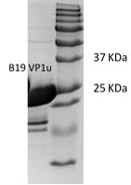
The B19 parvovirus is a small non-enveloped single-stranded DNA virus implicated in the childhood disease erythema infectiosum. The virus enters the cells via cadherin mediated endocytosis and undergoes several conformational changes in its capsid structure as it is trafficked through the endosome to the nucleus for viral replication. The B19 viral capsid is composed of 60 similar capsid proteins, with 95% of the copies identified as VP2 and the rest identified as VP1 protein. The B19 VP1u is the N terminal unique region of VP1 capsid protein. It has been implicated as critical for infectivity of the virus. Several studies have shown that the VP1u protein has PLA2 activity which may aid virus escape from the endosome during trafficking. To date, no data is available on its structure. Efforts to crystallize this protein have failed, and so we are characterizing VP1u using NMR spectroscopy.

Experimental
The B19 VP1u protein was heterologously expressed in BL21 DE3 cells to enable facile isotope enrichment. Purified protein protein samples were pooled and concentrated to make NMR samples at a concentration of 9 mg/mL (Fig 1). NMR data was acquired at 25°C on a Bruker Avance 600 spectrometer with a triple resonance cryo-probe.
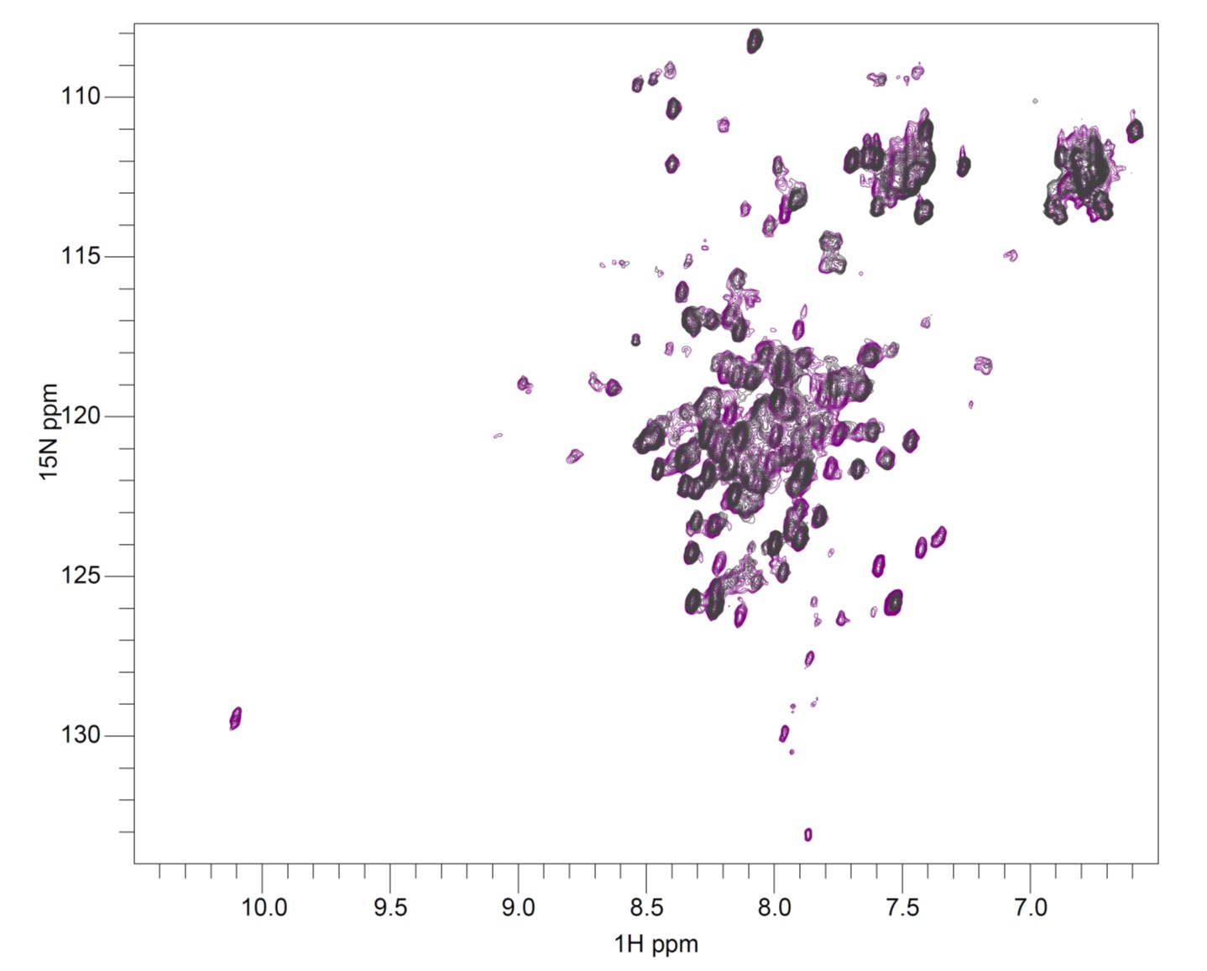
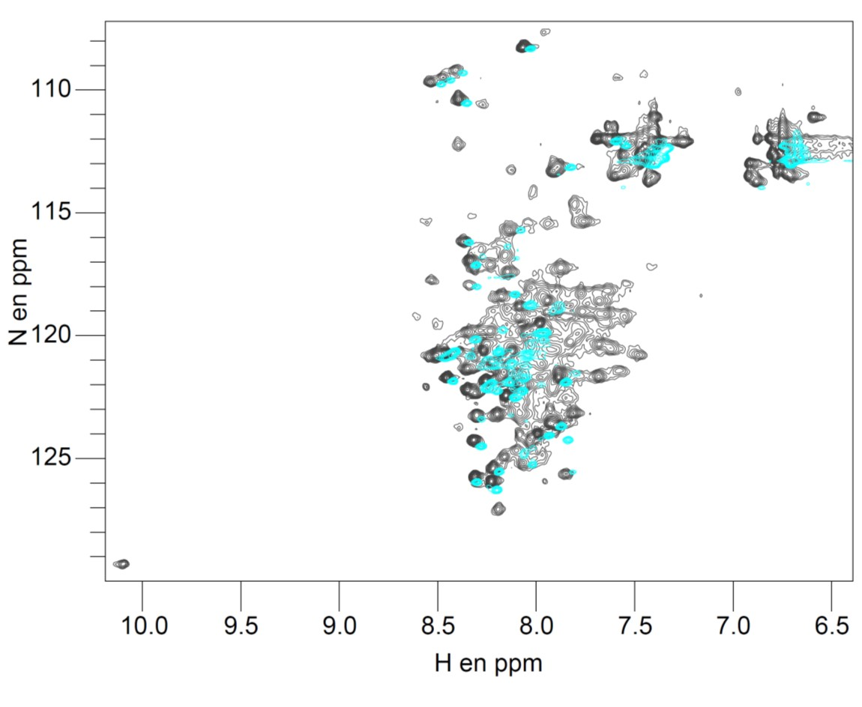
Fig 1: SDS page of purified B19 VP1u.

Fig 2: ¹H-¹⁵N HSQC spectra of Vp1u at 17°C (cyan) and 25°C (black grey).
Fig 3: ¹H-¹⁵N HSQC spectra of Vp1u at one (black grey) and 48 hours (purple) of NMR data acquistion.

Results and Discussion
We recorded two ¹H-¹⁵N-HSQC of the Vp1u protein at different temperature: 17°C and 25°C to assess its stability. At these temperatures, we noticed that Vp1u possesses an unfolded pattern overlaid with resonances suggestive of helical content. This result was confirmed by circular dichroism data, which indicates Vp1u is ~ 50% helical. At 25°C, we observed more peaks and better resolution (Fig 2). 3D assignment experiments were also recorded at 25°C, but Vp1u proteolytically degrades with time. At 48 Hours the ¹H-¹⁵N HSQC of VP1u presents some additional narrow peaks, suggesting the degradation of Vp1u (Fig 3). To avoid the Vp1u degradation we have identified conditions extending the stability of Vp1u for future NMR experiments.

Conclusions
Vp1u is a small protein of 28.75 kDa but has high helical content, which complicates its assignment. However, several NMR tools can be used to obtain structural information on Vp1u, including obtaining NMR at higher magnetic field. Future experiments at 800 MHz are planned.

Acknowledgements
A portion of this work was performed at the National High Magnetic Field Laboratory, which is supported by National Science Foundation Cooperative Agreement No. DMR-1157490 and the State of Florida.

