Interaction of HIV gp41 with the Viral Membrane Studied by EPR

Song, L. (NHMFL, FSU Biology and Physics); Hayati, Z., Liu, M. (NHMFL and FSU Physics); Dalzini, A. (NHMFL); Kim, M. and Reinherz, E.L. (Dana-Farber Cancer Institute, Boston)

Introduction
HIV enters human T cells through the fusion of viral and host-cell membranes. This fusion process is mediated by a surface protein, gp41, and the platform provided by the cholesterol-rich viral membrane. The membrane-bound region of gp41 plays critical roles in this fusion process and is a major target of anti-gp41 antibodies and vaccine design. Here, EPR and spin-labeling techniques were used to dissect the interactions between the viral membrane and the membrane-bound region of gp41, including the membrane proximal ectodomain region (MPER) and the transmembrane domain (TM).

Experimental
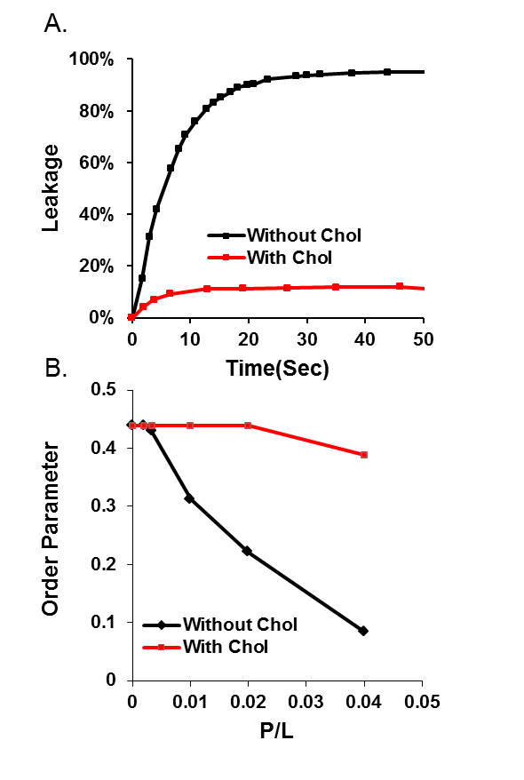
EPR spectra were collected on the Bruker E680 and HiPER spectrometers at the NHMFL. Liposomes with two different lipid compositions (phospholipids with and without 40% cholesterol) were prepared using the extrusion method. Bicelles were prepared using a standard method including hydration, sonication, and freeze-thaw cycles. To study membrane orientational disorder and permeability changes, 5-stearic acid spin label (5-SASL), 4-phosphonooxy-TEMPO (4-PT) and Vitamin C (VC) were used. A 4-PT/VC quenching assay was performed to determine membrane permeability. The quenching of 4-PT signal by VC was used to determine membrane leakage after MPER binding.

Results and Discussion
EPR spectra and the 4-PT/VC quenching assay were used to determine membrane permeability changes of liposomes after binding to the MPER. The spectral comparison in Fig.1 A) shows that the MPER induces significant leakage or membrane permeability changes for liposomes without cholesterol. For liposomes with 45% cholesterol, there is no significant membrane leakage. In contrast, in the case of the MPER/TM (data not shown), we observed large permeability changes for liposomes with 45% cholesterol upon peptide binding, which suggests that the transmembrane domain plays an important role in gp41 interaction with cholesterol-containing HIV membranes. To get insight into how the MPER perturbs lipid chain order, EPR spectra were collected on membrane-mimetic bicelles aligned in the magnetic field. The data indicate that the MPER can only disrupt lipid orientational order of bicelles without cholesterol. The bicelle results are consistent with the permeability data.
Fig.1 A) MPER-induced permeability changes of liposomes with and without cholesterol; B) Orientational disorder of bicelles in the presence of the MPER with different peptide to lipid ratios (P/L).

Conclusions
The analyses revealed that the MPER exerts its fusogenic activity by perturbing membrane properties and by inducing significant lipid fluidity (data not shown) and membrane permeability changes. The MPER also progressively decreases the orientational order of lipid acyl chains in magnetically aligned bicelles. Additionally, the MPER-induced membrane property changes are modulated by cholesterol content. These findings suggest that the membrane-bound region of gp41 facilitates HIV infection through its interaction with the cholesterol-rich viral membrane.

Acknowledgements
A portion of this work was performed at the NHMFL, which is supported by National Science Foundation (DMR-1157490) and the State of Florida. E.L. acknowledges the support of NIH grant AI126901 and L.S. acknowledges the support from NIH grant AI22860.

