Mechanism of Yeast N-glycosylation:
Structural Characterization of Ost4p and its Mutant
Chaudhary, B. and Mohanty, S. (Oklahoma State U., Chemistry)

Introduction
The co-translational transfer of a high mannose oligosaccharide group to the side chain of an asparagine in Asn-X-Thr/Ser (X≠ Pro ) sequon in nascent polypeptide is referred as N-linked glycosylation. Genetic defects in N-linked glycosylation in humans lead to a series of diseases, which includes but not limited to mental retardation, developmental delay, hypoglycemia, lever dysfunction etc., known as congenital disorders of glycosylation (CDG) (1). The enzyme responsible for catalyzing the N-glycosylation process is membrane-bound Oligosachharyl transferase (OST) (2). In yeast, eight of the nine non-identical membrane proteins forms OST complex. Three subunits, Stt3p, Ost4p and Ost3p form a sub-complex (3) with Ost4p serving as a bridge (4). We are trying to solve the 3D structure of Ost4p in detergent micelles and in bilayer to compare and contrast to the structure determined previously in mixed organic solvents (5).
Experimental
We expressed and purified ¹³C,¹⁵N labeled wild type Ost4p and reconstituted in 100 mM DPC micelle for collecting NMR data. We also expressed, purified and reconstituted Ost4pV23D mutant in 100 mM PDC. We collected ¹⁵N HSQC, 3D NOESY-HSQC and 3D TOCSY-HSQC on Ost4p and all 3D experiments for both backbone, side chain and NOESY of Ost4V23D at NHMFL. Sequential resonance assignments achieved for Os4p is shown below. Assignments for Ost4V23D is not shown here. Structure calculation for Ost4p is currently in progress.
Results and Discussion
The ¹⁵N HSQC (Figure 1) of Ost4p in 100 mM DPC micelle shows well-dispersed peaks suggesting that the protein has a well-folded structure under the experimental conditions. The 3D TOCSY-HSQC data ( Figure 2) was used to assign the side chain resonances and 3D NOESY-HSQC (Figure 3) was very useful for both resonance assignments and for providing distance constrains for 3D structure calculation, which is in progress.
Conclusions
The NMR data collected at NHMFL 800 MHz spectrometer helped to carry out the assignment of the integral membrane protein,Ost4p, a subunit of yeast OST.
Acknowledgements
A portion of this work was performed at the National High Magnetic Field Laboratory, which is supported by National Science Foundation Cooperative Agreement No. DMR-1157490 and the State of Florida.
References
[1] Westphal, V., et al., Hum Mutat., 22, 420–421 (2003).
[2] Knauer, R., et al., Biochim Biophys Acta., 1426, 259–273 (1999).
[3] Karaoglu, D., et al., J Biol Chem., 272, 32513–32520 (1997).
[4] Kim, H., et al., Proc Natl Acad Sci USA, 100, 7460–7464 (2003).
[5] Zubkov, S., et al., Proc Natl Acad Sci USA., 101, 3821–3826 (2004).
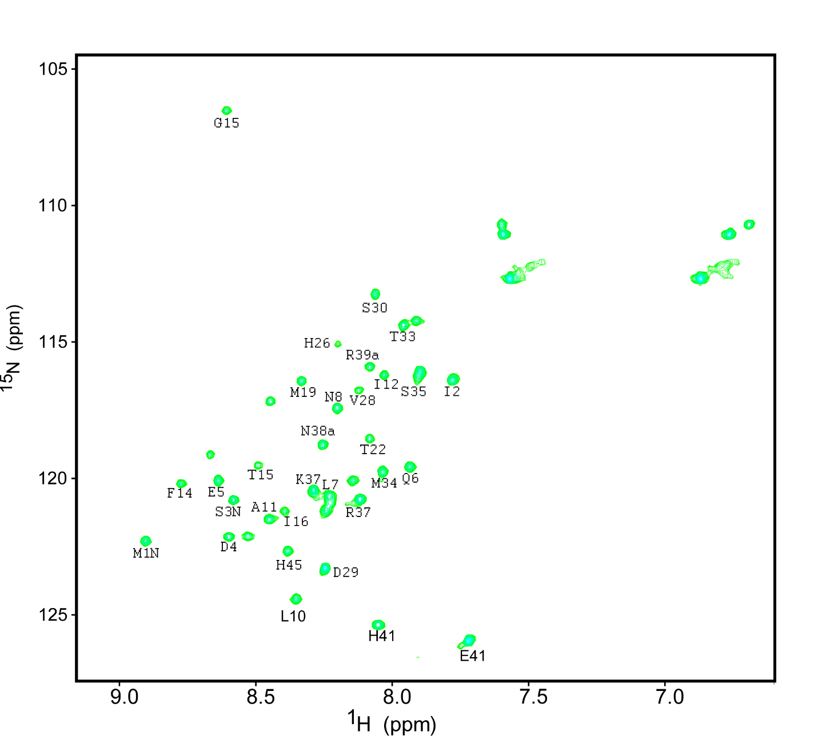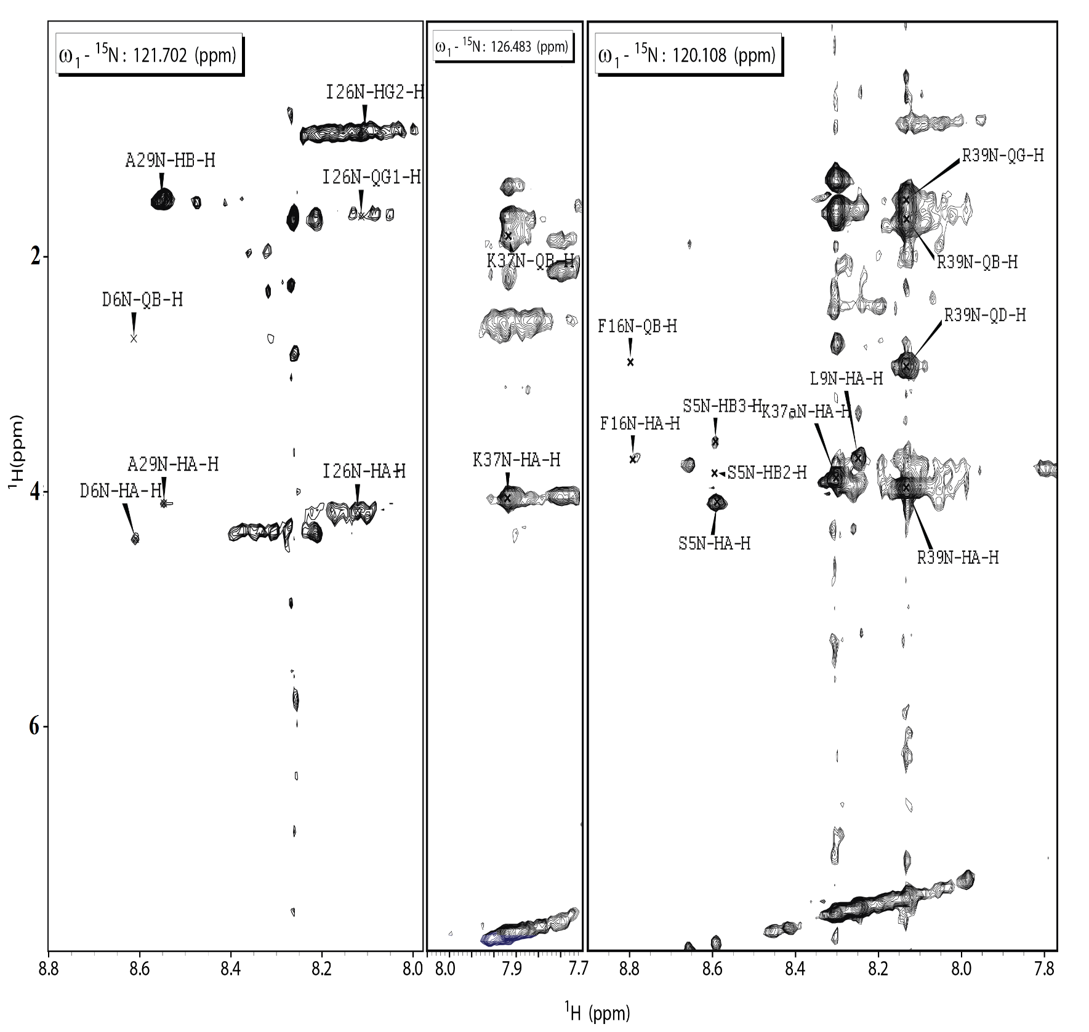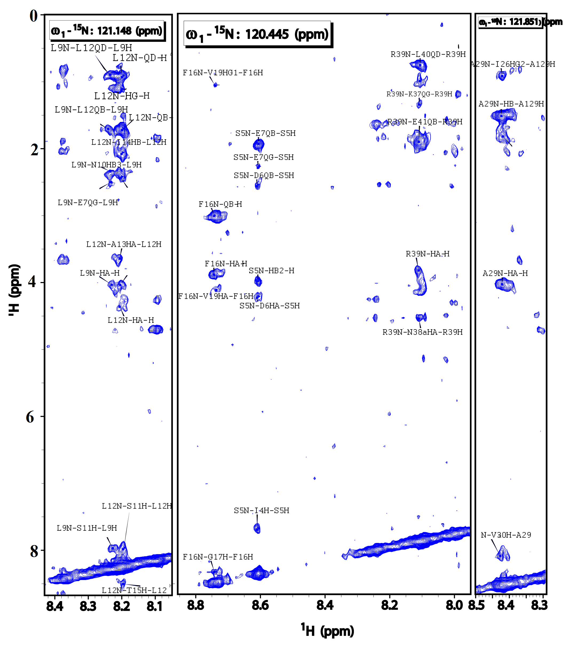 Figure 1: 15N HSQC of Ost4 Figure 2: 3DTOCSY HSQC stripes Figure 3:3D NOESY HSQC plot

