Lipid Interdigitation Promotes Thermal Stabilization Of Lipid Polymorphisms Induced By Surfactant Peptide B₁₋₂₅

Tran, N. (UF, Chemistry); Long, J.R. (UF, Biochemistry and Molecular Biology)

Introduction
PS is a lipid protein mixture that coats the inner lining of the alveoli and reduces the work needed to ventilate the alveoli and prevent alveolar collapse. Mammalian PS contains a highly conserved lipid composition, possessing evolutionarily optimized properties. With nearly 40 wt% of PS composed of a disaturated phospholipid, dipalmitoylphosphatidylcholine (DPPC), surface tension reduction to near 0 nM/m is achieved with DPPC enrichment at the alveolar air-water interface. Of the four surfactant proteins, SP-B is the only one capable of facilitating surface tension reduction and consequently is the only one required for survival. With the first 25 residues (SP-B₁₋₂₅) shown to recapture activity of full length SP-B, understanding the function of the highly conserved N-terminus has direct applications for advancing current PS replacement therapies. ²H and ³¹P NMR studies from our lab have shown the first direct evidence of surfactant protein B₁₋₂₅ (SP-B₁₋₂₅) inducing non-lamellar lipid morphologies in pulmonary surfactant (PS) lipid mimetic systems. Our results elucidate how SP-B₁₋₂₅ may promote PS lipid adsorption to the alveolar air-water interface, an essential requirement for proper lung compliance.

Experimental
²H and ³¹P NMR spectra were collected from -20-50 °C on a 500 MHz Bruker Avance III spectrometer. ²H spectra were collected using a quadrupolar echo pulse sequence with a 30 echo time and a ²H B₁ field of 38 kHz. ³¹P spectra were collected using 23 kHz proton decoupling and a ³¹P B₁ field of 15.6 kHz. ³¹P T₂ relaxation times were determined using a Hahn echo sequence with 23 kHz ¹H decoupling and echo delays () from 50 -70 ms.
Results and Discussion
We observed peptide-induced isotropic lipid phase behavior in hydrated assemblies of 4:1 DPPC/POPG, reflecting dynamic processes involved in lipid trafficking within the aqueous alveolar sub phase. ³¹P T₂ relaxation times confirm the isotropic phase to be consistent with a lipid cubic phase, illustrating the role of SP-B₁₋₂₅ in promoting an architectural framework for rapid lipid transit between lipid lamellae. The appearance and thermal stability of the lipid cubic phase was found to be highly dependent on the thermal cycling of peptide/lipid mixtures. Rapid heating of frozen samples to room temperature lead to coexistence of a cubic and interdigitated lipid phase that is isolated to DPPC lipids. Interestingly, this interdigitated lipid phase exhibits both thermal stability up to physiologic temperature (37 °C) and hysteretic phase behavior, consistent with formation of a DPPC ripple phase.

Conclusions
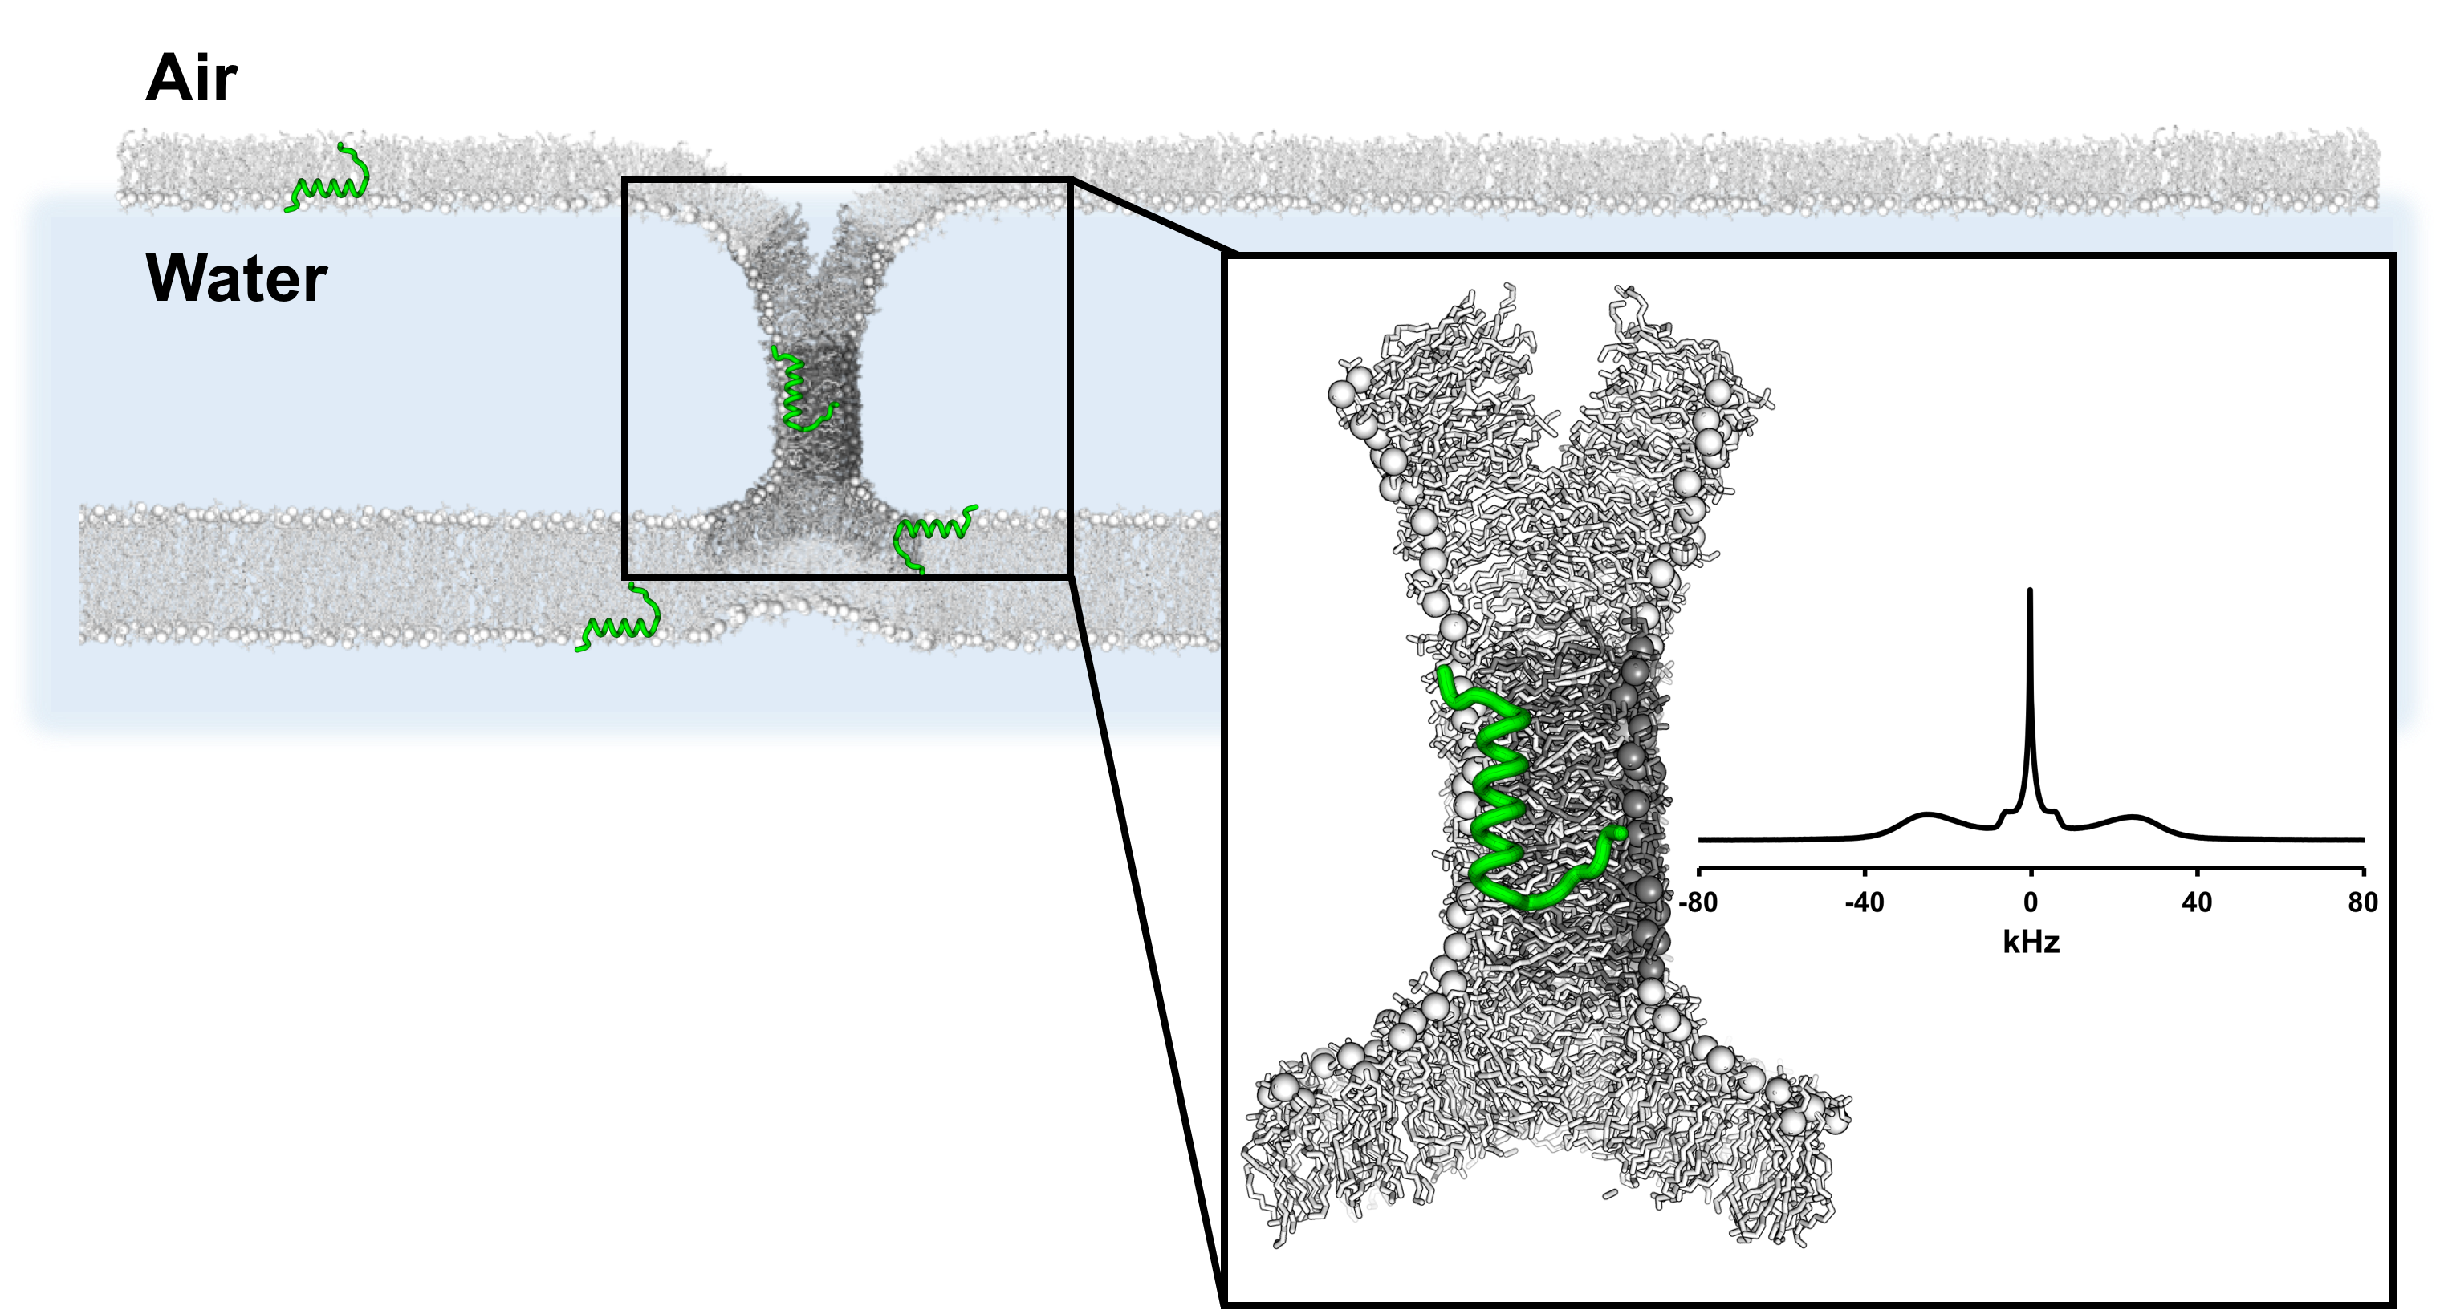
We propose a unique role for DPPC in stabilizing energetics of SP-B₁₋₂₅ induced lipid polymorphisms, given its preponderance in native mammalian PS. This study highlights the complex thermal phase behavior of lipids in PS model systems, providing a unique perspective for potential improvement of current clinical preparations and instillation of PS replacement therapeutics.
Fig.1 Model of SP-B₁₋₂₅ induced lipid trafficking from the alveolar aqueous sub phase to air-water interface. (box) Deuterium NMR spectra of 4:1 DPPC-d₆₂/POPG containing 5 mol% SP-B₁₋₂₅ at 37 °C. DPPC is shown to adopt a cubic and interdigitated lipid phase [1].

Acknowledgements
A portion of this work was performed at the National High Magnetic Field Laboratory, which is supported by National Science Foundation Cooperative Agreement No. DMR-1157490 and the State of Florida.

References
[1] Tran, M.Y., et al., J.Phys.Chm.B, 121, 9102-9112 (2017).

