Assessing Murine Cardiac Metabolism Using a 10 mm, ¹³C Optimized Cryoprobe

Ragavan, M., Tsarova, T., Prieto, F. (UF Biochemistry); Merritt, M. (UF Biochemistry and NHMFL)

Introduction
Heart failure is characterized by a profound shift in energy metabolism. The normal myocardium preferentially consumes fatty acids, with only 20 to 30 % of oxidative metabolism being supplied by glucose. Overpressure of the heart, either from high blood pressure or stenosis, causes myocardial hypertrophy and a switch to carbohydrate oxidation¹. Whether the switch in substrate preference is directly causal of hypertrophy, or a byproduct of it remains debated². We have previously measured the ability of propionate to modulate carbohydrate oxidation in the murine heart using hyperpolarized (HP) pyruvate³ and in experiments directly assessing glucose oxidation⁴. Here we detail initial experiments using the same tracer methods in the hypertrophic heart.
Experimental
Mouse hearts (healthy or failing) were excised and aorta was cannulated. The hearts were perfused in langendorff mode (with or without propionate) in an NMR magnet with a field strength of 14.1 T equipped with a 10 mm Bruker cryoprobe (AMRIS, UF, Gainesville). Shimming the magnet was accomplished using ²³Na signal from the heart. After 30 minutes of perfusion, hyperpolarized [1 – ¹³C]pyruvic acid was injected into the heart and ¹³C NMR spectra was recorded with a repetition time of 4s using 15° radiofrequency pulses.

Results and Discussion
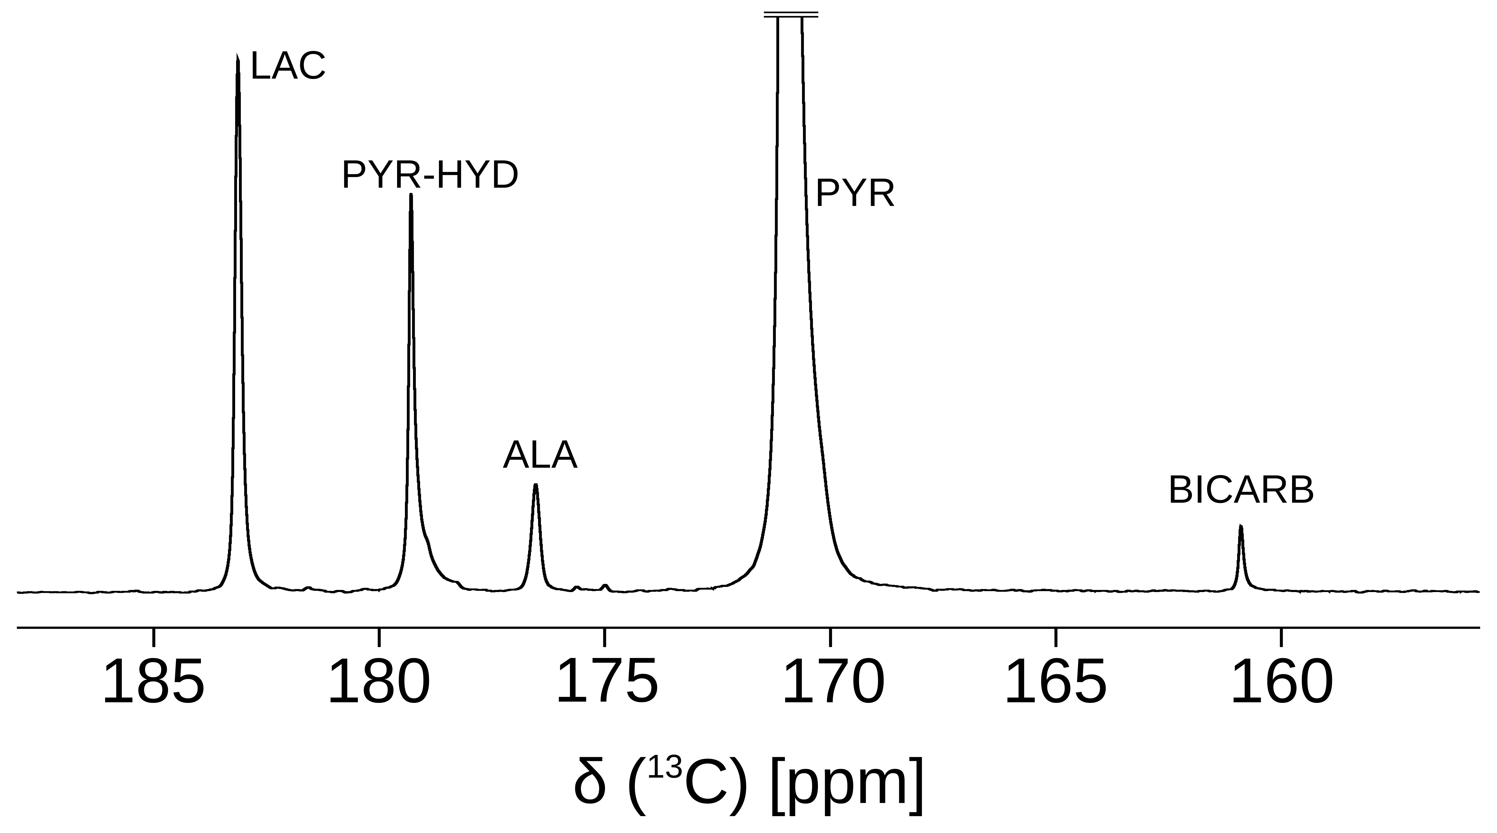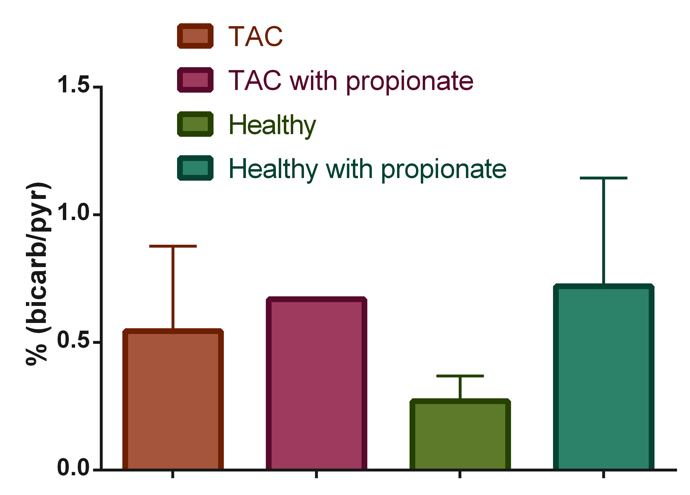
Fig.1 (left) Sum of 49 ¹³C NMR spectra recorded subsequent to the injection of HP [1 – ¹³C] pyruvic acid showing metabolic activity of the heart. (right) Ratio of bicarbonate to pyruvate in perfused healthy and failing (TAC) hearts in the presence and absence of propionate.
The Oxford HyperSense instrument readily produces signal enhancements of ~20000 fold for pyruvic acid, as measured by dissolution and measurement at room temperature and 14.1 T. Injection of the HP pyruvate into the functioning heart results in its rapid metabolism by exchange reactions with lactate and alanine as well as flux through pyruvate dehydrogenase to produce bicarbonate. The 10 mm cryoprobe supported by the MagLab provides an additional 4x gain in SNR for the measurements (Figure 1, Left). Pyruvate oxidation is increased in the hypertrophic heart (Figure 1, right).
Conclusions
The 10 mm cryoprobe paired with the HyperSense allow substrate selection to be measured in a straightforward manner in the perfused mouse heart.
Acknowledgements
A portion of this work was performed at the National High Magnetic Field Laboratory, which is supported by National Science Foundation Cooperative Agreement No. DMR-1157490 and the State of Florida. Additonal support was provided through Dr. Merritt’s startup package.
References
1 Huss JM, Kelly DP. Mitochondrial energy metabolism in heart failure: a question of balance. J Clin Invest 2005;115:547–55. https://doi.org/10.1172/JCI24405.
2 Dirkx E, da Costa Martins PA, De Windt LJ. Regulation of fetal gene expression in heart failure. Biochim Biophys Acta BBA - Mol Basis Dis 2013;1832:2414–24. https://doi.org/10.1016/j.bbadis.2013.07.023.
3 Purmal C, Kucejova B, Sherry AD, Burgess SC, Malloy CR, Merritt ME. Propionate stimulates pyruvate oxidation in the presence of acetate. Am J Physiol - Heart Circ Physiol 2014;307:H1134–41. https://doi.org/10.1152/ajpheart.00407.2014.
4 Ragavan M, Kirpich A, Fu X, Burgess SC, McIntyre LM, Merritt ME. A comprehensive analysis of myocardial substrate preference emphasizes the need for a synchronized fluxomic/metabolomic research design. Am J Physiol - Heart Circ Physiol 2017;312:H1215–23. https://doi.org/10.1152/ajpheart.00016.2017.

