Protein-Protein Interactions Involved in the Assembly of Bacterial Nanoinjectors Defined by EPR Spectroscopy

De Guzman, R.N. (U. of Kansas, Molecular Biosciences); Kaur, P., Hayati, Z. and Song, L. (FSU Biology and Physics, NHMFL)

Introduction
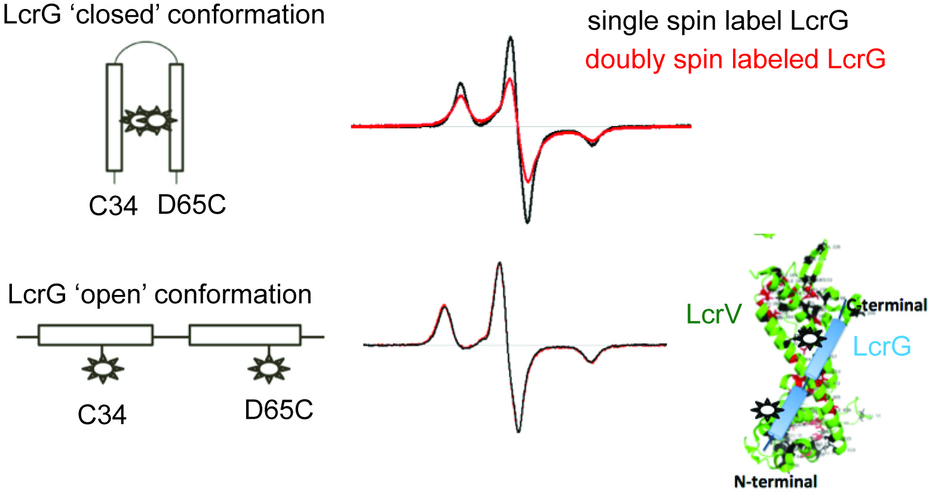

Fig.2 Models of (A) ‘open’ and (B) ‘closed’ conformations of doubly spin-labeled LcrG. EPR data (C) suggest a population of LcrG in ‘closed’ conformation.
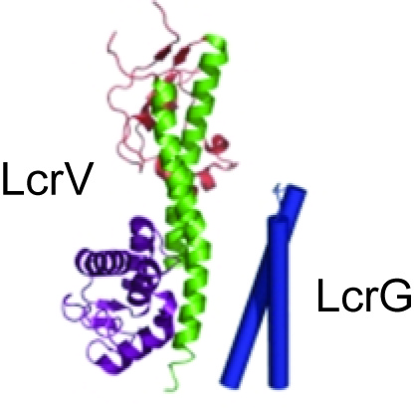
Fig.1 LcrG is expected to bind to LcrV in a closed conformation (image from ref. 1).
The goal of this project is to use EPR to determine the protein-protein interactions of two proteins from Yersinia pestis: LcrV and LcrG. These proteins are essential in the pathogenesis of Yersinia pestis, the causative agent of bubonic plague. Contrary to what was expected for LcrG – that it forms a coiled coil, our NMR results indicated that LcrG lacks a tertiary structure and consists only of secondary alpha helical structures [1]. However, the current hypothesis in the literature is that LcrG forms a coiled coil upon binding to LcrV (Fig.1) [2]. Our NMR analysis could not identify if the two helices are in close contact with each other [1], hence, we are using EPR.

Experimental
Site-directed cysteine mutants of LcrG recombinant proteins were expressed and purified following published methods [1]. MTSL spin labels were attached to the LcrG proteins following published protocols [3]. EPR experiments have been carried out at the NHMFL using a Bruker E680 spectrometer and the HiPER spectrometer. In 2016, we extended our studies from the Yersinia LcrG to the Pseudomonas PcrG protein. In 2017, we extended our EPR studies in identifying how LcrG interacts with LcrV.

Results and Discussion
Our preliminary EPR data of two spin labeled sites at C34 and D65C suggest that LcrG samples a 'closed' conformation (Fig.2). The EPR results show that spin labels at C34 and D65C are in close proximity to each other (Fig.2). In 2017, we were able to use EPR to determine how LcrG interacts with LcrV. Our preliminary EPR results suggest a model where LcrG adopts an 'open' conformation – where the two helices are not in close proximity with each other – when bound to LcrV (Fig.2).

Conclusions
The EPR model of LcrG-LcrV interaction will upend the current hypothesis in the literature (Fig.1) that assumes a 'closed' conformation for LcrG when bound to LcrV.

Acknowledgements
A portion of this work was performed at the National High Magnetic Field Laboratory, which is supported by National Science Foundation Cooperative Agreement No. DMR-1157490 and the State of Florida. This work is also supported by NIH grant AI074856 (R.N.D.).

References
[1] Chaudhury, S., et al., J. Mol. Biol. 427, 3096-3109 (2015).
[2] Blocker, A.J., et al., Proc. Natl. Acad. Sci. USA, 105, 6507-6513 (2008).
[3] Rathinavelan, T., et al., J. Mol. Biol., 426, 2958-2969 (2014).

