Conformations of DNA and Protein-DNA Complex Studied Using HiPER

Qin, P.Z. (U. of Southern California, Chemistry)

Introduction
Our work in connection with the National High Magnetic Field Laboratory centers on using the advance capability of the high power quasi-optical W-band EPR spectrometer (HiPER) to study conformations of nucleic acids and protein-nucleic acid complexes. CRISPR-Cas9 is an RNA-guided nuclease that cleave double-stranded DNAs at defined sequences. One of the key steps in Cas9 recognition of DNA is to unwind the double-helix to form a three-stranded R-loop structure. Using a unique spin-labeling strategy developed in my lab, we were able to measure distances in DNA as it interacts with Cas9. Using this method, we demonstrated direct detection of Cas9-mediated DNA unwinding.¹ Our results support a model in which the unwound non-target strand is stabilized by a positively-charged patch located between the two nuclease domains of Cas9, and reveal uneven increases in flexibility along the unwound non-target strand upon scissions of the DNA backbone.

Experimental
We have used HiPER to obtain distance measurements in a CRISPR-Cas9 protein-DNA-RNA complex and in a G4C2 DNA repeat sequence that has been linked to the pathogenesis of amyotrophic lateral sclerosis (ALS). Leveraging on high sensitivity of HiPER, we were able to measured distances using sample concentrations that are 100 times lower than that required on the standard EPR spectrometer in our own lab. The data allowed us to obtain information on these systems that is otherwise unavailable.
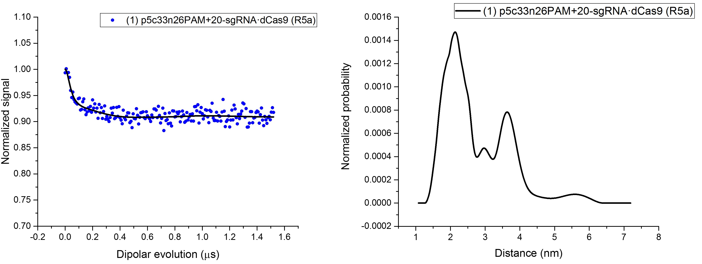
Fig.1 HiPER data on a Cas9-RNA-DNA complex.

Results and Discussion
We have now obtained preliminary HiPER data on the Cas9 complex. Using HiPER, we measured a distance in a spin-labeled Cas9 complex at a concentration of 20 uM, 10 times lower than what we used for the X-band measurement (Fig.1). The HiPER data gave a similar distance distribution profile as that obtained from the X-band measurement. The results established the procedure for studying Cas9 complexes using HiPER. Work is on-going to investigate an engineered variant of Cas9 that shows much enhanced target specificity. In a second project, we used HiPER to measure distances in a G4C2G4 DNA sequence, and used the data to derive the conformation of the folded DNA. Studies indicate that (G4C2)n repeats form a 4-strand quadruplex structure, in which tetrads of 4 guanines stacked on top of each other. One hypothesis states that G4C2 quadruplex presents conformations that are very different from a normal DNA duplex, which may lead to abnormal interactions with proteins and ultimately give rise to ALS. As a first step, we are investigating the simplest repeat unit, G4C2G4 (designated as “GCG”). Our biochemical characterization, together with available information in the literature, showed that at concentration below 5 uM, GCG predominately forms a two-stranded G-quadruplex. As the DNA concentration increases, additional multi-strand species became dominating. This presented a challenge for X-band EPR distance measurements, which required DNA concentration at 100 uM. In collaboration with Dr. Likai Song at the Maglab, we were able to obtain distance measurements on the GCG DNA with 2-uM spin-labeled samples. Using these measured distances as constraints and a set of new modeling methods developed in our group, we were able to definitively show that the 2-strand GCG quadruplex adopts a parallel conformation with three G-tetrad stacked on top of each other.

Acknowledgements
A portion of this work was performed at the National High Magnetic Field Laboratory, which is supported by National Science Foundation Cooperative Agreement No. DMR-1157490 and the State of Florida.

References
[1] Tangprasertchai, N.S., et.al., ACS Chem. Biol., 12, 1489-1493.

