Interactions of Protein Aggregates with Lipid Membranes Defined by Multi-Frequency EPR

Dalzini, A., Song, L. (FSU, NHMFL); Pan, J. (U of South Florida, Physics)

Introduction
Accumulation of the pathogenic form of Prion protein (PrP) is linked to the diseases known as transmissible spongiform encephalopathies. It has been shown that a specific segment of this protein, spanning residues 106-126 (PrP106-126), is particularly resistant to enzyme degradation and conserves the toxic effect of the full PrP. Although the amphipathic nature of PrP106-126 structure suggests that this peptide is prone to strongly interact with membranes, more information is needed to define peptide’s morphology; moreover, the specific mechanism through which PrP106-126 exerts its cytotoxic activity remains unclear. We combined AFM, Raman and EPR techniques to further reveal details on PrP106-126 interaction with model membranes of different compositions [1] .

Experimental
EPR experiments were conducted using a Bruker E680 spectrometer in X-band (9.5 GHz) and a HiPER spectrometer in W-band (95 GHz) at the NHMFL. Lipid bicelles and lipid vesicles with different lipid compositions, with 1% mol of 5-doxyl stearic acid spin label (5-SASL), are prepared in buffers with varied pH values. PrP was added to the lipids at increasing peptide/lipid (P/L) ratios. Lipid/Peptide mixtures are loaded into glass capillary tubes. Spectra are collected at room temperature for lipid vesicles and 308K for lipid bicelles.
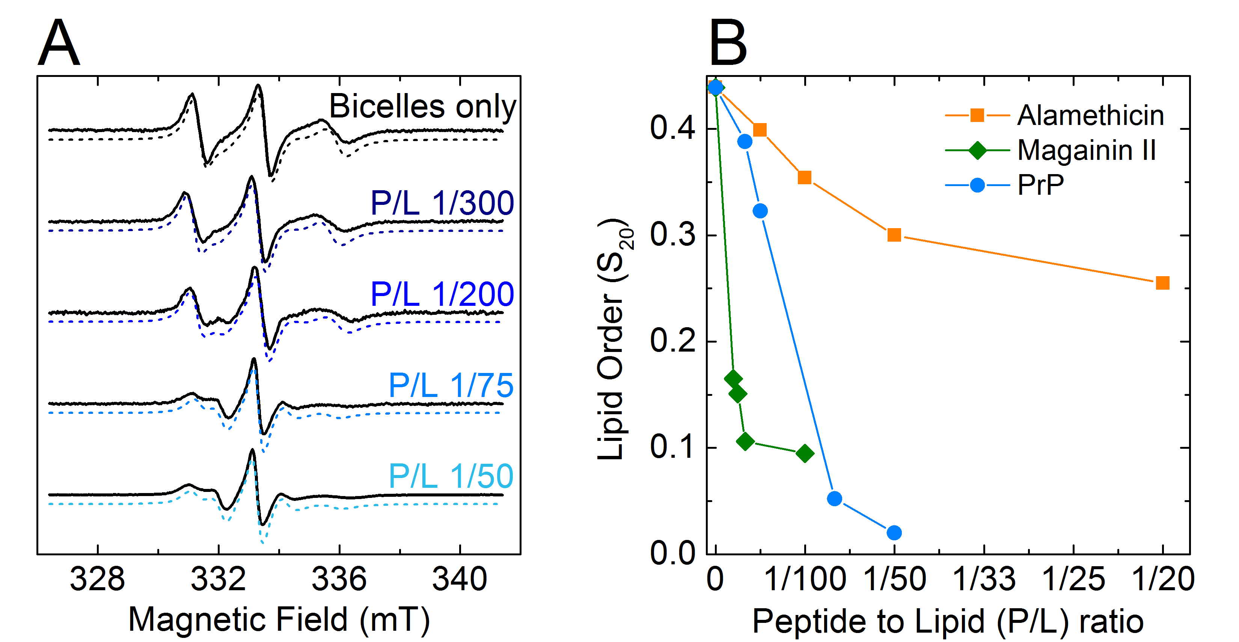

Fig.1. Lipid order analysis of EPR spectra. (A) Experimental (solid lines) and simulated (dashed lines) EPR spectra of DMPC/DHPC bicelles containing the spin label 5-SASL. The bilayer normal of the bicelles is aligned parallel to the magnetic field at 308 K. (B) Plot of the orientational order parameter S₂₀ as a function of the P/L ratio. For comparison, the reported values for alamethicin and magainin 2 are also displayed.
Results and Discussion
PrP showed a limited influence on the mobility of lipid vesicles of different composition. The highest fluidity change occurs when high quantities of PrP interact with negatively charged membranes (PE/PG) [see previous report]. The overall lipid disordering induced by Prp has been tested with DMPC/DHPC bicelles with increasing quantity of the PrP peptide. The data have been then simulated to obtain the lipid order parameter S₂₀. Fig.1 (A) shows the experimental and simulated spectra. Fig.1 (B) shows the lipid order parameter S₂₀ calculated for PrP at increasing P/L ratios compared to that of model peptides Alamethicin and Magainin II. Next, we plan to determine peptide-induced disordering on negatively charged bicelles and lipid-lateral-order changes using the HiPer spectrometer.

Conclusions
Previous data show that PrP has a small ability to induce changes in lipid fluidity; having two positively charged Lys residues in its sequence, PrP effect is higher on negatively charged liposomes. PrP binding has a dramatic effect on bicelle EPR lineshapes, causing a massive loss of order of the bicelle bilayer. This behavior, compared with that of reference peptides, indicates that PrP is able to induce cell death by causing disordered pores and leaking in lipid membranes. AFM and Raman experiments confirm that PrP106−126 induces porous defects by modulating membrane physical parameters such as the line tension and enhancing intrachain conformation disorder.

Acknowledgements
A portion of this work was performed at the NHMFL, which is supported by National Science Foundation (DMR-1157490) and the State of Florida. L.S. acknowledges support from NHMFL UCGP grant #5080. J.P. acknowledges the support from NIH 1R15GM117531-01.

References
[1] Pan, J., et al., J. Phys. Chem. B, 121, 5058-5071 (2017).

