Understanding the Structure and Role of the CrgA Dimer in the M. tuberculosis Division Complex Using the CrgA G44V Dimer Mutant, MAS NMR, and Interaction Assays

Taylor, J.A. (NHMFL); Qin, H. (FSU, Chemistry & Biochemistry) and Cross, T.A. (FSU, Chemistry & Biochemistry, NHMFL)

Introduction
CrgA is a two-transmembrane-helix protein of the Mtb division complex thought to play an important role in the recruiting of other divisome proteins. Prior research has proposed that CrgA interacts strongly with the other divisome proteins and work investigating these interactions have since been underway¹. Efforts to structurally characterize CrgA also has discovered that it may function as a dimer, first determined based on 2-hybrid assays.
Following mutation of Glycine-44 to Valine, the dimer was found to be dramatically stabilized based on SDS-PAGE gels. The reason for this is still under investigation. Since then, it has been found that the N-terminus is critical for dimer formation and while the implications are still being determined, it suggests weak electro-static interactions may be a determinant in dimer stability.

Experimental
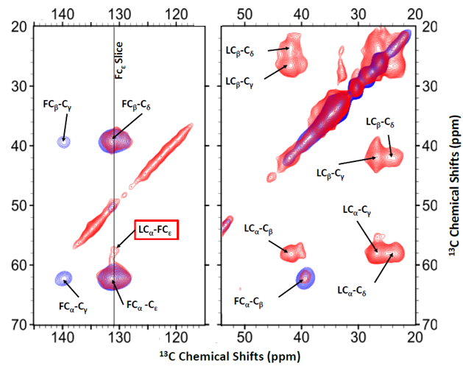
The CrgA G44V mutant protein was expressed in E. coli at 37ºC using specifically labeled C¹³ amino acids. Membrane fractions were collected and purified using high-speed ultracentrifugation and a Histidine-tag column. Differently-labeled dimer expressions were dissociated, combined, and placed within liposomes where they were then packed into a 3.2 mm MAS rotor. Solid-state NMR PARIS spectra were then acquired on a 14.1 T magnet using an NHMFL 3.2 mm Low-E triple-resonance biosolids MAS probe.
Additional interaction studies have likewise been done using Pulldown assays to study how dimerization affects the interaction with CwsA. Construct work has likewise been done to study CrgA interactions in-vivo using Bacterial Two-Hybrid Assays in E.coli.

Results and Discussion
Over the last year, an interaction between C¹³-labeled Leucine and Phenylalanine CrgA monomers was confirmed using 2D PARIS spectra (Fig.1). Cross-peaks between Phe and Leu at 130 and 139 ppm can be seen, indicating these residues to be in close proximity upon formation of the dimer. Work was likewise done investigating the role of the dimer in CrgA-CwsA interactions, and based on SDS-PAGE analysis, it was determined that dimerization is not necessary for interaction to occur as the F79A mutant, where the dimer is strongly reduced, still shows CwsA interaction. Likewise, it was found that the transmembrane helix likely plays a role in the interaction as the interaction still occurred following removal of the N- and C-termini (Fig. 2).

Fig.1 PARIS spectra of C¹³Leu-C¹³Phe CrgA G44V protein (264 scans, 12k kHz). Mixing times of 100 (blue) and 800 (red) used. Leu shifts: 22.6 (C_{δ}), 26.8 (C_{γ}), 41.5 (C_{β}), 57.9 (C_{α}). Phe shifts: 130.8 (C_{ε}), 132.7 (C_{δ}), 138.4 (C_{γ}). LC_{α}-FC_{ε} cross-peaks seen in the red spectra.
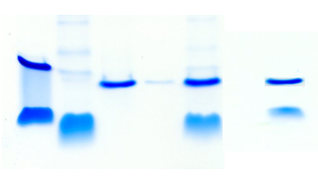
Conclusions
Current pulldown assay results suggest that the transmembrane region may play an important role in CrgA’s interaction with CwsA, and that dimerization is not necessary for interaction especially for the G44V mutant. Confirmed interface between Phe and Leu across the intra-helical space has provided insight into the structural nature of the dimer and additional construct work has been done in hopes of determining the specific residues that may be involved in this interaction.
Pulldown Results
Controls
CrgA G44V Δ1-29
CrgA F79A
CrgA G44V
CrgA Δ1-29
CwsA
Fig.2: SDS-PAGE for the CwsA-CrgA G44V 2TM and CwsA-CrgA F79A pulldown assays. Gel results suggest dimerization not critical for CwsA interaction and that the Transmembrane or loop region may be important for the interaction. Last wash and elution shown for each.
Acknowledgements
A portion of this work was performed at the NHMFL, supported by NSF DMR-1157490 and the State of Florida. This work was supported by NIH R01AI119178.

References
[1] Das, N., et al., Proc Natl Acad Sci USA, 112(2), E119-126 (2015).

