Protein Conformation Determined in Native Cellular Environments

Costello, W.N., Xiao, Y. and Frederick, K.K. (U. of Texas Southwestern, Biophysics)

Introduction
Structural investigations of biomolecules are typically confined to in vitro systems under extremely limited conditions. These investigations yield invaluable insights, but such experiments cannot possibly capture important structural features imposed by biological environments. We are developing the methodology to study protein structures in their native environment: the cell. To do so, we combine new biotechnology for sample preparation and state-of-the-art sensitivity-enhanced solid-state nuclear magnetic resonance (NMR) techniques [1]. Using a self-polymerizing yeast prion protein, Sup35, as a model system, we seek to determine how cellular environments influence the folding pathways of meta-stable and intrinsically disordered proteins. We recently demonstrated that structural studies of proteins at very low (endogenous) concentrations in their native contexts are not only possible, but also that the native context can and does have a dramatic influence on protein structure, particularly on a region that is intrinsically disordered in purified samples [1]. While these studies did not detect changes in the average structure of the amyloid core between purified Sup35 fibrils and Sup35 fibrils assembled in cell lysates, chemical shift degeneracy precluded detailed analysis. To overcome this problem we have segmentally isotopically labeled Sup35 to simplify the NMR spectra [2]. We seek to establish DNP NMR as a method for obtaining site-specific atomic-level information for proteins at endogenous levels in native environments Fig.1A.
Experimental
Using the 600 MHz WB DNP system at the National High Magnetic Field Laboratory in Tallahassee, we acquired one dimensional spectra (¹³C CP and ¹⁵N-filtered (z-TEDOR) ¹³C spectra) of samples of 10 µg of either uniformly ¹³C and ¹⁵N (in Fig.1B, F, G) or segmentally ¹³C and ¹⁵N labeled Sup35 polymerized into the amyloid conformation in yeast lysates grown on ¹²C enriched media. Samples contained 10 mM AMUPol and various concentrations of d₈-glycerol. Spectra were collected at 110 K with 10 kHz MAS.
Results and Discussion
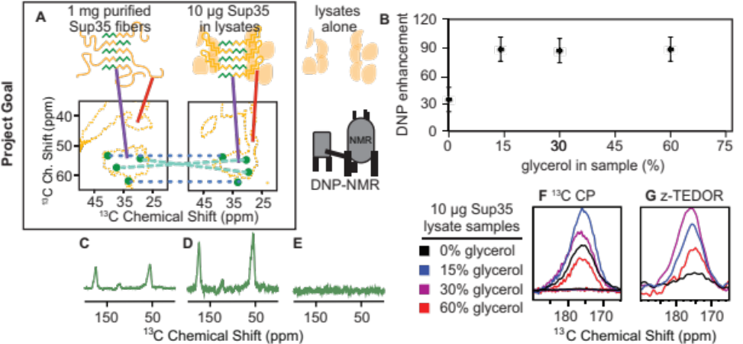
Because detecting segmentally labeled proteins in lysates sets a high bar for sensitivity, as a prelude to collecting data on these samples (where only 5% of the residues are isotopically labeled), we first optimized experimental conditions. For lysate-containing samples, we found that lower concentrations of glassing agents still result in high enhancements Fig.1B. Applying these conditions to samples of segmentally isotopically labeled proteins in unlabeled lysates, we obtained spectra selective for adjacent ¹³C and ¹⁵N sites (z-TEDOR) in 256 scans Fig.1D. This sample had higher sensitivity than that of a much higher concentration of purified fibrils Fig.1C, indicating high DNP enhancements. The signals were not a result of natural abundance sites in the lysate background Fig.1E.
Conclusions
DNP provides enough sensitivity to enable detection of a small number of sites in a protein at endogenous levels in its native cellular environment.
Acknowledgements
A portion of this work was performed at the NHMFL (NSF DMR-1157490) and the State of Florida. Additional funding from Lupe Murchinson Foundation,
Fig.1 A) DNP spectra of Sup35 purified and in lysates revealed structural differences in the IDP region (red line) but not the amyloid core (purple). A cartoon describing how segmental labeling (green) may allow determination of environmentally robust (blue) and environmentally sensitive (cyan) structural motifs. B) Samples containing cell lysates enhance well even at 15% glycerol (F & G are primary data). 1D z-TEDOR for segmentally labeled Sup35 C) purified fibers don’t enhance as well as D) 10 µg of fibers in lysates (ns= 256). E) There is no background signal from lysates alone.

the Welsh Foundation, the
Cancer Prevention Research
Institute of Texas (RR150076),
and NIH/BRG P41GM122698.
References
[1] Frederick, K.K., et al., Cell,
163, 620-629 (2015).
[2] Frederick, K.K., et al., PNAS, 114, 3642-3647 (2017).

