Development of State-of-the-Art Solid-State NMR Methods Suitable at Ultrahigh Magnetic Fields and Ultrafast MAS Spinning Rates

Wi, S. (NHMFL; Shin, Y. (FSU, Chemistry & Biochemistry); Cross, T.A. (FSU, Chemistry & Biochemistry, NHMFL) and Frydman, L. (NHMFL, Weizmann Institute of Science, Chemical Physics)

Introduction
A novel method for achieving two-dimensional (2D) ¹³C-¹³C exchange spectroscopy under fast magic-angle spinning (MAS) rates (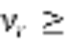 40 kHz) relying on a low power adiabatic chirp pulse mixing scheme, has been developed and demonstrated. The reason for developing such broadband ¹³C-¹³C homonuclear dipolar recoupling methods under fast MAS spinning rates while employing low rf pulses, is that conventional methods such as PDSD¹ or DARR,² popular under low MAS spinning rates, do not work well at fast spinning rates and in the presence of wide offset distributions. Moreover, other rf-pulse driven recoupling methods that are operational under an ultrahigh MAS spinning rate often possess the drawbacks of requiring strong rf pulses, which is both a burden on the probe and a major cause of heat generation in the sample that is particularly disadvantageous for studying biological samples at high fields.
Experimental
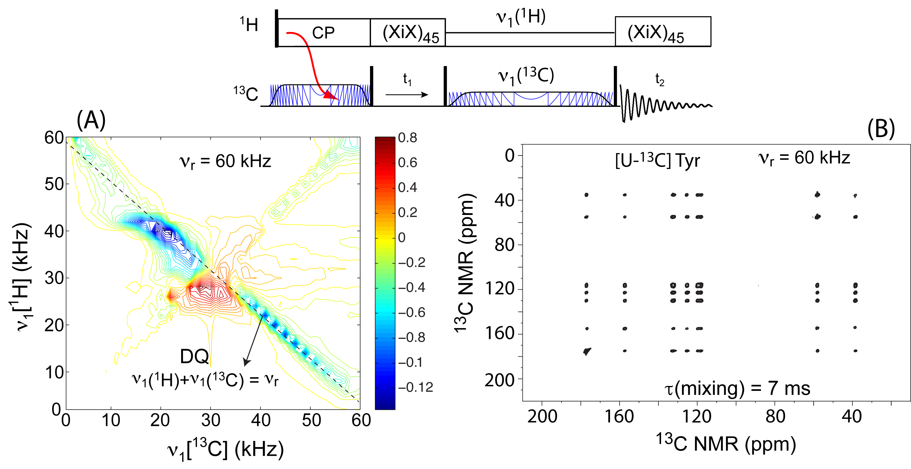
A pulse scheme of the standard ¹³C-¹³C exchange spectroscopy was adopted and endowed with an adiabatic chirp pulse mixing with a low rf pulse power along the ¹³C channel and simultaneously a low power pulse along ¹H channel satisfying 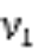(¹H) + (¹³C) =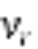, a double-quantum (DQ) Hartman-Hahn matching condition.³ Under fast MAS spinning rates this corresponds to a proton-assisted ¹³C-¹³C recoupling method that greatly alleviates the dipolar truncation effect,⁴ allowing to detect effectively long distances among (> 5 Å) ¹³C-¹³C pairs, even in the presence of the strong directly bonded ¹³C-¹³C dipolar pairs in uniformly ¹³C-labeled biological samples.
Results and Discussion
Shown in Figure 1 is a demonstration of the method’s efficiency using a 2D ¹³C-¹³C exchange NMR experiment at a MAS rate = 60 kHz. It shows the pulse scheme, a simulation map for finding the optimal rf pulse strengths, and an experimental result measured on [U-¹³C]Tyrosine. Panel (A) shows a well-defined DQ mixing mode arising along the dashed diagonal line (from the upper left-hand to the bottom right-hand corner), satisfying the (¹H)+ (¹³C) = condition.⁵ Panel (B) shows how all the carbon sites that are present in [U-¹³C]Tyrosine exhibit a total correlation (mixing time τ = 7 ms). We are currently extending its application to uniformly or selectively ¹³C-labeled proteins for assessing its competitiveness in real bioloical applications.

Fig.1 Pulse sequence (top), 2D rf pulse simulation map (A), and 2D ¹³C-¹³C NMR spectrum measured on [U-¹³C]Tyrosine (B) of the new method.
Conclusions
A novel method was successfully implemented for acquiring solid-state¹³C-¹³C exchange NMR spectrum of a uniformly labeled sample with a suppressed dipolar truncation effect under an ultrahigh MAS spinning rate while employing low rf pulse powers.
Acknowledgements
This work was performed at the NHMFL, which is supported by National Science Foundation Cooperative Agreement No. DMR-1157490 and the State of Florida, and by the Israel Science Foundation under grant 795/13.
References
[1] Szeverenyi, N.M., et al., J. Magn. Reson., 47, 462 (1982).
[2] Takegoshi, K., et al., Chem. Phys. Lett., 344, 631 (2001).
[3] Hartmann, S.R., et al., Phys. Rev., 128, 2042 (1962); Pines, A., et al., J. Chem. Phys., 59, 569 (1973).
[4] De Paëpe, G., et al., J. Chem. Phys., 129, 245101 (2008).
[5] Wi, S., et al., J. Chem. Phys., 142, 064201 (2015).

