Coherent Spectroscopy at 25 Tesla in a Photosynthetic Protein Complex

Maiuri, M., Oviedo, M.B., Dean, J.C. (Princeton U., Chemistry); Bishop, M. (MagLab); Toa, Z.S.D. (Princeton U., Chemistry); McGill, S. (MagLab); Scholes, G.D. (Princeton U., Chemistry)

Introduction
The observation of coherent oscillations in the ultrafast dynamics of photosynthetic proteins has stimulated deeper insights into the way light is harvested in photosynthesis [1]. Specialized chromophores (pigments) bounded to the protein absorb sunlight and transfer energy to reaction centers, acting as solar cells. Recent theoretical studies have predicted that the oscillations observed in light harvesting complexes are explained as vibronic coherence, that is an energy-resonant delocalization depending on: (i) the vibrations of a pigment and (ii) the electronic coupling between two of them [2]. An unequivocal identification of this coupling is challenging due to the complex analysis of signals generated in coherent multidimensional experiments. An ideal experiment should remove the interaction with the vibrational motion, perturbing only the electronic energy gap between two pigments and detect the intensity/energy redistribution caused by vibronic coupling. Here we show how a high external magnetic field can detune vibronic coupling in the light-harvesting complex isolated from a cryptophyte algae, namely PC645. This complex comprises eight pigments (fig.1A) and a prominent energy transfer channel occurs from the highest donor pair (DBVs) to the lowest acceptors (PCB) pigments.
Experimental
A broadband pump probe set-up [2] was implemented at the Split Florida-Helix facility pumped by a home build NOPA delivering pulses in the visible frequency range compressed below 20fs (fig. 1B). By a post-process Fourier analysis of the temporal pump-probe traces, we retrieved the modes forming the coherent signals and compared the results in the absence/presence (0/25T) of the magnetic field. We supported the changes observed at 25T with time-domain density functional theory, which predicted that strong magnetic fields will detune the electronic coupling of the DBV pair by ~40cm⁻¹. Furthermore, we tested that the 25T magnetic field did not change the coherent vibrations observed in the pump-probe map of the protein subunit containing only one pigment.
Results and Discussion
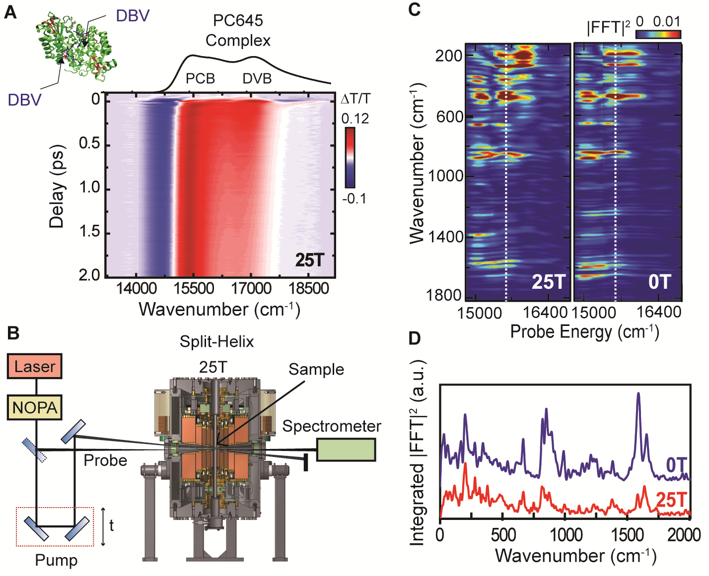
Fig.1A shows the pump-probe map obtained at 25T for the PC645 complex. The Fourier Transformed map is shown in fig. 1C and compared with the one obtained from the 0T experiment. Strong modes are displayed at low and high frequency in the PCB probe region. We experimentally observed a change in the amplitude of a high-frequency mode (fig.1D) that we interpreted as the result of the detuning of the electronic coupling. A careful study revealed that this excitonic transitions is coupled to an excited states PCB vibration at 1570cm⁻¹, assigned to the C=N stretching. The magnetic field allows to reveal and detune vibronic coupling in a photosynthetic complex.
Conclusions
We propose a new approach to study the coupling between electronic coherences and vibrations combining a very high magnetic field with femtosecond pump-probe spectroscopy. This work offers an unprecedent tool to inspect the oscillatory features observed in ultrafast time resolved experiments.
Acknowledgements
A portion of this work was performed at the National High Magnetic Field Laboratory, which is supported by National Science Foundation Cooperative Agreement No. DMR-1157490 and the State of Florida.
Fig.1 PC645 structure and absorption spectrum together with the pump-probe map at 25T (A). Scheme of the broadband ultrafast set-up (B). Fourier Transformed maps calculated from pump-probe maps at 0T and 25T (C) and corresponding integrated Fourier power spectra (D).
References
[1] Engel, G. S. et al. Nature, 446, 782-786 (2007).
[2] Kolli, A. et al. J. Chem. Phys., 137, 174109 (2012).
[3] Dean, J.D. et al Chem 1, 858-872 (2016).

